The health-relevant architecture of the everyday light exposome
Johannes Zauner^{1,✉}, Altug Didikoglu^{2,3}, Sam Aerts⁴, Gabriel Kwaku Agbeshie⁵, Kwadwo Owusu Akuffo⁵, Sena Gulsum Akgun³, Sema Nur Aydin³, David Baeza Moyano⁶, Daan Boesten⁴, John F.B. Bolte^{4,7}, Kai Broszio⁸, Guadalupe Cantarero García⁶, Roberto Alonso González Lezcano⁶, Carolina Guidolin⁹, Sarina Hilden¹, Nico Hogervorst⁴, Astrid Jansen⁴, Zeynep Kayar³, Stefan Källberg¹⁰, Suyoun Lee¹, Sofía Melero Tur⁶, Maria Nilsson Tengelin¹⁰, María Concepción Pérez Gutiérrez⁶, Andrea Sancho-Salas¹¹, Oliver Stefani¹², Ingemar Svensson¹⁰, Helga von-Breymann¹¹, and Manuel Spitschan^{1,9,13,14}
¹ Department Health and Sports Sciences, TUM School of Medicine and Health, Chronobiology & Health, Technical University of Munich, Munich, Germany
² Division of Diabetes, Endocrinology, and Gastroenterology, School of Medical Sciences, Faculty of Biology, Medicine and Health, The University of Manchester, Manchester, UK
³ Faculty of Science, Department of Neuroscience, Izmir Institute of Technology, Izmir, Türkiye
⁴ Smart Sensor Systems research group, The Hague University of Applied Sciences, Delft, The Netherlands
⁵ Department of Optometry and Visual Science, College of Science, Kwame Nkrumah University of Science and Technology, Kumasi, Ghana
⁶ Fundación Universitaria CEU San Pablo, Boadilla del Monte, Madrid, Spain
⁷ Centre for Sustainability, Environment and Health, National Institute for Public Health and the Environment (RIVM), Bilthoven, The Netherlands
⁸ Federal Institute for Occupational Safety and Health (BAuA), Dortmund, Germany
⁹ Max Planck Institute for Biological Cybernetics, Max Planck Research Group Translational Sensory & Circadian Neuroscience, Tübingen, Germany
¹⁰ RISE Research Institutes of Sweden, Borås, Sweden
¹¹ School of Architecture, University of Costa Rica, San José, Costa Rica
¹² Lucerne University of Applied Sciences and Arts, Lucerne, Switzerland
¹³ TUM Institute for Advanced Study (TUM-IAS), Technical University of Munich, Garching, Germany
¹⁴ TUMCREATE Ltd., Singapore, Singapore
✉ Correspondence: Johannes Zauner <johannes.zauner@tum.de>

Abstract
Light supports circadian regulation and is associated with non-communicable diseases, yet ocular exposure patterns remain poorly understood. We recruited 191 adults across nine sites in seven countries, combining diaries and contextual reports with near-eye (141 participants; 816 participant-days) and complementary chest-level measurements (154 participants; 902 participant-days). In near-eye analyses, only 24.0% of recorded daytime minutes met the recommendation of at least 250 lx melanopic equivalent daylight illuminance; 63.3% of pre-sleep and 87.7% of bedside sleep-environment minutes met their respective limits. Variation among people and days within sites exceeded that among sites (ratio 1.99; 95%-CI, 1.29–4.77). In hourly models, light source and setting contributed the largest shares of fitted variation after time of day. Site-average outdoor exposure was 9.35 times that while awake at home (95%-CI, 6.95–12.59; 714.2 versus 76.4 lx). This baseline identifies a daytime exposure gap and supports testing interventions in everyday settings to improve light exposure and health.
Keywords: ocular light exposure; melanopic equivalent daylight illuminance; wearable sensing; environmental health; exposome; non-communicable disease; circadian light; multicountry study.

Introduction
Light reaching the eye supports vision and signals circadian timing, sleep, alertness and neuroendocrine responses^{1–5}. Melanopic equivalent daylight illuminance (melanopic EDI) weights illuminance for melanopsin-related sensitivity and is most relevant to these effects^{6,7}. Expert consensus recommends at least 250 lx melanopic EDI at the eye during daytime, no more than 10 lx during the three hours before sleep and no more than 1 lx in the sleep environment for healthy adults with regular daytime schedules⁸. These physiology-based ranges make daily light a health-relevant exposure, but are not individual risk functions.
Population studies and reviews associate personal light patterns with sleep and major non-communicable diseases⁹. Wrist-sensor studies link light timing and day-night distribution with sleep timing and sleepiness, psychiatric disorders, incident type 2 diabetes, cardiovascular disease and mortality^{10–15}. Other cohorts link evening, nocturnal or seasonal light with sleep in bipolar disorder and with obesity, diabetes, hypertension and metabolic health^{16–19}. The exposome framework characterises non-genetic exposures across the life course^{20,21}, yet rarely includes time-resolved ocular melanopic light, the everyday component examined here. These studies establish population relevance but mostly measured broad-spectrum wrist or bedside light, providing only proxy evidence for melanopic ocular exposure.
An everyday exposure baseline against these recommendations is missing. Personal exposure to natural and electric light follows an expected 24-hour rhythm, including in large wrist-sensor cohorts²², but previous studies focus on particular populations, occupations or settings^{23–25}. Its amplitude and timing across sites and countries, and the contributions of time, site, individuals, day-to-day variation and immediate context, remain uncertain. Daylight availability, satellite estimates and fixed-site measurements cannot resolve these layers as people move through buildings, transport, outdoor spaces and sleep environments²⁶. Sensor position also matters: near-eye sensing is closer to the incident ocular field but is not a retinal measurement; wrist and chest sensors capture related fields shaped by posture, wear and occlusion^{27–33}.
Using the harmonised MeLiDos protocol, we measured personal light across nine sites in seven countries^{34,35}. The near-eye sensor characterised ocular light exposure during wear, alongside diaries, light-source and immediate-setting reports, sleep information and questionnaires. The complementary chest sensor provided non-ocular environmental evidence and enabled participation among people reluctant to wear the glasses-mounted sensor. We sought a multisite recommendation-based baseline, assessing temporal, environmental and routine contributions alongside selected person-level correlates. We use architecture to describe how everyday light exposure is organised across time, sites, people, days and immediate settings, and benchmark this component of the exposome against health-based light recommendations. Although not global, the protocol enables harmonised measurement elsewhere, progressively closing gaps across locations, civil photoperiods, latitudes and climates and building towards a global account of ocular light exposure.

Results

A multisite baseline and recommendation adherence
The normalised roster comprised 191 participants across Borås (SE), Delft (NL), Dortmund (DE), Tübingen (DE), Munich (DE), Madrid (ES), Izmir (TR), San José (CR) and Kumasi (GH). Of these, 184 contributed 1,478 participant-days with recorded, non-all-zero light data at either position before quality screening. After screening, the near-eye dataset contained 141 participants and 816 participant-days, the complementary chest dataset 154 and 902, and the common sample 112 participants and 643 participant-days. Near-eye measurements provide ocular-exposure evidence during wear, whereas chest measurements are non-ocular; both describe the bedside sleep environment during reported sleep. Supplementary Table S1 gives the sample flow.
The pooled near-eye record followed the expected 24-hour rhythm: low overnight exposure, a morning rise, higher daytime values and an evening decline. Seventeen complementary metrics captured thematic streams rather than one score. Level metrics described daily geometric mean melanopic EDI and the brightest and darkest supported 10-hour means; duration and timing metrics quantified exposure ranges, sustained bright periods, bright or dark windows and threshold crossings. Dose integrated intensity, regularity captured stability and fragmentation, and melanopic daylight efficacy (MDER) described spectral composition relative to visual illuminance. These features are not interchangeable health-response estimates. Supplementary Table S2 and Supplementary Figure S1 give the metric dictionary and site distributions; Supplementary Figure S2 shows a worked derivation. Figure 1 and Table 1 summarise the design and data structure.
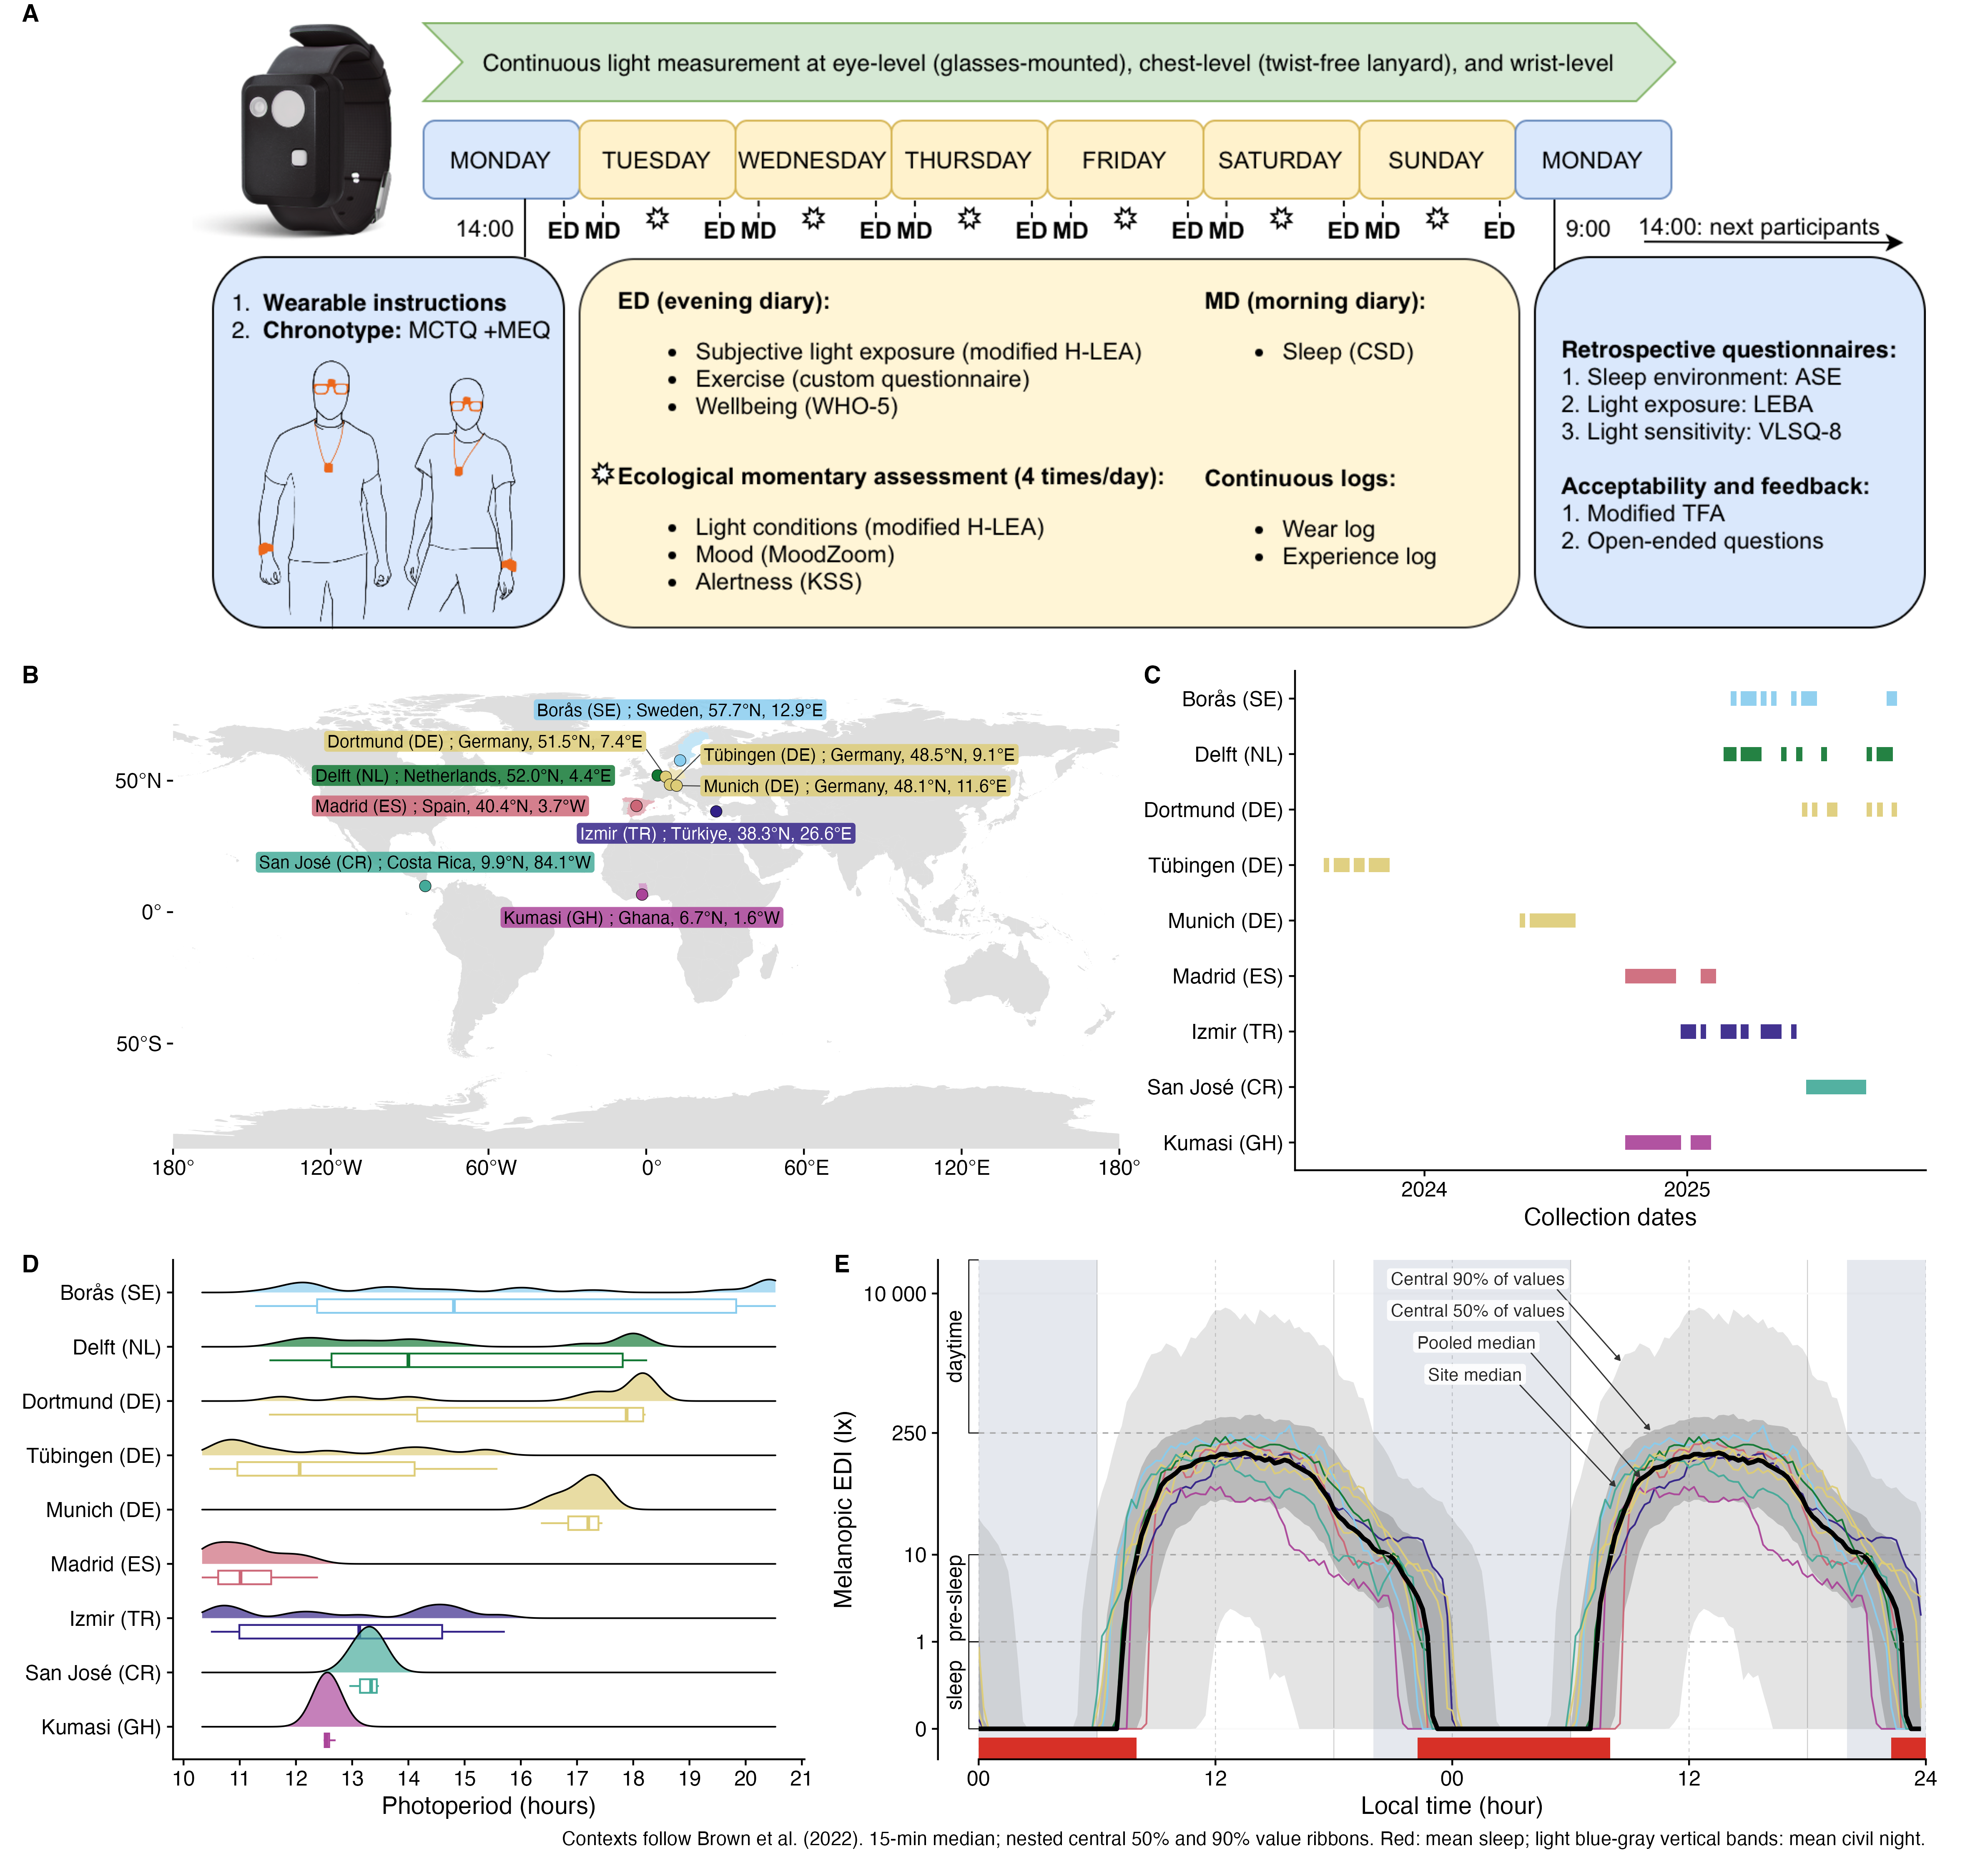
Figure 1: Five-panel overview of the eight-day protocol, sensor positions, nine country-coded sites, collection windows, civil photoperiod, and the pooled near-eye daily profile. A, Eight-day field protocol and sensor positions. The wrist logger is shown as a protocol device but is not an exposure channel analysed in this manuscript. B, Nine sites in seven countries. C, Site collection periods. D, Observed civil photoperiod. E, Site and pooled 15-minute median near-eye melanopic equivalent daylight illuminance profiles from 816 participant-days contributed by 141 participants, repeated over 48 hours for display only. Grey ribbons show the central 50% and 90% of measured values, not confidence intervals; coloured lines are site medians, the black line is the pooled median, and red and blue shading show mean reported sleep and civil night (sun elevation < -6°). During reported sleep, the measurement represents the bedside sleep environment.

Table 1: Participant and measurement characteristics overall and by country-coded study site. The table distinguishes the 191-person roster, participants and participant-days with recorded light data, and the screened near-eye and complementary chest samples. Model-specific samples are reported with each analysis. Of the 191 roster participants, 184 contributed the 1,478 recorded participant-days. Continuous participant characteristics are median with the stated percentile range.
 | Overall | Borås (SE) | Delft (NL) | Dortmund (DE) | Tübingen (DE) | Munich (DE) | Madrid (ES) | Izmir (TR) | San José (CR) | Kumasi (GH)
Site specifics
Institution | Overall | RISE | THUAS | BAuA | MPI | TUM | FUSPCEU | IZTECH | UCR | KNUST
Country | Not applicable | Sweden | Netherlands | Germany | Germany | Germany | Spain | Türkiye | Costa Rica | Ghana
City | Not applicable | Borås | Delft | Dortmund | Tübingen | Munich | Madrid | Izmir | San José | Kumasi
Coordinates | Not applicable | 57.7°N, 12.9°E | 52.0°N, 4.4°E | 51.5°N, 7.4°E | 48.5°N, 9.1°E | 48.1°N, 11.6°E | 40.4°N, 3.7°W | 38.3°N, 26.6°E | 9.9°N, 84.1°W | 6.7°N, 1.6°W
Data collection
Participants¹ | 191 roster  (g:143; c:157; p:116) | 17 roster  (g:14; c:17; p:14) | 20 roster  (g:13; c:15; p:13) | 24 roster  (g:19; c:22; p:19) | 26 roster  (g:26; c:0; p:0) | 10 roster  (g:10; c:10; p:10) | 23 roster  (g:23; c:22; p:22) | 17 roster  (g:17; c:17; p:17) | 39 roster  (g:6; c:39; p:6) | 15 roster  (g:15; c:15; p:15)
Participant-days¹ | 1478 roster  (g:1134  c:1246; p:902) | 137 roster  (g:107  c:137; p:107) | 125 roster  (g:107  c:124; p:106) | 176 roster  (g:145  c:163; p:132) | 208 roster  (g:208  c:0; p:0) | 80 roster  (g:80  c:80; p:80) | 182 roster  (g:182  c:174; p:174) | 138 roster  (g:138  c:138; p:138) | 312 roster  (g:48  c:312; p:48) | 120 roster  (g:119  c:118; p:117)
Participant time² | 116w 4d | 11w 23h | 11w 23h | 15w 2d | 21w 3d | 8w 4d | 18w 3d | 14w 3d | 4w 4d | 11w 4d
Declared non-wear² | g:4w 1d (3.66%) | g:2d 14h (3.34%) | g:3d 1h (3.92%) | g:3d 15h (3.42%) | g:6d 10h (4.30%) | g:2d 17h (4.55%) | g:2d 20h (2.20%) | g:3d 3h (3.13%) | g:1d 11h (4.66%) | g:3d 21h (4.80%)
Screened days^{1,3} | g:816  c:902 | g:78  c:96 | g:78  c:93 | g:107  c:114 | g:150  c:0 | g:60  c:60 | g:129  c:123 | g:101  c:102 | g:32  c:230 | g:81  c:84
Civil photoperiod^{4,2} | 13.25 h (10.62–18.20)  (n=1478 d) | 14.81 h (11.80–20.49)  (n=137 d) | 14.00 h (11.88–18.09)  (n=125 d) | 17.88 h (11.76–18.22)  (n=176 d) | 12.07 h (10.55–15.41)  (n=208 d) | 17.20 h (16.45–17.45)  (n=80 d) | 11.01 h (10.35–12.22)  (n=182 d) | 13.13 h (10.52–15.57)  (n=138 d) | 13.34 h (13.01–13.47)  (n=312 d) | 12.54 h (12.49–12.68)  (n=120 d)
Participant information
Age⁴ | 28 y (21 y–52 y)  (n=191 N) | 38 y (22.6 y–64.8 y)  (n=17 N) | 30.5 y (19.9 y–57.1 y)  (n=20 N) | 35.5 y (20.1 y–58.5 y)  (n=24 N) | 27 y (22 y–37 y)  (n=26 N) | 27.5 y (22.2 y–29 y)  (n=10 N) | 31 y (20.2 y–54.3 y)  (n=23 N) | 24 y (21 y–29.6 y)  (n=17 N) | 34 y (22 y–48.1 y)  (n=39 N) | 23 y (20.1 y–25 y)  (n=15 N)
Sex⁵ | F:105 / M:86  (n=191) | F:6 / M:11  (n=17) | F:8 / M:12  (n=20) | F:13 / M:11  (n=24) | F:14 / M:12  (n=26) | F:6 / M:4  (n=10) | F:15 / M:8  (n=23) | F:11 / M:6  (n=17) | F:24 / M:15  (n=39) | F:8 / M:7  (n=15)
Employment status⁶ | F:163 / P:26 / N:2  (n=191) | F:16 / P:0 / N:1  (n=17) | F:11 / P:9 / N:0  (n=20) | F:21 / P:3 / N:0  (n=24) | F:23 / P:3 / N:0  (n=26) | F:9 / P:1 / N:0  (n=10) | F:21 / P:2 / N:0  (n=23) | F:15 / P:2 / N:0  (n=17) | F:34 / P:5 / N:0  (n=39) | F:13 / P:1 / N:1  (n=15)
Chronotype group⁷ | m:62 / i:94 / e:30  (n=186) | m:8 / i:4 / e:5  (n=17) | m:3 / i:9 / e:3  (n=15) | m:8 / i:13 / e:3  (n=24) | m:9 / i:9 / e:8  (n=26) | m:0 / i:8 / e:2  (n=10) | m:5 / i:17 / e:1  (n=23) | m:2 / i:10 / e:5  (n=17) | m:16 / i:20 / e:3  (n=39) | m:11 / i:4 / e:0  (n=15)
Sleep-corrected midsleep on free days^{4,8} | 04:03 (02:08–06:15)  (n=185 N) | 02:55 (02:04–05:09)  (n=17 N) | 04:31 (03:05–05:37)  (n=15 N) | 03:47 (02:17–04:49)  (n=24 N) | 04:33 (02:41–06:04)  (n=26 N) | 05:08 (04:12–06:04)  (n=10 N) | 04:48 (03:10–06:52)  (n=22 N) | 05:29 (03:35–06:49)  (n=17 N) | 03:42 (02:17–05:31)  (n=39 N) | 02:19 (01:22–03:26)  (n=15 N)
¹g, near-eye glasses position; c, complementary chest position; p, paired common sample in which the same participant-day is available at both positions.
²w: weeks; d: days; h: hours; min: minutes. Participant time and declared non-wear use eligible real minutes on screened days; both are shown for near eye only.
³Screened days are the final participant-days after the 80% completeness screen and exclusion of exact-all-zero melEDI days.
⁴Median (5th percentile, 95th percentile).
⁵Sex categories: Female and Male.
⁶Employment categories: Full/studying, Part/marginal, and Not employed.
⁷Chronotype groups follow the Morningness–Eveningness Questionnaire score.
⁸MCTQ: Munich Chronotype Questionnaire; MEQ: Morningness–Eveningness Questionnaire. Clock summaries are circular.

Exposure was within the applicable recommendation during 24.0% of daytime minutes, 63.3% of pre-sleep minutes and 87.7% of sleep minutes. This represented 137,792 of 573,712 waking daytime minutes, 81,894 of 129,390 pre-sleep minutes and 336,052 of 383,366 minutes during reported sleep. The sleep quantity describes the bedside sleep environment because the device was not worn at the eye; the Discussion addresses low-light measurement accuracy. Supplementary Table S3 gives exact numerators, denominators and complementary ranges.
These pooled-minute percentages describe how often exposure lay within range, not participant adherence. Model-based comparisons retained each window’s adherent and valid-minute counts.
The adherence model included 2,298 periods from 140 participants and 794 cycles (1,043,192 valid minutes), linking preceding sleep, daytime and following pre-sleep to the wake-start date’s day type; windows qualified independently. Free-versus-work adherence was 5.1 percentage points lower during daytime (95% confidence interval [95% CI] 2.4 to 7.8 lower), 5.9 higher pre-sleep (1.4 to 10.5) and 6.5 lower during sleep (3.8 to 9.1). At least 80% coverage preserved daytime and sleep interval conclusions, but pre-sleep was inconclusive (4.1 points, 95% CI -0.9 to 9.1). Temporal dependence remained unresolved.
The window-by-site-by-day-type interaction was retained (FDR-adjusted p = 0.008), with site variation during daytime and sleep (both p = 0.002), not detected pre-sleep (p = 0.818). Relative to the site-average free-minus-work contrast, Dortmund (DE) was 14.8 points higher during daytime (95% CI 6.7 to 22.9; FDR-adjusted p = 0.004), Madrid (ES) 9.2 lower (-15.6 to -2.8; p = 0.044), and Kumasi (GH) 6.3 higher during sleep (3.5 to 9.1; p < 0.001). These departures met a separate 27-test FDR criterion and retained directions and interval conclusions at 80% coverage.
On the design-standardized response scale, marginal R² was 58.0% and conditional R² 60.2%; the participant increment was 2.3 percentage points and observation/distribution variation 39.8%. Shapley allocated 94.2% of marginal R² to recommendation window, 4.8% to site and 1.0% to day type. Site’s 2.8-point allocation was about 1.2 times the participant-intercept increment and about five times the 0.6-point day-type allocation. Allocations are point-only; the window share partly reflects different thresholds. Table 2 and Supplementary Figures S4 and S5 give adherence estimates.

Table 2: Recommendation adherence by Brown et al. recommendation window and day type. Observed valid-minute fractions are descriptive; work-day and free-day estimates and their difference are model-based, with 95% confidence intervals and false-discovery-rate-adjusted p-values. Each of nine sites receives equal weight in the model estimates. Daytime, Pre-sleep and Sleep identify the recommendation windows: daytime excludes the three hours before reported sleep, pre-sleep comprises those three hours, and sleep describes the bedside sleep environment. The wake-start date assigns the day type to the preceding sleep, daytime and following pre-sleep windows; each window qualifies independently. Only the primary any-valid sample is shown: 2,298 periods, 140 participants, 794 cycles and 1,043,192 valid minutes. The 80% coverage sensitivity remains reported in the Results and Methods; its pre-sleep interval includes zero, and temporal dependence remains unresolved. Confidence-interval exclusion and FDR decisions are separate summaries. Descriptive pooled-minute fractions are detailed in Supplementary Table S3. Adherence does not classify participants.
 |  | Observed pooled-minute adherence | Site-average recommendation-window model
 | Recommendation | Valid minutes meeting recommendation, n/N (%) | Work-day adherence, % (95% CI) | Free-day adherence, % (95% CI) | Free minus Work, percentage points (95% CI) | FDR-adjusted p
Daytime | At least 250 lx melanopic EDI during daytime | 137,792/573,712 (24.0%) | 26.6 (24.5 to 28.7) | 21.5 (19.2 to 23.8) | -5.1 (-7.8 to -2.4) | <0.001
Pre-sleep | No more than 10 lx melanopic EDI during the three hours before sleep | 81,894/129,390 (63.3%) | 62.0 (58.8 to 65.2) | 67.9 (64.2 to 71.6) | +5.9 (+1.4 to +10.5) | 0.011
Sleep | No more than 1 lx melanopic EDI in the sleep environment | 336,052/383,366 (87.7%) | 90.4 (88.9 to 91.9) | 83.9 (81.4 to 86.5) | -6.5 (-9.1 to -3.8) | <0.001
Only the primary any-valid sample is shown. Observed minute fractions and fitted recommendation-window estimates are different quantities. Each of the nine sites receives equal weight in fitted estimates. Windows qualify independently and inherit day type from the wake-start date. Sleep describes the bedside sleep environment. Temporal dependence remains unresolved; the pre-sleep interval includes zero under the 80% coverage restriction.

Exploratory cross-window within-participant contrasts per 10-percentage-point difference in daytime adherence were -0.26 points for sleep (95% CI -0.95 to 0.43) and -1.09 for pre-sleep (-2.75 to 0.56). Unresolved temporal dependence precluded a within-participant claim; intervals including zero do not establish absence. Between participants, 10 points higher average daytime adherence was associated with 2.52 points lower sleep adherence (1.48 to 3.55 lower; FDR-adjusted p < 0.001) and 3.59 lower pre-sleep adherence (1.25 to 5.94 lower; p = 0.005), consistent with higher evening and nighttime exposure during monitoring. Both met the four-effect FDR criterion; directions and interval conclusions persisted at 80% coverage (maximum change 0.60 points). Supplementary Table S4 gives estimates and Supplementary Figure S6 participant profiles.

Personal and day-to-day differences exceed site differences
A nonlinear model decomposed personal light exposure into common local-clock, site and participant curves, and participant-day shifts. Near-eye in-sample R² was 0.775. Participant curves were 1.80 times as dispersed as site curves (95% CI 1.16 to 4.33); participant curves plus day shifts had a dispersion ratio of 1.99 (1.29 to 4.77). After accounting for time of day, fitted variation among people and their days within sites exceeded variation among sites.
Shares of full-model R² showed the same hierarchy: 78.9% for the shared local-clock pattern, 12.9% for participant patterns, 6.2% for participant-day shifts and 2.0% for site patterns. The participant-pattern share was 6.41 times the site-pattern share (3.85 to 15.14), and the combined participant-pattern and participant-day-shift share was 9.49 times the site-pattern share (5.77 to 21.81).
The shared rhythm did not imply uniform amplitude. Relative to the fitted site-average daily pattern, Borås (SE) ratios were 2.04 to 4.64 from 06:00 to 11:00 and 1.80 to 2.73 from 15:00 to 19:00. Madrid (ES) ratios were 0.15 to 0.47 from 05:30 to 10:30 and 0.40 to 0.57 from 17:30 to 20:30. Izmir (TR) shifted from 0.51 to 0.59 at 06:00 to 08:30 to 1.98 to 4.28 at 21:00 to 24:00, while Kumasi (GH) was 0.11 to 0.38 from 11:30 to 23:00. These are clock-specific departures from the average curve.
The chest model had an in-sample R² of 0.737. Of this full-model R², common time accounted for 79.1%, participant patterns 11.9%, participant-day shifts 7.0% and site patterns 2.1%. Common-sample comparisons supported the combined participant-plus-day ordering, but the participant-only contrast was less stable. Cross-position similarity is complementary context, not replication, equivalence or interchangeability. Figure 2 shows the fitted layers; Supplementary Tables S5 and S6 give both decompositions.
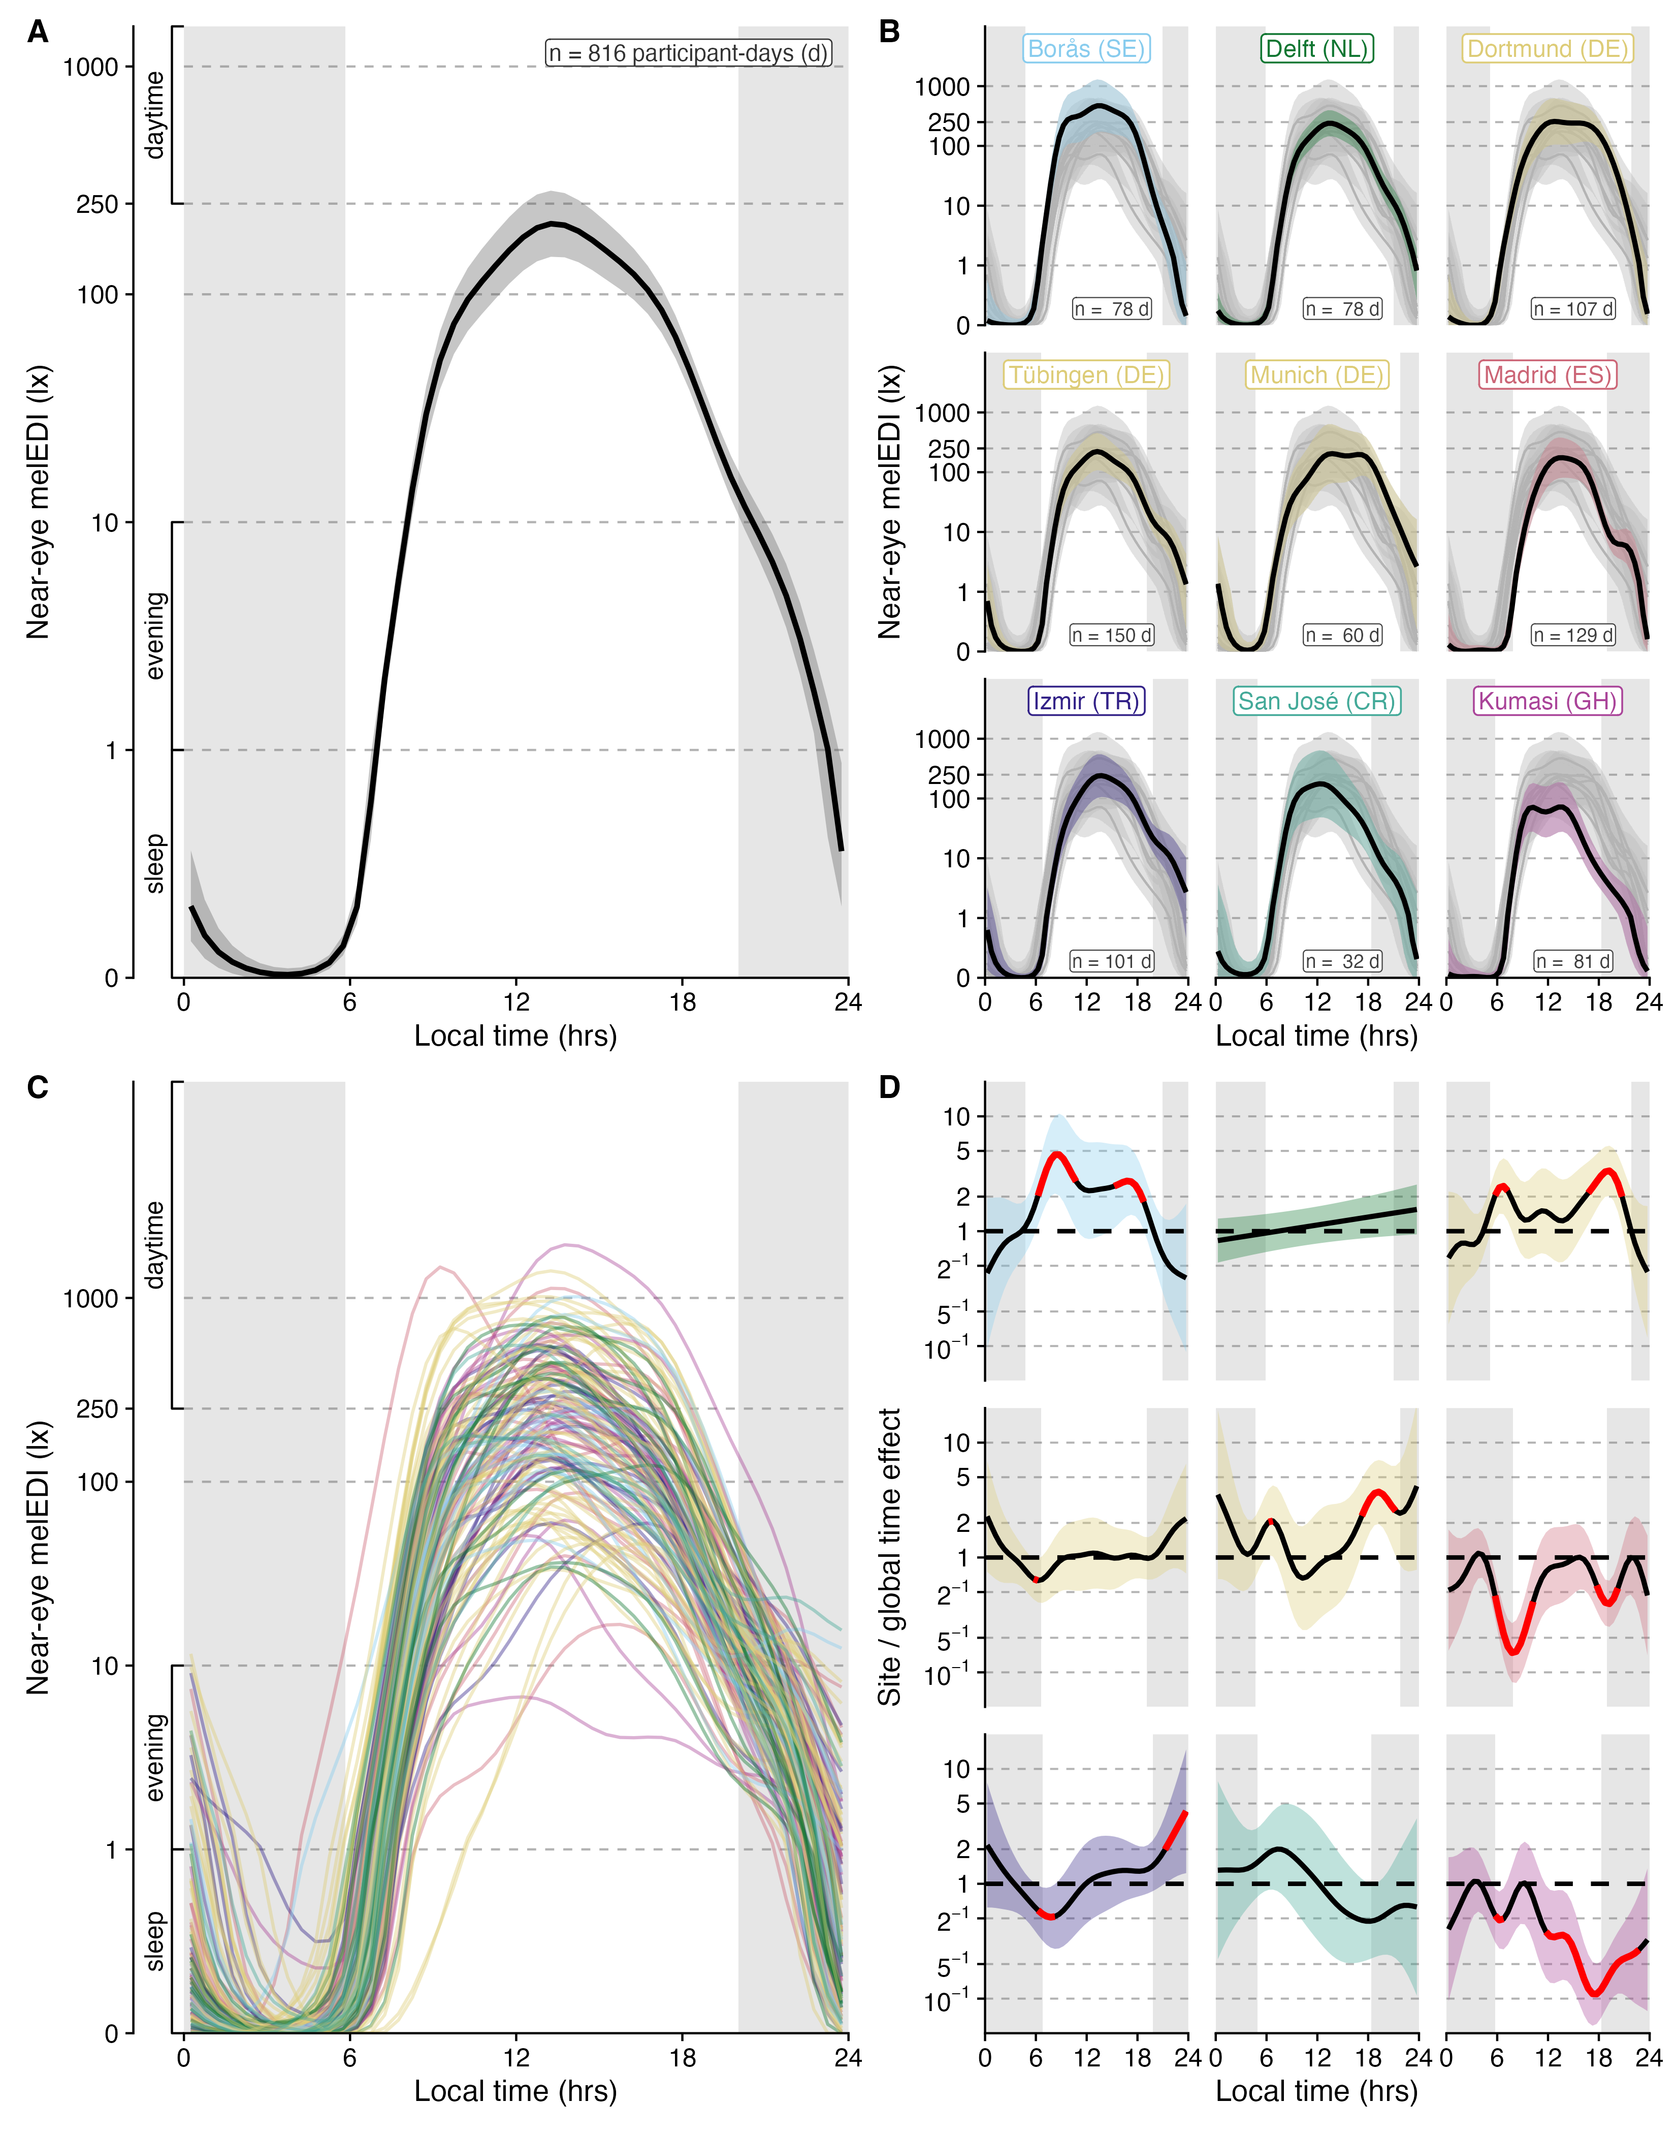
Figure 2: Multiscale daily pattern of near-eye melanopic equivalent daylight illuminance. A, Site-average daily curve. B, Fitted site curves. C, Fitted participant curves after the shared local-clock and site patterns were considered. D, Ratio of each fitted site curve to the site-average curve on the melanopic equivalent daylight illuminance plus 0.1 lx scale. Grey bands show mean civil night. Shaded bands are clock-specific 95% confidence intervals; red segments identify displayed half-hours whose interval did not include the site-average curve and are descriptive clock-specific contrasts. The analysis included 141 participants and 816 participant-days across nine sites. The label “global time effect” denotes the site-average local-clock curve (panel A).

Geography and photoperiod provide partial context
Site associations were stream-specific. Site differences met the FDR criterion for 10 of 17 near-eye metrics: all three level metrics, time above 250 lx melEDI during wake, time below 10 lx melEDI before sleep, midpoint of the brightest 10 hours, midpoint of the darkest 10 hours, mean timing of exposure above 250 lx melEDI, last light timing above 250 lx melEDI, and MDER. They were not FDR-retained for interdaily stability, intradaily variability, time above 1,000 lx melEDI, time below 1 lx melEDI during sleep, longest continuous period above 250 lx melEDI, first light timing above 250 lx melEDI, and melEDI dose. Across metric models, conditional R² averaged 37.8%; participant-associated R² averaged 26.1% among the 15 participant-day metrics. Among the 10 metrics with site support, site-associated part R² averaged 8.7%. These non-additive components reinforce the stronger individual-level contribution in the daily-pattern analysis.
Civil-photoperiod associations were selective. Per additional hour, the fitted daily geometric mean was 1.18 times higher (95% CI 1.11 to 1.26), the brightest-10-hour mean 1.24 times higher (1.13 to 1.36), waking time above 250 lx 1.14 times higher (1.07 to 1.20) and daily dose 1.28 times higher (1.17 to 1.39). Each hour was also associated with 0.134 h less time below 10 lx before sleep (0.066 to 0.201 h less) and the last exposure above 250 lx occurring 0.323 h later (0.186 to 0.460 h). Civil photoperiod met the FDR criterion for 12 of 17 metrics but not interdaily stability, intradaily variability, time below 1 lx melEDI during sleep, midpoint of the brightest 10 hours, and first light timing above 250 lx melEDI. Among supported models, photoperiod-associated part R² averaged 5.9%; the corresponding mean for the 7 supported latitude models was 3.8%. These averages describe different supported metric sets and do not compare independent or causal contributions.
Across the recorded 10.33 to 20.52 h of civil photoperiod, six of nine level, exposure-history, and duration-based metrics changed from increasing to a sustained near-flat tail between 14.24 and 16.20 hours of photoperiod: the daily mean, both 10-hour window means, time above 1,000 lx, waking time above 250 lx and dose. Pre-sleep time below 10 lx, sleep-environment time below 1 lx and the longest period above 250 lx did not. This transition means that the effect of photoperiod becomes uncertain around 14 to 16 hours. The fitted slope became compatible with zero and remained so through the observed maximum. Some classifications were sensitive to site, sample or model form. Several limitations apply as discussed below: latitude was confounded with site, collection periods and photoperiod overlap differed, and weather, built environment, culture and routine could not be separated. The metric-specific results are summarised in Table 3, Supplementary Figures S7 and S8, and Supplementary Tables S7 and S8.

Table 3: Near-eye personal light-exposure metrics and their geographic and photoperiod context. Descriptive exposure values are medians with interquartile ranges (25th to 75th percentiles). Density plots show site distributions and are descriptive. Metrics are grouped into thematic streams and describe distinct features of the daily exposure pattern rather than interchangeable health-response estimates. Model cells report overall-site evidence, civil-photoperiod associations with 95% confidence intervals, FDR decisions, participant-associated model information and model-specific R² summaries where applicable. Site and photoperiod part-R² values may contain overlapping fitted information and must not be summed. Associations are observational. Absolute latitude is fixed within and confounded with study site, so separate models containing either site or latitude are reported; complete latitude and model-adequacy results are provided in the Supplementary Information.
Near-eye personal light-exposure metrics and their geographic and photoperiod context
Metric | Descriptive summary |  | Association evidence |  | Modelled variation
Metric | Overall distribution | Site distribution | Overall site | Civil photoperiod | R² summary
Duration
Time above 1,000 lx melEDI  Bright-light exposure duration; relevant to daytime alerting and circadian entrainment. | Unit h  Median 0.683  IQR 0.183 to 1.558  Participants 141  Days 816 | 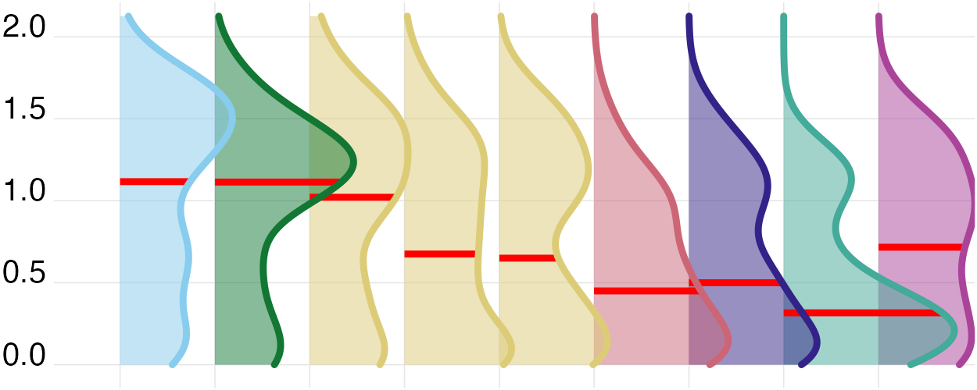 | FDR not supported; adjusted p 0.071  Part R² 4.7% (2.6% to 12.1%) | Estimate Ratio per 1 h: 1.206 (1.128 to 1.288)  FDR supported; adjusted p <0.001  Part R² 9.0% (3.7% to 15.7%) | Marginal 21.5% (16.3% to 32.3%)  Conditional 50.1% (40.2% to 57.6%)  Participant-associated 28.6% (17.7% to 34.2%)
Time above 250 lx melEDI during wake  Waking time in recommended daytime light; relevant to alertness, entrainment, and subsequent sleep. | Unit h  Median 2.417  IQR 0.850 to 4.617  Participants 141  Days 737 | 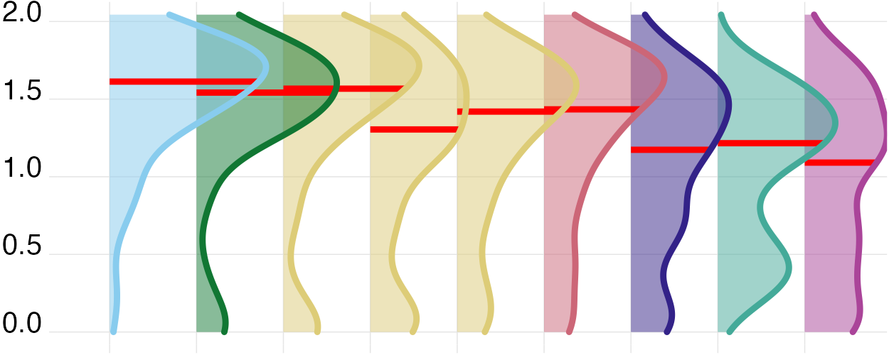 | FDR supported; adjusted p 0.007  Part R² 8.6% (5.2% to 18.7%) | Estimate Ratio per 1 h: 1.136 (1.073 to 1.202)  FDR supported; adjusted p <0.001  Part R² 6.4% (2.0% to 12.7%) | Marginal 18.0% (12.9% to 29.1%)  Conditional 50.1% (41.6% to 58.0%)  Participant-associated 32.1% (20.7% to 36.7%)
Time below 10 lx melEDI before sleep  Low-light time before bed; limits evening melatonin suppression and circadian delay. | Unit h  Median 1.883  IQR 1.025 to 2.583  Participants 139  Days 655 | 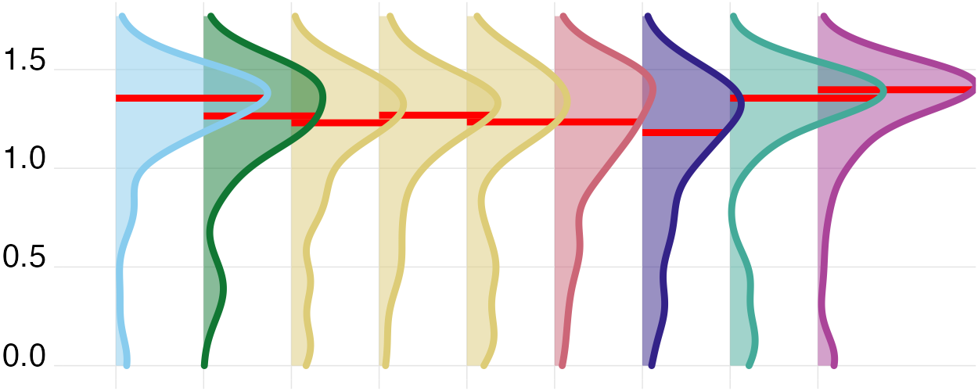 | FDR supported; adjusted p 0.049  Part R² 5.4% (3.2% to 13.4%) | Estimate Difference per 1 h: -0.134 (-0.201 to -0.066)  FDR supported; adjusted p <0.001  Part R² 4.9% (1.2% to 10.5%) | Marginal 7.6% (4.6% to 17.2%)  Conditional 38.3% (31.8% to 48.5%)  Participant-associated 30.7% (21.7% to 38.1%)
Time below 1 lx melEDI during sleep  Darkness during sleep; supports nocturnal melatonin and an undisturbed sleep environment. | Unit h  Median 7.133  IQR 5.967 to 8.250  Participants 141  Days 778 | 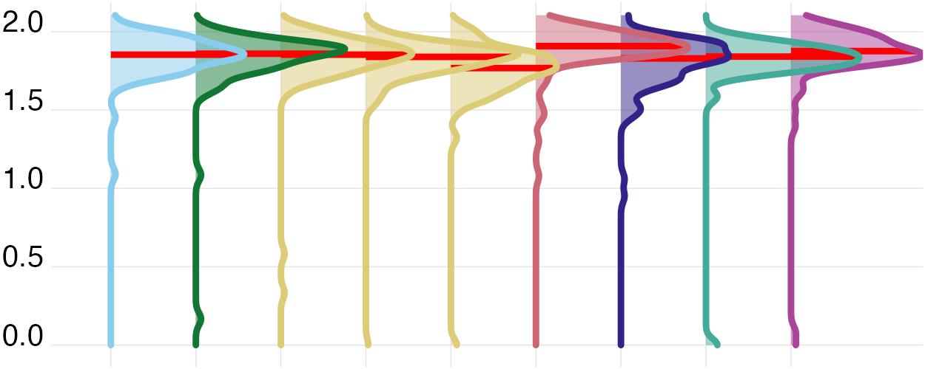 | FDR not supported; adjusted p 0.058  Part R² 5.4% (3.2% to 14.2%) | Estimate Ratio per 1 h: 0.987 (0.968 to 1.006)  FDR not supported; adjusted p 0.227  Part R² 0.6% (0.0% to 3.8%) | Marginal 8.0% (5.1% to 18.2%)  Conditional 40.9% (32.8% to 48.5%)  Participant-associated 32.9% (22.0% to 37.8%)
Longest period above 250 lx melEDI  Longest sustained bright-light bout; captures continuity of daytime circadian stimulation. | Unit h  Median 0.633  IQR 0.283 to 1.204  Participants 141  Days 816 | 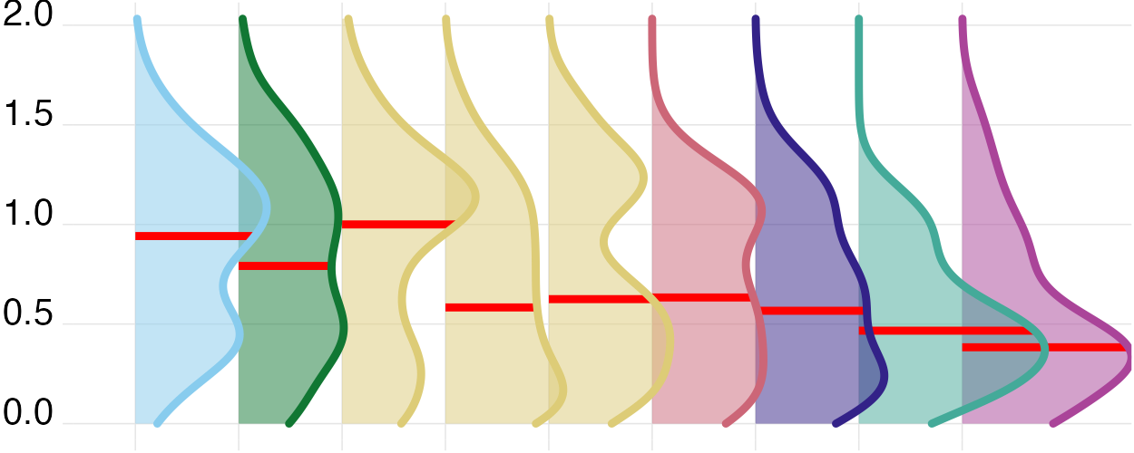 | FDR not supported; adjusted p 0.398  Part R² 2.2% (1.4% to 8.1%) | Estimate Ratio per 1 h: 1.125 (1.065 to 1.187)  FDR supported; adjusted p <0.001  Part R² 4.9% (1.3% to 9.6%) | Marginal 10.0% (6.1% to 17.9%)  Conditional 36.3% (29.9% to 45.3%)  Participant-associated 26.3% (18.7% to 33.0%)
Dynamics
Interdaily stability  Day-to-day regularity of the light–dark pattern; higher regularity supports circadian stability. | Unit dimensionless  Median 0.308  IQR 0.248 to 0.380  Participants 141  Days 816 | 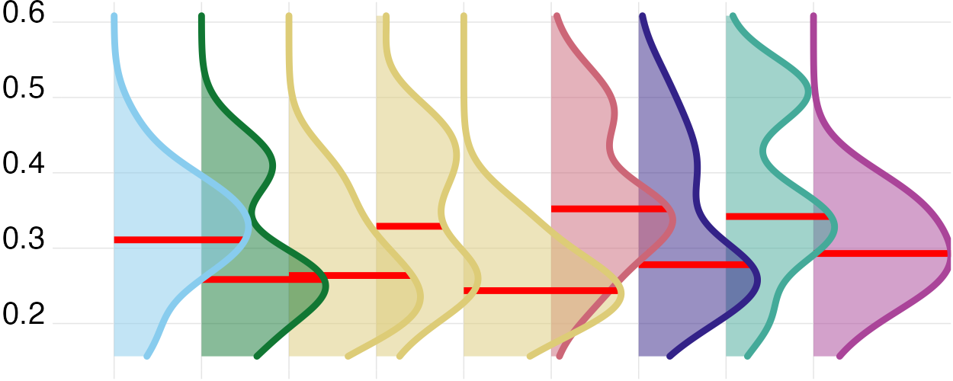 | FDR not supported; adjusted p 0.228  Part R² 6.9% (4.1% to 20.4%) | Estimate Odds ratio per 1 h: 0.983 (0.944 to 1.024)  FDR not supported; adjusted p 0.401  Part R² 0.4% (0.0% to 4.6%) | Marginal 15.4% (10.4% to 30.8%)  Conditional 15.4% (10.4% to 30.8%)  Participant-associated Not applicable
Intradaily variability  Within-day fragmentation of light exposure; higher values indicate less consolidated light–dark input. | Unit dimensionless  Median 1.253  IQR 0.930 to 1.502  Participants 141  Days 816 | 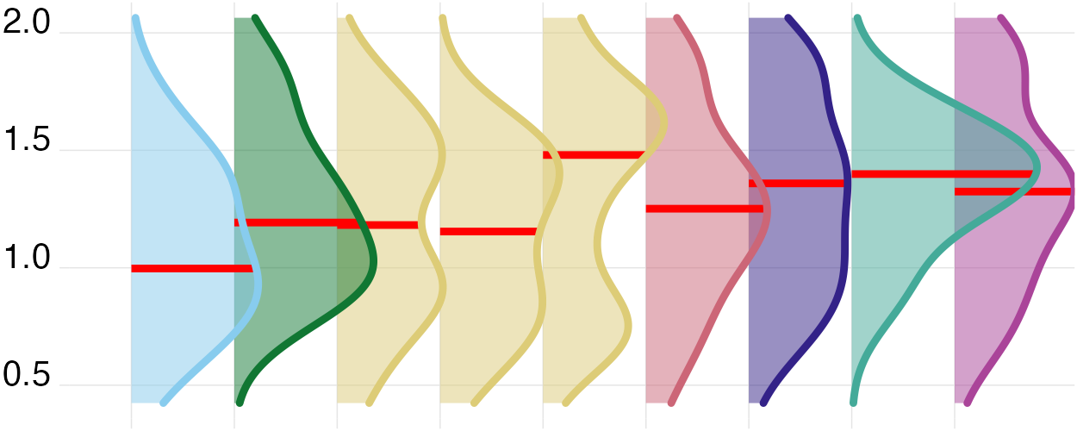 | FDR not supported; adjusted p 0.483  Part R² 5.1% (3.8% to 18.7%) | Estimate Difference per 1 h: -0.019 (-0.056 to 0.019)  FDR not supported; adjusted p 0.327  Part R² 0.7% (0.0% to 5.7%) | Marginal 5.9% (4.6% to 21.2%)  Conditional 5.9% (4.6% to 21.2%)  Participant-associated Not applicable
Exposure history
melEDI dose  Intensity–duration-weighted melanopic exposure; summarizes cumulative non-visual retinal light input. | Unit klx·h  Median 4.960  IQR 1.936 to 12.313  Participants 141  Days 761 | 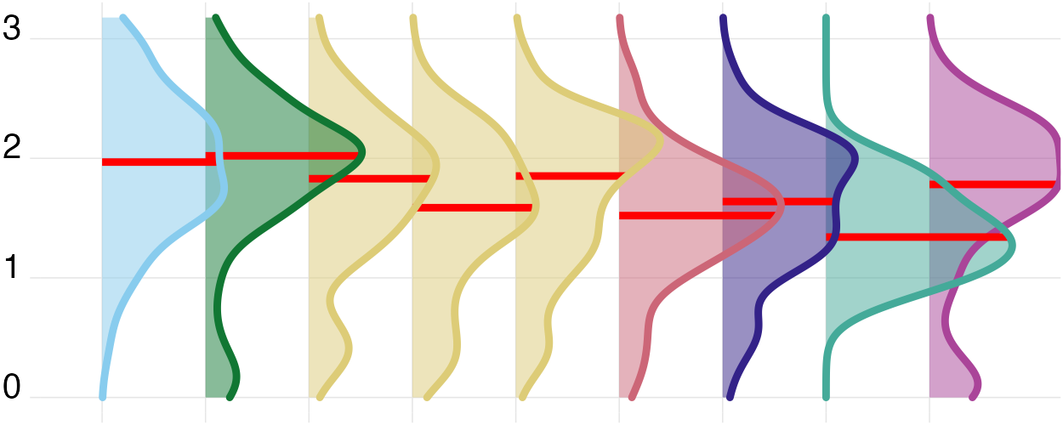 | FDR not supported; adjusted p 0.209  Part R² 2.8% (1.7% to 8.6%) | Estimate Ratio per 1 h: 1.275 (1.169 to 1.391)  FDR supported; adjusted p <0.001  Part R² 7.5% (3.1% to 12.9%) | Marginal 11.8% (7.7% to 19.7%)  Conditional 33.8% (26.7% to 42.8%)  Participant-associated 22.0% (14.5% to 28.7%)
Level
Mean melEDI  Geometric average of daily melEDI values, including zeros; summarizes overall exposure while reducing peak influence. | Unit lx  Median 5.154  IQR 2.831 to 9.225  Participants 141  Days 816 | 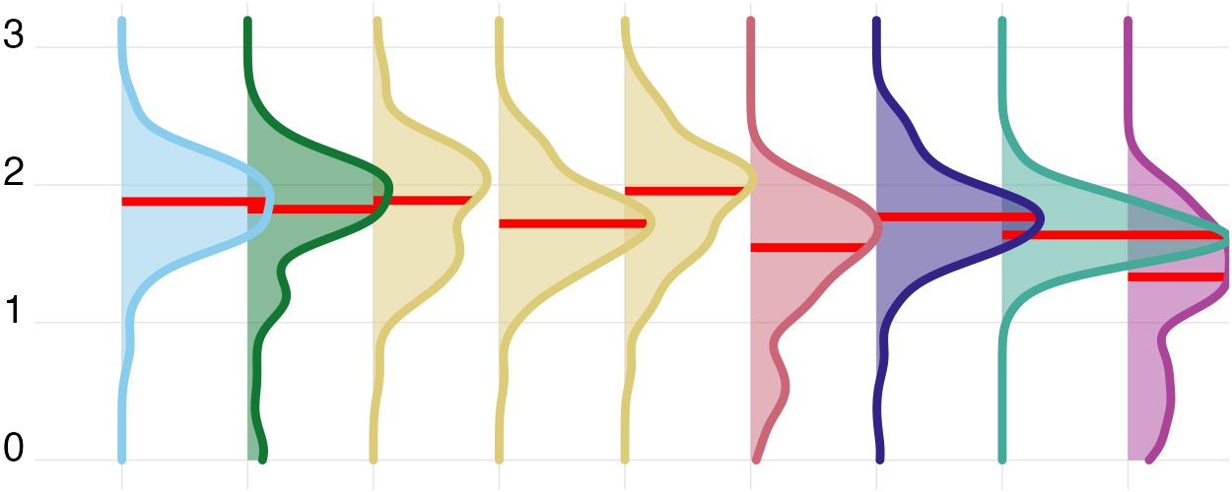 | FDR supported; adjusted p <0.001  Part R² 8.4% (4.8% to 16.6%) | Estimate Ratio per 1 h: 1.181 (1.109 to 1.257)  FDR supported; adjusted p <0.001  Part R² 7.7% (2.9% to 13.9%) | Marginal 25.4% (18.6% to 34.4%)  Conditional 57.7% (51.9% to 65.1%)  Participant-associated 32.3% (24.5% to 39.4%)
Brightest 10 h mean  Mean of the brightest 10 hours; reflects the strength of the main daytime light episode. | Unit lx  Median 110.566  IQR 41.513 to 243.212  Participants 141  Days 816 | 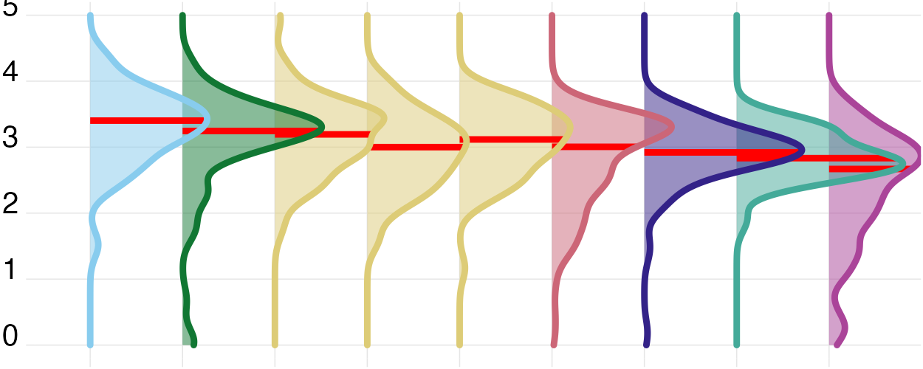 | FDR supported; adjusted p 0.011  Part R² 5.7% (3.3% to 12.7%) | Estimate Ratio per 1 h: 1.243 (1.133 to 1.363)  FDR supported; adjusted p <0.001  Part R² 5.8% (1.9% to 11.1%) | Marginal 17.6% (12.1% to 26.0%)  Conditional 46.0% (39.6% to 54.3%)  Participant-associated 28.4% (20.9% to 35.4%)
Darkest 10 h mean  Mean of the darkest 10 hours; lower values during the biological night favour melatonin preservation and sleep. | Unit lx  Median 0.103  IQR 0.020 to 0.253  Participants 141  Days 816 | 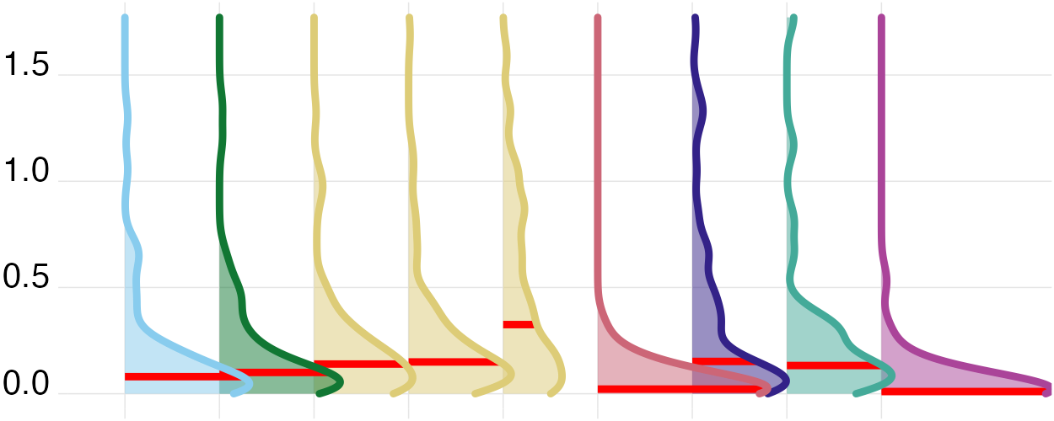 | FDR supported; adjusted p <0.001  Part R² 13.7% (9.2% to 23.9%) | Estimate Ratio per 1 h: 1.088 (1.034 to 1.144)  FDR supported; adjusted p 0.002  Part R² 3.4% (0.5% to 8.3%) | Marginal 22.0% (15.8% to 31.8%)  Conditional 61.1% (55.3% to 68.1%)  Participant-associated 39.1% (30.4% to 46.2%)
Spectrum
Melanopic daylight efficacy ratio  Mean of viable one-minute melEDI/illuminance ratios; indicates melanopic efficacy relative to visual light. | Unit dimensionless  Median 0.724  IQR 0.643 to 0.795  Participants 137  Days 687 |  | FDR supported; adjusted p <0.001  Part R² 9.6% (6.0% to 17.8%) | Estimate Difference per 1 h: 0.024 (0.017 to 0.031)  FDR supported; adjusted p <0.001  Part R² 13.0% (6.7% to 20.6%) | Marginal 27.8% (21.3% to 38.1%)  Conditional 60.5% (54.6% to 68.2%)  Participant-associated 32.7% (24.1% to 40.0%)
Timing
Midpoint of the brightest 10 hours  Centre time of the brightest 10 hours; indexes the main daily circadian light cue. | Unit clock time  Median 13:44  IQR 12:48 to 15:00  Participants 141  Days 816 |  | FDR supported; adjusted p <0.001  Part R² 6.5% (4.4% to 12.6%) | Estimate Difference per 1 h: 0.054 (-0.045 to 0.153)  FDR not supported; adjusted p 0.305  Part R² 0.2% (0.0% to 1.8%) | Marginal 6.7% (4.6% to 13.0%)  Conditional 22.9% (16.9% to 31.6%)  Participant-associated 16.2% (9.6% to 22.4%)
Midpoint of the darkest 10 hours  Centre time of the darkest 10 hours; indexes the main daily darkness cue. | Unit clock time  Median 02:54  IQR 02:01 to 03:50  Participants 141  Days 816 |  | FDR supported; adjusted p 0.020  Part R² 4.6% (3.0% to 10.5%) | Estimate Difference per 1 h: -0.148 (-0.245 to -0.050)  FDR supported; adjusted p 0.004  Part R² 2.1% (0.3% to 5.6%) | Marginal 8.6% (5.9% to 15.8%)  Conditional 28.2% (22.1% to 36.7%)  Participant-associated 19.6% (12.6% to 25.8%)
First light timing above 250 lx melEDI  First waking bright-light exposure; morning timing can advance circadian phase and promote alertness. | Unit clock time  Median 09:08  IQR 08:02 to 10:40  Participants 140  Days 727 |  | FDR not supported; adjusted p 0.112  Part R² 3.8% (2.3% to 10.2%) | Estimate Difference per 1 h: -0.097 (-0.247 to 0.053)  FDR not supported; adjusted p 0.227  Part R² 0.5% (0.0% to 2.8%) | Marginal 6.8% (4.4% to 14.4%)  Conditional 31.0% (24.6% to 40.5%)  Participant-associated 24.2% (16.2% to 31.5%)
Last light timing above 250 lx melEDI  Last bright-light exposure; later timing may delay circadian phase and sleep onset. | Unit clock time  Median 18:08  IQR 16:27 to 19:42  Participants 141  Days 687 |  | FDR supported; adjusted p <0.001  Part R² 11.6% (8.3% to 18.6%) | Estimate Difference per 1 h: 0.323 (0.186 to 0.460)  FDR supported; adjusted p <0.001  Part R² 4.5% (1.5% to 8.5%) | Marginal 22.2% (17.0% to 30.2%)  Conditional 37.9% (31.6% to 46.3%)  Participant-associated 15.8% (9.7% to 22.3%)
Mean timing of exposure above 250 lx melEDI  Average bright-light timing; summarizes the phase of daily circadian stimulation. | Unit clock time  Median 13:29  IQR 12:29 to 14:39  Participants 141  Days 742 |  | FDR supported; adjusted p <0.001  Part R² 12.7% (9.4% to 19.2%) | Estimate Difference per 1 h: 0.121 (0.028 to 0.213)  FDR supported; adjusted p 0.013  Part R² 1.2% (0.1% to 3.6%) | Marginal 14.7% (10.7% to 21.9%)  Conditional 25.7% (19.8% to 34.2%)  Participant-associated 11.0% (5.3% to 17.2%)
Overall distributions are medians and interquartile ranges. Participants and Days give descriptive support; model-specific samples are in Supplementary Table S7. Site and photoperiod part-R² can overlap and must not be summed. Participant-associated R² is conditional minus marginal R² and is not applicable to participant-level outcomes. Distribution colours follow the shared site key in Figure 1 and Supplementary Table S2. MDER is the mean of viable minute-level ratios. Grey site or photoperiod cells did not meet the corresponding FDR criterion. These observational associations are not causal allocations.

Immediate environments and routines reorganise exposure
Self-reported light source was strongly associated with one-hour near-eye exposure, with an FDR-supported light-source-by-site interaction. Site-average interaction-model estimates were 959.6 lx melanopic EDI for outdoor daylight (95% CI 786.8 to 1,170.2), 198.8 lx for indoor daylight (169.3 to 233.4), 85.1 lx for indoor electric light (71.6 to 101.1) and 23.8 lx for a display screen (17.4 to 32.5). Outdoor daylight was 11.27 times the indoor-electric estimate (8.71 to 14.60) and exceeded the 250-lx daytime recommendation, whereas the indoor-daylight and indoor-electric intervals were below it. During reported sleep, darkness and external-light estimates were 2.24 lx (1.54 to 3.26) and 11.18 lx (8.06 to 15.51), both above the 1-lx bedside upper limit. Outdoor electric light remained imprecise relative to indoor electric light near eye (ratio 1.019, 0.336 to 3.090; FDR-adjusted p = 0.973). These contextual averages do not classify people or hours as adherent.
External light during sleep in Munich (DE) was estimated at 130.2 lx, 11.65 times the corresponding site average; sleep darkness in Kumasi (GH) was 0.371 lx, 0.166 times its site average. Sparse site-category cells limited some estimates.
The primary analysis used a population-mean quasi-Tweedie model with participant-cluster-robust covariance for uncertainty; lag-one residual correlation remained 0.288. Fitted versus observed exact-zero proportions were 39.8% and 27.8%, respectively. An exploratory mixed-effects model quantified variance explained after adding a participant intercept to site-by-light-source fixed terms. Marginal R² was 0.796 and conditional R² 0.876, an 8.0-percentage-point increase in explained variance from the participant intercept. Of the marginal R², light source accounted for 89.3%, site 7.1% and their interaction 3.7%. Separately, an exploratory time-of-day model attributed 60.4% of variation in fitted hourly patterns to global time of day and 24.2% to light-source deviations. Among these two components, light source accounted for 28.6%. The remaining shares were 5.2% for site, 7.6% for participant patterns and 2.5% for day-to-day shifts.
A sensitivity adjusted the population-average light-source comparisons for each participant’s overall category distribution, distinguishing hour-to-hour differences within participants from differences in category composition between participants. The overall category pattern was retained. For external light during sleep, the near-eye ratio relative to indoor electric light changed from 0.449 in the primary additive model to 0.333 (95% CI 0.190 to 0.585), a 25.8% decrease. Thus, between-participant category composition influenced the magnitude, but not the direction, of this contrast. Supplementary Figure S9 shows the temporal, support and site-specific results.
Immediate setting combined behaviour and environment, with an FDR-supported activity-by-site interaction. Site-average near-eye estimates were 714.2 lx outdoors (95% CI 561.7 to 908.2), 331.2 lx on the road or in a vehicle (274.4 to 399.8), 198.9 lx during office or home work (173.9 to 227.5), 76.4 lx while awake at home (62.0 to 94.1) and 4.28 lx during sleep (3.06 to 5.99). The sleep category included many low or zero observations and occasional high stray-light readings, so its fitted mean need not represent a typical observation. Relative to awake time at home, the ratios were 9.35 outdoors, 4.34 for travel, 2.60 for work and 0.056 during sleep. The outdoor estimate exceeded the 250-lx daytime recommendation, the work estimate remained below it, and the sleep estimate exceeded the 1-lx bedside-environment upper limit. Borås (SE) had a fitted outdoor estimate of 3,054 lx, 4.28 times the site average, whereas Tübingen (DE) had 127 lx, 0.18 times the site average. In an exploratory mixed model of five setting categories, marginal R² was 0.766 near eye and 0.768 at the chest. Adding the participant intercept raised conditional R² to 0.858 and 0.859, an explained-variance increment of 9.2 percentage points at both positions. Of the marginal R², immediate setting accounted for 80.7% near eye and 86.1% at the chest, site 12.5% and 5.9%, and their interaction 6.9% and 8.0%, respectively. Figure 3 shows the immediate-setting patterns and site-specific estimates. Separately, an exploratory near-eye time-of-day model attributed 52.5% of variation in fitted hourly patterns to time of day and 30.7% to immediate setting. Among these two components, immediate setting accounted for 36.9%. The remaining shares were 5.6% for site, 8.4% for participant patterns and 2.8% for day-to-day shifts.
Figure 3: Personal light exposure by immediate setting across time of day and study sites. The diary variable labelled activity combines behaviour and environmental setting. A–C, Exploratory time-of-day analysis. Panel A shows site-average expected one-hour melanopic EDI with clock-specific 95% confidence intervals; the dashed black curve is the site-average local-clock smooth. Panel B shows each setting curve relative to that smooth, with 1 as the reference. Panel C shows effective weighted hours; open circles indicate locally sparse support and grey regions indicate times without observations. D, Site-average category estimates and site-specific deviation ratios from the activity-by-site interaction model, with participant-cluster-robust 95% confidence intervals and FDR-adjusted p values. Each multi-select participant-hour contributes weight 1/k to every retained setting category. The Other category is sparse and display-only. The fitted frame contains 126 participants, 724 participant-days, 16,135 unique participant-hours, 16,135 effective weighted hours and 4,746 exact-zero participant-hours. Estimates are observational.
Across models of free versus work day, active versus sedentary daily activity status and previous-night sleep duration, the site-average reference was a work, sedentary day following an average 7.8 h of sleep; expected near-eye exposure was 89 lx melanopic EDI (95% CI 67 to 119). Active versus sedentary status was associated with 2.06 times the expected exposure (1.54 to 2.76; FDR-adjusted p < 0.001). A model constraining the free-versus-work association across sites estimated 1.45 times higher exposure on free days (1.14 to 1.85; FDR-adjusted p = 0.004). Allowing the association to differ by site gave an inconclusive site-average ratio of 1.15 (0.93 to 1.44; FDR-adjusted p = 0.298), while some sites differed (interaction p = 0.017). Exploratory ratios were FDR-retained in Borås (SE; 1.95, 1.26 to 3.01) and Dortmund (DE; 2.44, 1.42 to 4.22), with FDR-adjusted p = 0.013 for each. The free-versus-work result was also inconclusive under the alternative working variance and sensitive to omitting either site. Each additional hour of previous-night sleep duration, centred at 8 h, had an inconclusive ratio of 0.98 (0.85 to 1.12; FDR-adjusted p = 0.745). Excluding six participants outside the employment requirement left 15,871 supported hours from 684 participant-days and 131 participants across all nine sites. The free-versus-work, active-versus-sedentary and previous-sleep associations remained stable within model uncertainty; the predictor-by-site interaction for day type also remained FDR-supported. Supplementary Table S9 and Supplementary Figures S10, S11, S12 and S13 report common, temporal, position-specific and site-specific results.

Person-level correlates are selective
Self-report analyses did not support general exposure profiling. None of 68 prespecified near-eye associations between four light-exposure-related behaviour (LEBA) factors and 17 metrics retained FDR support. Unsatisfactory model checks made the sleep-environment metric unfit for inference, so its estimates were suppressed. Neither average associations nor site interactions across nine visual-light-sensitivity (VLSQ-8) outcomes retained FDR support at either position. Supplementary Tables S10, S11 and S12, and Supplementary Figures S14 and S15, give the full results.
Each hour later in corrected midsleep on free days (MCTQ questionnaire) was associated with first exposure above 250 lx occurring 0.381 h later (95% CI 0.146 to 0.616; FDR-adjusted p = 0.003). Each 10-point shift towards greater morning preference (MEQ questionnaire) was separately associated with first exposure above 250 lx occurring 0.444 h earlier (0.189 to 0.699 h earlier; FDR-adjusted p = 0.001). The brightest- and darkest-10-hour midpoints followed the same directions; last exposure and the longest-bright-period midpoint did not retain support. The distinct questionnaires were not combined. Supplementary Table S13 and Supplementary Figure S16 show adjusted estimates; Supplementary Figure S17 shows observed timing distributions.
Each additional decade of age was associated with higher near-eye brightest-10-hour mean, time above 1,000 lx and daily dose, with ratios from 1.27 to 1.31. These cross-sectional associations may reflect cohort, occupation, behaviour or other confounding, not ageing itself. Neither near-eye metric associations with biological sex nor near-eye age-by-site or sex-by-site interactions met the FDR criterion. In a separate daily-pattern analysis, near-eye and chest profiles differed by biological sex (FDR-adjusted p = 0.028 and 0.029), but the difference did not meet the FDR criterion after restriction to records with complete immediate-setting data and adjustment. This attenuation is compatible with immediate-setting patterning, but restriction and adjustment cannot be disentangled as mechanisms. Gender was recorded separately but not analysed; its category matched biological sex in all but one case. Supplementary Tables S10, S14 and S15, and Supplementary Figures S18 and S19, give the complete results.

Measurement position and robustness constrain interpretation
The paired sample of 112 participants and 643 participant-days allowed separate near-eye and chest models to be compared within the same participants and participant-days. The full chest dataset of 154 participants and 902 participant-days broadened coverage beyond the 141 participants and 816 participant-days near eye. At several sites, especially San José (CR), offering a chest sensor enabled recruitment among people reluctant to wear the glasses-mounted sensor. This improved feasibility, not the ocular-exposure sample.
A parallel analysis of overlapping MeLiDos data reported structured position differences across scale, metric, context, site, day and participant³³. Our separate and common-sample analyses likewise show directional agreement but differences in magnitude or support. Eight-site chest adherence retained daytime and pre-sleep directions and interval conclusions, with calibration and temporal qualifications, but provided no sleep ocular claim or paired test. We neither pooled positions nor inferred equivalence or a universal correction.
Non-estimable planned quantities were four sleep-environment variants (main plus three sensitivity variants) at each position in the light-behaviour analysis (LEBA), and one longest-period sensitivity comparison incompatible with the metric representation. We retained these outcomes rather than replacing them with zero or null findings. Qualifications for zeros, residuals, dependence, nonlinear-term overlap, sparse support and influence remain with the affected analyses and in Methods.

Discussion
The expected 24-hour rhythm was evident across nine sites in seven countries. The advance was a multiscale account of this everyday exposome component: amplitude across sites, people and days, and its reorganisation across immediate settings. The shared local-clock pattern accounted for the largest share of full-model R² in the daily-pattern analysis. Separate hourly decompositions showed large light-source and immediate-setting contrasts, with the next-largest shares of variation in fitted hourly patterns after time of day. Participant patterns and participant-day shifts together exceeded site patterns in the daily-pattern model, while site, photoperiod and measured person-level associations were metric-specific. Different outcomes and decompositions make this a qualitative synthesis rather than a single quantitative ranking.
The consensus recommendations provide the clearest health-relevant benchmark. Only 24.0% of waking minutes reached the daytime range, while 63.3% of pre-sleep and 87.7% of bedside sleep-environment minutes met their upper limits. Modelled free-day adherence was lower during daytime and preceding sleep, varying by site. Pre-sleep adherence was higher but inconclusive under stricter coverage; temporal dependence remained unresolved. Outdoor exposure exceeded the daytime recommendation, but all other conditions remained below it on average. The fitted sleep-category mean exceeded the bedside limit, while 87.7% of pooled bedside sleep-environment minutes met it. These quantities describe different aspects of the exposure distribution and should be interpreted together. These pooled fractions, recommendation-window proportions and hourly means are distinct estimands. Together, they identify intervention opportunities and shortfalls. The recommendations principally address healthy adults aged 18 to 55 with regular daytime schedules⁸.
This baseline connects mechanistic recommendations with population evidence. Large wrist-sensor cohorts have associated day and night light patterns with psychiatric disorders, incident type 2 diabetes, cardiovascular disease and mortality, and light timing with sleep timing and sleepiness^{10–15}. Other cohorts have linked evening, nocturnal or strongly seasonal light with sleep in bipolar disorder, obesity, diabetes, hypertension and metabolic health^{16–19}. These outcomes span sleep and major non-communicable diseases. The exposome frames environmental contributions across the life course^{20,21} but rarely includes time-resolved ocular light. This evidence supports personal-light measurement, not clinical risk classification of our exposure categories. Most cohorts used wrist or bedside illuminance without resolving melanopic exposure at the eye, immediate light source or its multiscale architecture.
Exploratory inverse associations of average daytime with sleep and pre-sleep adherence show why the three recommendation windows should not be collapsed into one score. They may reflect schedules, environments or other between-participant differences, not a within-person trade-off or stable phenotype. In exploratory nonlinear models, light source and immediate setting accounted for substantially more variation in fitted hourly patterns than participant-specific patterns: 24.2% versus 7.6%, and 30.7% versus 8.4%, respectively. This finding is consistent with schedules and immediate environments being prominent correlates of hourly exposure, but it is not a causal explanation for the cross-window adherence association. Longitudinal models of dependence and changing routines are needed to test whether improving one part of the pattern displaces or supports another.
Location mattered, but not as one north-to-south ranking. Site differences included daily level, waking bright-light duration, pre-sleep duration, spectral composition and several timing metrics, while dose and regularity did not show the same site pattern. Civil photoperiod was associated with a broader set of metrics, with larger day-length associations for bright-light level and dose than for the darkest daily window. Between 14.2 and 16.2 h of civil photoperiod, six of nine metrics showed signs of uncertainty about a photoperiod effect beyond that point. Sites were sampled in distinct calendar periods and covered unequal photoperiod ranges, leaving latitude, season, weather, temperature, culture, mobility and the built environment entangled. Repeated seasonal sampling across more sites is needed to separate these influences.
Immediate setting patterned exposure, consistent with environmental opportunity, built settings and behaviour³⁶. Outdoor daylight and being outdoors exceeded indoor electric light and awake time at home, respectively; active days exceeded sedentary days. Site interactions placed outdoors-category exposure higher in Borås (SE) than Tübingen (DE), while the free-versus-work association was most evident in Borås (SE) and Dortmund (DE). Participant intercepts captured remaining between-participant variation, not individual responses or predictions. Future monitoring should preserve local clock time, location, immediate setting, daylight access and site; self-selection, occupation, mobility and weather remain potential confounders.
Light-behaviour and visual-sensitivity scores did not meet their FDR criteria, whereas chronotype aligned with selected timing outcomes and age with selected bright-light and dose metrics. This accords with evidence linking circadian preference or timing to daylight exposure, sleep and routine, without identifying causal direction^{37–40}. Metric-level biological-sex comparisons were inconclusive near the eye. The complete available-data curve differed by biological sex, but immediate-setting-complete analyses did not retain this separation. Person-level patterns may concern specific exposure dimensions rather than a general high-versus-low phenotype.
Near-eye sensing approximates the incident ocular field during wake but is not a retinal measurement; chest sensing samples a related environmental field. Studies show structured differences by body position, morphology, posture and surrounding light^{29–31}. The matched sample and parallel placement study show metric- and context-specific MeLiDos differences without a universal correction³³. The chest option broadened recruitment among people unwilling to wear glasses-mounted sensors, especially in San José (CR). Study design must balance biological proximity, burden and recruitment while keeping estimands position-specific.
The harmonised protocol combined repeated near-eye sensing with local-clock and contextual information across nine sites and seven countries. A generalised additive model separated the shared 24-hour pattern from site, participant and participant-day layers obscured by daily summaries. Collecting these data demanded substantial effort from participants and study teams. Glasses-mounted loggers required fitting, explanation and daily handling; removal, occlusion, charging, discomfort, weather and social acceptability all affected measurement quality^{41–43}. Despite this burden, the protocol measured closer to the incident ocular field at high temporal and contextual resolution.
Several limitations qualify these findings. Modest site samples limit site estimates, interactions and subgroup evaluation. Healthy working-age adults may not represent children, adolescents, older or clinical populations, shift workers, people outside employment, or those with restricted mobility or atypical living conditions. Sparse latitude-by-photoperiod coverage leaves latitude, seasonality, culture, climate and built environment entangled and requires broader seasonal sampling. Retrospective hourly setting and light-source reports enabled harmonisation but could not distinguish fine-grained settings or behaviours within home, work or transport. Very low readings require caution. The manufacturer specifies an operating range starting at 1 lx, and independent laboratory testing began at 2 lx⁴⁴. A scene-based field validation found high overall agreement with laboratory-grade spectral references, but underestimation increased at lower intensities and varied with lighting, time, scene complexity and site⁴⁵. Single-digit values therefore approximate low-light exposure rather than provide precise measurements. Finally, no health outcome was measured.
This nine-site reference locates everyday ocular light exposure within the exposome, benchmarks it against physiology-based recommendations, highlights within-site variation among people and days, and identifies temporal, contextual and positional information for future cohorts. Everyday ocular light exposure is structured, measurable and strongly shaped by behaviour and micro-environment, but cannot be reduced to site, latitude or photoperiod. Next steps are broader sampling across photoperiods, latitudes and locations and prospective links to sleep, mental, metabolic, cardiovascular and other outcomes. Causal health benefits or policy effects require interventions and representative longitudinal designs. Potential interventions through clinical advice, occupational health, building design, urban planning or public-health guidance must address the contexts in which people receive light. Time-resolved near-eye measurement offers a practical route from circadian biology to precision prevention and context-sensitive environmental health.

Methods

Study design and sites
MeLiDos is a prospective multicentre observational field study of personal light exposure conducted with a harmonised protocol³⁵. Participants completed an eight-day ambulatory protocol comprising continuous light logging, repeated smartphone assessments and daily diaries under free-living conditions. At an in-person registration visit, participants provided consent, completed baseline questionnaires, received study instructions and were fitted with the loggers. Seven consecutive recording days separated registration and return visits; most sites recorded from Monday to Monday, while Dortmund (DE) recorded from Tuesday to Tuesday. If a return visit was delayed, participants continued until formal study termination and device retrieval. Data were collected between August 2023 and October 2025 at Borås (SE), Delft (NL), Dortmund (DE), Tübingen (DE), Munich (DE), Madrid (ES), Izmir (TR), San José (CR) and Kumasi (GH). The Kumasi (GH) and Izmir (TR) collections are described in site-specific data notes^{46,47}. Sites were an opportunity sample of consortium partners and were not selected to represent national populations. Questionnaire materials were administered in the local language except in Tübingen (DE) and Kumasi (GH), where English was used, and translated materials followed a harmonised translation, review, adjudication, pretesting and documentation process⁴⁸.

Participants, recruitment and ethics
The registered target population comprised adults aged 18 to 65 years in full-time employment or part-time employment above 80%. Exclusion criteria included diagnosed psychiatric or sleep disorders, shift work in the preceding two months, regular tobacco or recreational drug use, photosensitising medication, visual impairment incompatible with the devices and residence outside the local study area during recording. The study population included nine participants outside the registered age or employment criteria: one participant older than 65 years, two recorded as not employed and seven recorded as marginally employed; one participant met both criteria for exclusion. For the age and biological-sex analysis, a joint age-and-employment exclusion sensitivity removed six participants from the near-eye models and nine from the chest models. All 11 FDR-supported main findings retained their direction and support, and none of the 68 main-effect FDR decisions changed. For the day-type, exercise and sleep analysis, a separate near-eye employment sensitivity reduced the sample from 137 to 131 participants; the directions and FDR conclusions for the main associations, and the site-heterogeneity conclusions, were unchanged. Students and trainees were retained in both checks.
The target was at least 15 participants per site, based on prior power calculations and allowing for up to one-third dropout or incomplete recording (15->10)⁴⁹. The study roster was below 15 participants only in Munich (DE; n = 10), and no site had fewer than 10 participants. The final near-eye sample was below 15 in Borås (SE; n = 13), Delft (NL; n = 13), Munich (DE; n = 10) and San José (CR; n = 6); San José was the only site below the dropout-adjusted threshold of 10 (Table 1). Participants were recruited through local advertisements and institutional mailing lists. At some sites, especially San José (CR), reluctance to wear the glasses-mounted near-eye sensor limited recruitment, and the chest option broadened recruitment possibilities.
The small near-eye sample in San José (CR; n = 6) limits the precision of site-specific estimates and the ability to detect associations within that site. The reported leave-one-site-out sensitivity analyses thus assessed the influence of individual sites on pooled and site-average estimates. The larger chest-level sample in San José (n = 39) provides more extensive complementary data, although findings from this measurement position remain distinct from near-eye exposure in all reported analyses.
All participants provided written informed consent. Approvals were obtained from the Ethics Committee of the Technical University of Munich for Tübingen (DE; 2023-115-S-KK) and for Munich (DE) and Dortmund (DE; 2024-118-S-SB); the Dortmund (DE) site at the Federal Institute for Occupational Safety and Health (BAuA) operated under this TUM multicentre approval. The other approvals were from the Swedish Ethical Review Authority for Borås (SE; 2024-06792-01), the THUAS Ethics Committee for Delft (NL; positive review dated 29 May 2024), the Research Ethics Committee of Universidad San Pablo-CEU for Madrid (ES; 834/24/106), the Scientific Research and Publication Ethics Committee of the Faculty of Science and Engineering at İzmir Institute of Technology for Izmir (TR; decision 5/1), the Comité Ético Científico of Universidad de Costa Rica for San José (CR; CEC-279-2025), and the Committee on Human Research, Publications and Ethics of Kwame Nkrumah University of Science and Technology for Kumasi (GH; CHRPE/AP/644/24). The protocol was first trialled with participants at the Tübingen (DE) site, whose feedback informed procedural refinements before implementation at the remaining sites; further details are reported in the published protocol³⁵.

Personal light measurements
Personal light was recorded every 10 s with spectrally sensitive ActLumus loggers (Condor Instruments, São Paulo, Brazil). Eight visible-band channels were processed by the device to generate photopic and alpha-opic quantities, including melanopic EDI⁶. The manufacturer specified a factory-calibrated operating range of 1 to 100,000 lx and 10% precision at 1,000 lx. Independent testing against a criterion spectrometer across indoor LED and outdoor daylight conditions covered 2 to 100,000 lx and reported mean photopic error of +3.3% (SD 13.4%) for ActLumus⁴⁴. A subsequent scene-based field validation found high overall agreement with laboratory-grade spectral reference instruments, together with systematic underestimation that varied with intensity and setting⁴⁵. Participants wore the near-eye device centrally on non-prescription spectacle frames and, where available, a complementary pendant-mounted device at the chest. The near-eye position measures light closer to the eye but is not a direct retinal measurement. The chest position provided a separate measurement of the local environmental light field. Paired common-sample analyses evaluated how closely it tracked the near-eye measurement as a potential ocular proxy. During reported sleep, devices were placed facing upward on a bedside surface near head level, so both positions characterise the bedside sleep environment. Participants recorded removals and placed devices in an opaque bag during waking non-wear^{43,50}.
The placement analysis from the same project used overlapping MeLiDos data and is cited as related methodological evidence, not independent replication³³. No analysis pooled sensor positions or estimated a universal conversion. Common-sample analyses retained the same participants and participant-days or participant-hours at both positions and fitted each position separately.

Contextual and person-level measures
Participants completed the core Consensus Sleep Diary after awakening⁵¹, together with evening reports and paper diaries recording light source and an activity-environment category for each hour. Smartphone assessments of sleepiness and mood were scheduled at 11:00, 14:00, 17:00 and 20:00, and evening questionnaires assessed wellbeing and physical activity^{52–54}. Smartphone measures and baseline or end-of-study questionnaires used MyCap integrated with REDCap^{55,56}. Participants photographed and uploaded the paper hourly diaries each day.
The modified Harvard Light Exposure Assessment categories were indoor electric light, outdoor electric light, indoor daylight, outdoor daylight including shade, an emissive display, darkness during sleep and external light during sleep⁵⁷. The primary light-source analysis used one retained category per participant-hour. The diary variable labelled activity combined behaviour and environmental setting. Its categories distinguished sleep, awake time at home, motorised travel, active travel, office or home work, outdoor work, outdoor leisure and other activities. We therefore refer to this variable as immediate setting in the narrative. For analysis, outdoor travel, outdoor work and outdoor leisure were combined as Outdoors. Reports could contain concurrent categories; duplicates were removed and an hour with k retained labels contributed weight 1/k to each, preserving total weight one. Day type was coded as work or free day, daily activity status as sedentary or active, and previous sleep duration was linked from the preceding sleep period.
Baseline measures recorded age, biological sex, gender, employment and chronotype; end-of-study measures covered visual light sensitivity, the sleep environment and habitual light-exposure behaviour. Chronotype was represented separately by corrected midsleep on free days from the Munich Chronotype Questionnaire and the Morningness-Eveningness Questionnaire, whose higher scores indicate greater morning preference^{58,59}. Visual sensitivity used the VLSQ-8⁶⁰, sleep environment used the Assessment of Sleep Environment⁶¹, and four Light Exposure Behaviour Assessment (LEBA) factors represented outdoor time, device use in bed, ambient light before bed and morning or daytime light use⁶². Biological sex and gender were recorded as separate variables. Models analysed biological sex, coded Female or Male, but did not analyse gender; its recorded category matched biological sex in all but one case.

Time, sleep/wake status and coverage preparation
Processing preserved both actual time in Coordinated Universal Time and local wall-clock time. Actual time ordered observations and measured elapsed gaps; local time aligned daily patterns across sites. Repeated local minutes during autumn clock changes remained distinct in actual time, and structurally absent spring minutes remained missing. Melanopic EDI values at or above the validated 100,000-lx operating boundary were unavailable analytically but retained in the raw channel with a flag.
Diary-defined sleep began at reported sleep preparation and ended at reported wake. Sleep values were retained as the intended bedside record. Declared waking non-wear made the analytical light value unavailable; missing wear labels were not treated as non-wear. Complete 1,440-minute local participant-day grids preserved unsupported periods as missing rather than deleting rows or replacing them with zero. A day was eligible when at least 80% of this combined waking and bedside-sleep record had valid melanopic EDI. Hourly summaries required at least 50% valid minutes in that hour, but an unsupported hour did not erase valid minutes from the daily decision or minute-based metrics. Two otherwise eligible near-eye days and three chest days with finite but entirely zero melanopic EDI were excluded by the defined exact-all-zero screen.

Exposure metrics
Metrics were derived in R⁶³ with LightLogR^{64,65}. The 17 outcomes represented complementary properties of the daily pattern. Three level metrics described the daily geometric mean melanopic EDI and the mean melanopic EDI in the brightest and darkest 10-hour windows. Five duration metrics quantified time above 1,000 lx, waking time above 250 lx, pre-sleep time below 10 lx, sleep-environment time below 1 lx and the longest continuous period above 250 lx. Five timing metrics located the brightest and darkest windows and the first, last and mean timing above 250 lx. Melanopic EDI dose integrated exposure over time, melanopic daylight efficacy ratio characterised spectral composition relative to visual illuminance, and interdaily stability and intradaily variability characterised regularity and fragmentation. Geometric means were calculated from log10(melanopic EDI + 0.1 lx), followed by inverse transformation and removal of the same offset⁶⁶. All-observed-zero windows were retained as exact zero within verified numerical tolerance. Metric-specific support rules made only the affected metric unavailable, not the participant-day. A longest-period duration remained a lower bound when missing data could conceal a longer period; exactly identified periods were examined separately.
The melanopic daylight efficacy ratio was the arithmetic mean of viable one-minute melanopic EDI to photopic-illuminance ratios on a complete 1,440-position local-clock grid. Both channels had to be finite and strictly positive, and at least 720 positions were required. Repeated autumn minutes were averaged within each channel before division, and absent spring minutes remained missing.

Recommendation-window and adherence analyses
We compared valid one-minute values with the Brown et al. recommendation ranges⁸: at least 250 lx melanopic EDI during daytime, no more than 10 lx during pre-sleep and no more than 1 lx during sleep. Daytime comprised diary-defined wake excluding the three hours before reported sleep, pre-sleep comprised those three hours and sleep comprised the reported sleep interval. Each descriptive numerator was divided by all valid near-eye-record minutes in the corresponding window and pooled across the analysed sample. Daytime and pre-sleep used the worn near-eye record; sleep used the bedside sleep-environment record.
The main adherence analysis retained one row per window period and defined adherence as adherent valid minutes divided by all valid minutes in that period. Each cycle linked the sleep interval ending at wake, the ensuing daytime interval excluding pre-sleep, and the following three hours before the next reported sleep. All three inherited the work or free label of the wake-start calendar date, even when a window crossed midnight. Actual diary dates and UTC boundaries established chronology; gaps between diary dates were not bridged. Windows qualified independently, so a cycle need not contain three eligible windows. The any-valid primary sample retained at least one valid comparison; the coverage sensitivity required valid minutes for at least 80% of each expected window interval. Expected duration defined coverage, not the likelihood denominator. Missing minutes were not imputed. Exact 0% and 100% periods remained in an endpoint-inflated beta-binomial model. Its mean included the full window-by-site-by-day-type interaction and a participant intercept; extra wholly non-adherent and wholly adherent periods and window-specific dispersion were modelled separately. Population-average adherence integrated the participant distribution and gave each of nine sites equal weight. Separate FDR families covered three window-specific free-minus-work contrasts, three window-specific site interactions, the global interaction, 27 site-specific contrasts against zero, 54 site-minus-average levels and 27 site-effect-minus-average contrasts. The last family’s coverage repetition assessed stability without another FDR adjustment. Variance decomposition used balanced 54-cell global and 18-cell within-window references; Shapley allocations and R² were point-only. Chest models used a separate two-window, eight-site sample and did not test paired placement differences.
The exploratory cross-window extension used daytime adherence as the predictor and the preceding sleep or following pre-sleep adherence as outcomes under the same wake-start-date alignment. It retained pairwise-complete observations, not necessarily complete three-window cycles: 1,376 outcome rows comprised 758 daytime-sleep and 618 daytime-pre-sleep pairs from 140 participants and 761 cycles. Its predefined eligibility rules did not include every potential main-model pair. The model separated each participant’s cycle-specific daytime deviation from their observed average, adjusting for window, site, day type, their corresponding interactions and the participant’s day-type composition. Response-scale contrasts used equal-site and 50:50 work/free weighting. The four within- and between-participant associations formed a separate FDR family. Positive serial dependence remained unresolved and some sensitivity fits were non-estimable, so no within-participant day-level claim was stated. Descriptive profiles used unweighted equal-cycle participant means, with daytime deduplicated within participant and cycle, for 139 complete profiles and 417 participant-window points. These are anonymous monitoring-period summaries, not ranks or stable participant types.
The main model passed all five applicable endpoint-calibration checks in both samples, but temporal dependence still qualified inference. The 80% coverage restriction retained the daytime and sleep directions and interval conclusions; pre-sleep retained direction but not exclusion of zero. Diary-indexed grouping was a separate sensitivity. Pre-sleep interval conclusions also changed under 70% and 90% coverage and restriction to participants observed on both day types. Actual-date temporal endpoint models failed structural checks. Their beta-binomial fallbacks changed both the response family and random-effects structure, retained boundary cautions and failed all five endpoint-calibration checks in both samples. They did not replace the primary model or resolve its temporal limitation. All nine site-deletion checks and four participant-deletion checks were estimable; one participant deletion and the ordinary-binomial diagnostic failed and supplied no derived inference. The separate chest model retained calibration and temporal qualifications. In the exploratory extension, the 80% restriction preserved all four directions and interval conclusions, but incomplete influence checks and unresolved dependence limited robustness claims.

Daily temporal architecture
The daily-pattern analysis used supported 30-minute arithmetic means, retaining a bin when at least 15 one-minute values were valid. The outcome was log10(melanopic EDI + 0.1 lx). A generalised additive model fitted with mgcv::bam() and fREML combined a cyclic common local-clock smooth, sum-to-zero site curves, participant curves and participant-day random intercepts^{67–70}. A boundary-aware first-order autoregressive working structure prevented residual sequences from crossing participant-day, clock-repeat or gap boundaries. Fitted-curve dispersion was compared on a common 48-bin grid. A Shapley decomposition averaged each component’s addition to R² across all component orders, thereby distributing the model’s explained variance^{71,72}. The decomposition partitioned the full model’s row-weighted in-sample R² for log10(melanopic EDI + 0.1 lx), defined as the reduction in squared prediction error relative to predicting the fitted-sample mean. The percentages therefore partition full-model R² on that transformed response scale. They are not percentages of variance explained in raw melanopic EDI and do not indicate causal or out-of-sample predictive importance. Confidence intervals for dispersion and R²-share ratios used 2,000 hierarchical cluster resamples while holding the fitted model structure fixed.

Geographic and photoperiod analyses
We analysed 17 participant-level or participant-day metrics with metric-specific Gaussian or Tweedie exponential-dispersion models^{73,74}. We treated overall site differences, civil photoperiod (day length including civil twilight), absolute latitude and the adequacy of a linear latitude term relative to site as four separate model questions, each adjusted as a complete 17-test FDR family. Participant-day models included participant random intercepts. Mixed-effects models were fitted with lme4 or glmmTMB, and component R² values were obtained with performance where reported^{75–77}. Site and latitude were not entered as independent fixed predictors in one model because each site has one latitude; site and latitude models instead used the same observations and photoperiod adjustment. Site follow-up contrasts were calculated with emmeans only after a supported overall site test and compared each site with a site-average estimate, obtained by giving each included site equal weight⁷⁸.
Nonlinear photoperiod analyses fitted each of nine planned metrics separately with a generalised additive model estimated by restricted maximum likelihood, a thin-plate photoperiod smooth with basis dimension six and participant random effects nested within site. The derivative, meaning the slope of the fitted curve, was evaluated with gratia at 100 equally spaced photoperiod values with 95% intervals⁷⁹. A qualifying descriptive transition required the preceding slope interval to be wholly above zero, the next interval to include zero and every later interval through the recorded maximum to include zero as well. This procedure located a change in the fitted slope but did not test equivalence, a mechanism or a physiological ceiling. Expanded-basis, fixed-site, common-sample and leave-one-site-out analyses assessed stability. The gap-timing-unaware sensitivity dataset still passed the 50%-per-hour and 80%-per-day rules, but did not use the timing of remaining missing observations for an additional metric-specific adjustment.

Immediate-context and routine analyses
Light-source and activity-environment analyses modelled the zero-aware one-hour geometric mean melanopic EDI with fixed-power quasi-Tweedie log-mean models and participant-cluster-robust inference^{73,74}. Additive fixed-site models supplied primary category tests. Category-by-site interaction models supplied site-average category estimates, ratios and site-specific context when the interaction was supported. The activity-environment analysis retained fractional 1/k weights for concurrent labels. FDR adjustments were applied to the declared category and site-contrast families. Exact-zero calibration, residual dependence, sparse cells and deletion refits were retained as model checks. A secondary population-mean sensitivity added six participant-level category-proportion terms to the light-source model while retaining participant-clustered covariance. This separated hour-to-hour category differences within participants from between-participant differences in category composition; it did not estimate participant random slopes. Exploratory glmmTMB Tweedie log-link models fitted by maximum likelihood then added one common participant intercept to site-by-category fixed effects at the near-eye position for light source and separately at both positions for the activity-environment variable, with the power fixed at 1.539919^{76,77}. The activity-environment models retained the five named categories, excluded Other-only hours and used exact 1/k weights. Their fixed-predictor variance used the same fractional weights so every participant-hour contributed one unit. Marginal and conditional R² used a lognormal distribution-specific variance approximation, and hierarchy-respecting Shapley allocations distributed marginal R² across site, category and their interaction. Percentages from the exploratory time-of-day models instead partition variance among fitted linear-predictor values. Because they do not compare this with observed outcome variance, they are not R². Results describe them as variation in fitted hourly patterns, not variance explained in raw exposure. These were model-based point descriptions without bootstrap intervals. No model included random category slopes.
The participant-hour analysis modelled each supported participant-hour with a zero-inclusive quasi-Poisson log-link model, fixed site associations and participant-cluster HC3 uncertainty. Free versus work day, active versus sedentary daily activity status and previous-night sleep duration centred at 8 h were entered together. Three-test FDR families were applied separately to pooled associations, predictor-by-site interactions and practical contrasts.

Person-level analyses
Light-related behaviour, visual sensitivity, chronotype, age and measured biological sex were evaluated with site-adjusted metric-specific models. Participant-day outcomes generally used Gaussian or Tweedie mixed models with participant random intercepts; participant-level dynamics outcomes used fixed-effect models. Each analysis retained its complete prespecified false-discovery-rate families, including non-estimable outcomes. Chronotype instruments were modelled separately across five timing outcomes. Age associations were scaled per decade, and female-minus-male contrasts used male as the reference. Average associations and predictor-by-site interactions were distinct questions.
The complete biological-sex curve analysis used supported 30-minute arithmetic means transformed as log10(melanopic EDI + 0.1 lx). The generalised additive model included cyclic common and female-specific curves, site curves, participant curves, participant-day random effects and boundary-aware first-order autoregression. The primary test jointly assessed the time-constant and time-varying female-minus-male contributions across the complete 24-hour curve. Clock-specific uncertainty was participant-cluster robust. Level-versus-shape attribution and adjustment for the activity-environment variable were secondary or exploratory analyses.

Multiplicity, uncertainty, model checks and sensitivities
Tests were two-sided. We controlled the false discovery rate with the Benjamini-Hochberg procedure separately within each declared complete family⁸⁰. We report 95% confidence intervals and FDR-adjusted p values for confirmatory families. A result that did not meet an FDR-adjusted criterion was treated as inconclusive rather than as evidence of absence or equivalence. Unless stated otherwise, site-average estimates gave each included site equal weight on the fitted scale before back-transformation. Exploratory analyses retained separate multiplicity families and are labelled as such.
Model checks addressed convergence, rank, singularity, residual distribution, zero mass, fitted support, heteroscedasticity, serial dependence, nonlinear-term overlap and participant or site influence. Qualifications were attached to the affected results. Prespecified or structured sensitivities included the separately prepared gap-timing-unaware dataset, common sensor-position samples, alternative support or metric definitions, model-form changes, participant deletion and leave-one-site-out checks. Near-eye and chest models remained separate in every comparison. Analyses were conducted in R, with tidyverse packages supporting data handling and reporting^{63,81}. Exact package versions, formulas, inputs and output files are documented in the analysis pages and project repository.

Preregistration and deviations
The study was preregistered with AsPredicted (#273407)⁸². The final analyses preserve the registered scientific questions but include documented changes to placement priority, state and coverage rules, metric definitions, outcome construction, model families, site structure, multiplicity and sensitivity handling. The main manuscript is organised around the resulting scientific estimands. Supplementary Methods: Preregistration deviations (supplied as a separate Word document) describes the scientific changes and qualifications.

Data availability
All data used in this study are available through the MeLiDos Project GitHub organisation and are archived in the MeLiDos Zenodo community. Public site datasets have persistent records for Kumasi (GH), Madrid (ES), Dortmund (DE), Izmir (TR), Tübingen (DE), San José (CR), Munich (DE), Borås (SE) and Delft (NL)^{83–91}. These records and other project resources are indexed through the MeLiDos Project Data Hub⁹² and accessed reproducibly through the documented melidosData interface⁹³.

Code availability
The project repository contains the analysis code, local input data, and instructions for reproducing the manuscript, supplementary information, and analysis webpages with Quarto.

References
1. Czeisler, C. A. & Gooley, J. J. Sleep and circadian rhythms in humans. Cold Spring Harbor Symposia on Quantitative Biology 72, 579–597 (2007).
2. Dijk, D.-J. & Archer, S. N. Light, sleep, and circadian rhythms: Together again. PLoS Biology 7, e1000145 (2009).
3. Roenneberg, T. & Merrow, M. Entrainment of the human circadian clock. Cold Spring Harbor Symposia on Quantitative Biology 72, 293–299 (2007).
4. Blume, C., Garbazza, C. & Spitschan, M. Effects of light on human circadian rhythms, sleep and mood. Somnologie 23, 147–156 (2019).
5. Spitschan, M. et al. Ocular light and optical radiation exposure as a modifiable environmental determinant of health: Expert consensus on research gaps and priorities. BMC Medicine 24, 119 (2026).
6. International Commission on Illumination. CIE S 026/E:2018: CIE System for Metrology of Optical Radiation for ipRGC-Influenced Responses to Light. (2018) doi:10.25039/S026.2018.
7. Brown, T. M. Melanopic illuminance defines the magnitude of human circadian light responses under a wide range of conditions. Journal of Pineal Research 69, e12655 (2020).
8. Brown, T. M. et al. Recommendations for daytime, evening, and nighttime indoor light exposure to best support physiology, sleep, and wakefulness in healthy adults. PLOS Biology 20, e3001571 (2022).
9. Spitschan, M. & Zauner, J. Light exposure as a modifiable determinant of mental health. Current Psychiatry Reports 28, 24 (2026).
10. Didikoglu, A. et al. Associations between light exposure and sleep timing and sleepiness while awake in a sample of UK adults in everyday life. Proceedings of the National Academy of Sciences 120, e2301608120 (2023).
11. Lok, R. et al. Timing of outdoor light exposure is associated with sleep-wake consolidation in community-dwelling older men. Frontiers in Sleep 2, 1268379 (2023).
12. Burns, A. C. et al. Day and night light exposure are associated with psychiatric disorders: An objective light study in >85,000 people. Nature Mental Health 1, 853–862 (2023).
13. Windred, D. P. et al. Personal light exposure patterns and incidence of type 2 diabetes: Analysis of 13 million hours of light sensor data and 670,000 person-years of prospective observation. The Lancet Regional Health - Europe 42, 100943 (2024).
14. Windred, D. P. et al. Light exposure at night and cardiovascular disease incidence. JAMA Network Open 8, e2539031 (2025).
15. Windred, D. P. et al. Brighter nights and darker days predict higher mortality risk: A prospective analysis of personal light exposure in >88,000 individuals. Proceedings of the National Academy of Sciences 121, e2405924121 (2024).
16. Esaki, Y. et al. Effect of evening light exposure on sleep in bipolar disorder: A longitudinal analysis for repeated measures in the APPLE cohort. Australian & New Zealand Journal of Psychiatry 55, 305–313 (2021).
17. Obayashi, K., Saeki, K. & Kurumatani, N. Ambient light exposure and changes in obesity parameters: A longitudinal study of the HEIJO-KYO cohort. The Journal of Clinical Endocrinology & Metabolism 101, 3539–3547 (2016).
18. Kim, M. et al. Light at night in older age is associated with obesity, diabetes, and hypertension. Sleep 46, zsac130 (2023).
19. Gubin, D. et al. Light environment of Arctic solstices is coupled with melatonin phase-amplitude changes and decline of metabolic health. Journal of Pineal Research 77, e70023 (2025).
20. Vineis, P. From John Snow to omics: The long journey of environmental epidemiology. European Journal of Epidemiology 33, 355–363 (2018).
21. Vermeulen, R., Schymanski, E. L., Barabási, A.-L. & Miller, G. W. The exposome and health: Where chemistry meets biology. Science 367, 392–396 (2020).
22. Wallace, D. A. et al. Characteristics of objectively-measured naturalistic light exposure patterns in U.S. Adults: A cross-sectional analysis of two cohorts. Science of The Total Environment 969, 178839 (2025).
23. Savides, T. J., Messin, S., Senger, C. & Kripke, D. F. Natural light exposure of young adults. Physiology & Behavior 38, 571–574 (1986).
24. Price, L. L. A., Khazova, M. & Udovičić, L. Assessment of the light exposures of shift-working nurses in London and Dortmund in relation to recommendations for sleep and circadian health. Annals of Work Exposures and Health 66, 447–458 (2022).
25. Biller, A. M. et al. Physiologically-relevant light exposure and light behaviour in Switzerland and Malaysia. Journal of Exposure Science & Environmental Epidemiology 36, 409–422 (2026).
26. Huss, A. et al. Shedding some light in the dark—a comparison of personal measurements with satellite-based estimates of exposure to light at night among children in the Netherlands. Environmental Health Perspectives 127, 067001 (2019).
27. van Duijnhoven, J. et al. Measuring light exposure in daily life: A review of wearable light loggers. Building and Environment 274, 112771 (2025).
28. Hartmeyer, S., Webler, F. & Andersen, M. Towards a framework for light-dosimetry studies: Methodological considerations. Lighting Research & Technology 55, 377–399 (2023).
29. de Vries, S. W., Mardaljevic, J. & van Duijnhoven, J. Characterising inter-individual variability in simulated personal light exposure: Impact of body morphology on light-dosimetry. in CIE x051:2025 Proceedings of the CIE 2025 Midterm Meeting Vienna, Austria, July 4–11, 2025: Scientific Conference (July 7–9, 2025) 207–216 (CIE, 2025). doi:10.25039/x051.2025/62xbgg.
30. de Vries, S. W., Mardaljevic, J. & van Duijnhoven, J. Impact of wear position on dosimeter performance: A hybrid measurement-simulation approach to quantify in-situ factors. npj Biological Timing and Sleep 3, 20 (2026).
31. de Vries, S. W., Mardaljevic, J. & van Duijnhoven, J. Impact of wear position on dosimeter performance: Measurement validity under simulated indoor illumination. npj Biological Timing and Sleep 3, 19 (2026).
32. Gibaldi, A., Harb, E. N., Wildsoet, C. F. & Banks, M. S. A child-friendly wearable device for quantifying environmental risk factors for myopia. Translational Vision Science & Technology 13, 28 (2024).
33. Zauner, J., de Vries, S. W., Didikoglu, A., van Duijnhoven, J. & Spitschan, M. Sensor placement causes outcome-dependent bias in ambulatory light-exposure estimates. bioRxiv https://doi.org/10.64898/2026.07.28.741277 (2026).
34. Spitschan, M. et al. Illuminating the future of wearable light metrology: Overview of the MeLiDos project. Measurement 235, 114909 (2024).
35. Guidolin, C. et al. Protocol for a prospective, multicentre, cross-sectional cohort study to assess personal light exposure. BMC Public Health 24, 3285 (2024).
36. Biller, A. M., Balakrishnan, P. & Spitschan, M. Behavioural determinants of physiologically-relevant light exposure. Communications Psychology 2, 114 (2024).
37. Roenneberg, T., Pilz, L. K., Zerbini, G. & Winnebeck, E. C. Chronotype and social jetlag: A (self-) critical review. Biology 8, 54 (2019).
38. Tortello, C. et al. Chronotype delay and sleep disturbances shaped by the Antarctic polar night. Scientific Reports 13, 15957 (2023).
39. Bonatto, F. S. et al. Daylight exposure and mood in real life: Direct association and mediating role of sleep and routine regularity. Chronobiology International 41, 1128–1141 (2024).
40. da Costa Lopes, L., Ribeiro da Silva Vallim, J., Tufik, S., Louzada, F. & D’Almeida, V. Associations between real-life light exposure patterns and sleep behaviour in adolescents. Journal of Sleep Research 34, e14315 (2025).
41. Stefani, O. et al. Wearable light loggers in field conditions: Corneal light characteristics, user compliance, and acceptance. Clocks & Sleep 6, 619–634 (2024).
42. Zauner, J., Biller, A. M. & Spitschan, M. Impact of light logger and dosimeter placement on wearability and appeal in real-life settings. Open Research Europe 5, 293 (2025).
43. Zauner, J. et al. Auxiliary data, quality assurance and quality control for wearable light loggers and optical radiation dosimeters. npj Biological Timing and Sleep 3, 11 (2026).
44. Ishihara, A. et al. Performance of wearable light sensors for measuring photopic and melanopic illuminance under laboratory and free-living conditions. Sleep 49, zsaf358 (2026).
45. Gemici, B. et al. Scene-based field validation of wearable light loggers. (2026) doi:10.48550/arXiv.2606.20719.
46. Agbeshie, G. K. et al. Physiologically relevant real-world light exposure and its behavioural and environmental determinants in Kumasi, Ghana. Open Research Europe 5, 300 (2025).
47. Akgun, S. G. et al. Physiologically relevant real-world light exposure and its behavioural and environmental determinants in Izmir, Türkiye. Open Research Europe 6, 333 (2026).
48. Walde, P. & Völlm, B. A. The TRAPD approach as a method for questionnaire translation. Frontiers in Psychiatry 14, 1199989 (2023).
49. Zauner, J., Udovicic, L. & Spitschan, M. Power analysis for personal light exposure measurements and interventions. PLOS ONE 19, e0308768 (2024).
50. Guidolin, C., Zauner, J., Hartmeyer, S. L. & Spitschan, M. Collecting, detecting, and handling non-wear intervals in longitudinal light exposure data. Behavior Research Methods 58, 36 (2026).
51. Carney, C. E. et al. The consensus sleep diary: Standardizing prospective sleep self-monitoring. Sleep 35, 287–302 (2012).
52. Kaida, K. et al. Validation of the Karolinska sleepiness scale against performance and EEG variables. Clinical Neurophysiology 117, 1574–1581 (2006).
53. Tsanas, A. et al. Daily longitudinal self-monitoring of mood variability in bipolar disorder and borderline personality disorder. Journal of Affective Disorders 205, 225–233 (2016).
54. Sischka, P. E., Costa, A. P., Steffgen, G. & Schmidt, A. F. The WHO-5 well-being index validation based on item response theory and the analysis of measurement invariance across 35 countries. Journal of Affective Disorders Reports 1, 100020 (2020).
55. Harris, P. A. et al. MyCap: A flexible and configurable platform for mobilizing the participant voice. JAMIA Open 5, ooac047 (2022).
56. Patridge, E. F. & Bardyn, T. P. Research electronic data capture (REDCap). Journal of the Medical Library Association 106, 142–144 (2018).
57. Bajaj, A., Rosner, B., Lockley, S. W. & Schernhammer, E. S. Validation of a light questionnaire with real-life photopic illuminance measurements: The Harvard light exposure assessment questionnaire. Cancer Epidemiology, Biomarkers & Prevention 20, 1341–1349 (2011).
58. Kantermann, T., Sung, H. & Burgess, H. J. Comparing the morningness-eveningness questionnaire and Munich ChronoType questionnaire to the dim light melatonin onset. Journal of Biological Rhythms 30, 449–453 (2015).
59. Horne, J. A. & Östberg, O. A self-assessment questionnaire to determine morningness-eveningness in human circadian rhythms. International Journal of Chronobiology 4, 97–110 (1976).
60. Verriotto, J. D. et al. New methods for quantification of visual photosensitivity threshold and symptoms. Translational Vision Science & Technology 6, 18 (2017).
61. Grandner, M. A. et al. Development and initial validation of the assessment of sleep environment (ASE): Describing and quantifying the impact of subjective environmental factors on sleep. International Journal of Environmental Research and Public Health 19, 13599 (2022).
62. Siraji, M. A. et al. An inventory of human light exposure behaviour. Scientific Reports 13, 22151 (2023).
63. R Core Team. R: A language and environment for statistical computing. R Foundation for Statistical Computing Version 4.6.1 https://www.R-project.org/ (2026).
64. Zauner, J., Hartmeyer, S. & Spitschan, M. LightLogR: Reproducible analysis of personal light exposure data. Journal of Open Source Software 10, 7601 (2025).
65. Hartmeyer, S. & Andersen, M. Towards a framework for light-dosimetry studies: Quantification metrics. Lighting Research & Technology 56, 337–365 (2024).
66. Zauner, J., Guidolin, C. & Spitschan, M. How to deal with darkness: Modeling and visualization of zero-inflated personal light exposure data on a logarithmic scale. Journal of Biological Rhythms 40, 480–490 (2025).
67. Hastie, T. & Tibshirani, R. Generalized additive models. Statistical Science 1, 297–310 (1986).
68. Hastie, T. & Tibshirani, R. Generalized additive models for medical research. Statistical Methods in Medical Research 4, 187–196 (1995).
69. Wood, S. N. Fast stable restricted maximum likelihood and marginal likelihood estimation of semiparametric generalized linear models. Journal of the Royal Statistical Society Series B: Statistical Methodology 73, 3–36 (2011).
70. Pedersen, E. J., Miller, D. L., Simpson, G. L. & Ross, N. Hierarchical generalized additive models in ecology: An introduction with mgcv. PeerJ 7, e6876 (2019).
71. Azen, R. & Budescu, D. V. The dominance analysis approach for comparing predictors in multiple regression. Psychological Methods 8, 129–148 (2003).
72. Grömping, U. Estimators of relative importance in linear regression based on variance decomposition. The American Statistician 61, 139–147 (2007).
73. Jørgensen, B. Exponential dispersion models. Journal of the Royal Statistical Society: Series B (Methodological) 49, 127–145 (1987).
74. Dunn, P. K. & Smyth, G. K. Series evaluation of Tweedie exponential dispersion model densities. Statistics and Computing 15, 267–280 (2005).
75. Bates, D., Mächler, M., Bolker, B. & Walker, S. Fitting linear mixed-effects models using lme4. Journal of Statistical Software 67, 1–48 (2015).
76. Brooks, M. E. et al. glmmTMB balances speed and flexibility among packages for zero-inflated generalized linear mixed modeling. The R Journal 9, 378–400 (2017).
77. Lüdecke, D., Ben-Shachar, M. S., Patil, I., Waggoner, P. & Makowski, D. performance: An R package for assessment, comparison and testing of statistical models. Journal of Open Source Software 6, 3139 (2021).
78. Lenth, R. V. & Piaskowski, J. emmeans: Estimated marginal means, aka least-squares means. Version 2.0.3 https://doi.org/10.32614/CRAN.package.emmeans (2026).
79. Simpson, G. L. gratia: An R package for exploring generalized additive models. Journal of Open Source Software 9, 6962 (2024).
80. Benjamini, Y. & Hochberg, Y. Controlling the false discovery rate: A practical and powerful approach to multiple testing. Journal of the Royal Statistical Society Series B: Statistical Methodology 57, 289–300 (1995).
81. Wickham, H. et al. Welcome to the tidyverse. Journal of Open Source Software 4, 1686 (2019).
82. Zauner, J., Didikoglu, A. & Spitschan, M. MeLiDos Project – Multi-country determinants of personal light exposure. https://aspredicted.org/te3zw2.pdf (2026).
83. Akuffo, K. O., Agbeshie, G. K., Zauner, J. & Spitschan, M. Personal light exposure dataset for Kumasi, Ghana. Zenodo https://doi.org/10.5281/zenodo.15576731 (2026).
84. Baeza Moyano, D. et al. Personal light exposure dataset for Madrid, Spain. Zenodo https://doi.org/10.5281/zenodo.16834951 (2026).
85. Broszio, K., Zauner, J. & Spitschan, M. Personal light exposure dataset for Dortmund, Germany. Zenodo https://doi.org/10.5281/zenodo.18111232 (2026).
86. Didikoglu, A. et al. Personal light exposure dataset for Izmir, Türkiye. Zenodo https://doi.org/10.5281/zenodo.16568109 (2026).
87. Guidolin, C., Zauner, J. & Spitschan, M. Personal light exposure dataset for Tuebingen, Germany. Zenodo https://doi.org/10.5281/zenodo.16895188 (2026).
88. Sancho-Salas, A., von-Breymann, H., Zauner, J. & Spitschan, M. Personal light exposure dataset for San Pedro, San José, Costa Rica. Zenodo https://doi.org/10.5281/zenodo.17289456 (2026).
89. Hilden, S., Lee, S., Zauner, J. & Spitschan, M. Personal light exposure dataset for Munich, Germany. Zenodo https://doi.org/10.5281/zenodo.16893901 (2026).
90. Nilsson Tengelin, M., Svensson, I., Källberg, S., Zauner, J. & Spitschan, M. Personal light exposure dataset for Borås, Sweden. Zenodo https://doi.org/10.5281/zenodo.18925834 (2026).
91. Aerts, S. et al. Personal light exposure dataset for Delft, the Netherlands. Zenodo https://doi.org/10.5281/zenodo.17979893 (2026).
92. Zauner, J. et al. MeLiDos project data hub. Zenodo https://doi.org/10.5281/zenodo.19678543 (2026).
93. Zauner, J. & Spitschan, M. melidosData: Load data from the MeLiDos field study. Version 1.0.6 https://melidosproject.github.io/melidosData/ (2026).

Acknowledgements
We thank everyone who volunteered for the study, including those who did not complete the protocol, and the MeLiDos partners Iberoptics and LNE for lending wearable devices used in this research.

Funding
The MeLiDos project (22NRM05 MeLiDos) received funding from the European Partnership on Metrology, co-financed by the European Union’s Horizon Europe Research and Innovation Programme and the Participating States. The views and opinions expressed are those of the authors only and do not necessarily reflect those of the European Union or EURAMET. Neither the European Union nor the granting authority can be held responsible for them. A.D. was also supported by the Scientific and Technological Research Council of Türkiye, TÜBİTAK (project 224S740). The funders had no role in study design, data collection and analysis, the decision to publish or preparation of the manuscript.

Author contributions
- Conceptualization: J.Z., A.D., S.A., J.B., O.S. and M.S.
- Data curation: J.Z., A.D., G.K.A., S.A., S.G.A., S.N.A., Z.K., D.B.M., M.N.T., S.M.T., N.H., S.H., A.J., D.B., A.S.S. and M.S.
- Formal analysis: J.Z.
- Funding acquisition: A.D., K.O.A., K.B., D.B.M., M.N.T., J.B., S.K., A.S.S. and M.S.
- Investigation: A.D., G.K.A., S.A., S.G.A., S.N.A., Z.K., M.C.P.G., R.A.G.L., S.L., D.B.M., M.N.T., S.M.T., N.H., S.H., A.J., C.G., D.B., I.S., A.S.S., H.v.B., K.B., S.K. and M.S.
- Methodology: J.Z., A.D., K.O.A., K.B., C.G., D.B.M., M.C.P.G., R.A.G.L., M.N.T., S.M.T., O.S., G.C.G. and M.S.
- Project administration: J.Z., A.D., G.K.A., S.A., S.G.A., S.N.A., K.O.A., D.B.M., J.B., A.S.S., K.B., A.J. and M.S.
- Resources: J.Z., A.D., G.K.A., K.O.A., J.B., K.B., A.S.S. and M.S.
- Software: J.Z.
- Supervision: J.Z., A.D., S.A., J.B. and M.S.
- Validation: J.Z., A.D. and M.S.
- Visualization: J.Z.
- Writing – original draft: J.Z.
- Writing – review & editing: all authors.

Competing interests
M.S. declares the following potential competing interests between 2021 and 2025: academic roles as a member of the Board of Directors of the Society of Light, Rhythms, and Circadian Health, Chair of Joint Technical Committee 20 of the International Commission on Illumination, member of the Daylight Academy, and Chair of the Research Data Alliance Working Group Optical Radiation and Visual Experience Data; remunerated roles as Speaker of the Steering Committee of the Daylight Academy, ad hoc reviewer for the Health and Digital Executive Agency of the European Commission and the Swedish Research Council, Associate Editor for LEUKOS, examiner for the University of Manchester, Flinders University and the University of Southern Norway, and consultant for LyS Technologies and RoX Health; research funding and support from the Max Planck Society, Max Planck Foundation, Max Planck Innovation, Technical University of Munich, Wellcome Trust, National Research Foundation Singapore, European Partnership on Metrology, VELUX Foundation, Bayerisch-Tschechische Hochschulagentur, BayFrance/Bayerisch-Französisches Hochschulzentrum, BayFOR/Bayerische Forschungsallianz and Reality Labs Research; honoraria for talks from ISGlobal, the Research Foundation of the City University of New York and Stadt Ebersberg, Museum Wald und Umwelt; travel reimbursements from the Daimler und Benz Stiftung; and being named on European Patent Application EP23159999.4A, “System and method for corneal-plane physiologically-relevant light logging with an application to personalized light interventions related to health and well-being.” M.S. declares that these roles and relationships had no influence on the work presented here.
J.Z. declares the following potential competing interests between 2021 and 2025: academic roles as a member of Joint Technical Committee 20 of the International Commission on Illumination, member of the Research Data Alliance Working Group Optical Radiation and Visual Experience Data, and Speaker of group 2, melanopic effects of light, of the Technical Scientific Committee of the German Society of Lighting Technology and Design; remunerated roles as examiner for the Swiss Lighting Society; teacher for the German Society of Lighting Technology and Design, Munich University of Applied Sciences and the Technical University of Applied Sciences Rosenheim; associated partner at 3lpi lighting design + engineering, Munich; tool and three-dimensional-model designer for Zumtobel Lighting GmbH; and course designer for Munich University of Applied Sciences and Virtual University Bavaria; honoraria for talks from the German Society of Lighting Technology and Design, Lamilux/Heinrich Strunz GmbH, Robert Bosch Hospital Stuttgart, Ergotopia GmbH, the German Social Accident Insurance Institution for the Administrative Sector, BRIXEN CULTUR, KITEO GmbH & Co. KG and Augsburg University of Applied Sciences; travel reimbursements from the Daimler und Benz Stiftung; and, together with 3lpi, holding European Union Intellectual Property Office design patent 008194021-0001 through -0006 for a non-visually optimized luminaire.
A.D. declares academic roles as a member of Joint Technical Committee 20 of the International Commission on Illumination and Division Reporter DR6-50 for the “4th Manchester Workshop on Light Metrics for Biology: Light Pollution.” A.D. declares that these roles had no influence on the work presented here. D.B. is also owner of Minus 15 B.V., a company active in the lighting sector. All other authors declare no competing interests.

Supplementary Information

Supplementary materials
Supplementary Methods: Preregistration deviations is supplied as a separate Word document (preregistration-deviations.docx). It describes all departures from the registered plan and the associated qualifications.
Near-eye and complementary chest measurements remain separate sensor-position estimands. Common-sample analyses use the same participants and participant-days at both positions and fit the positions separately. They do not pool positions, test equivalence, or establish a universal correction. Detailed model checks, sensitivities, exact formulas, and package versions are documented in the analysis pages. The project repository provides the data, code and reproduction instructions.

Supplementary figures

Supplementary Figure S1. Near-eye metric distributions
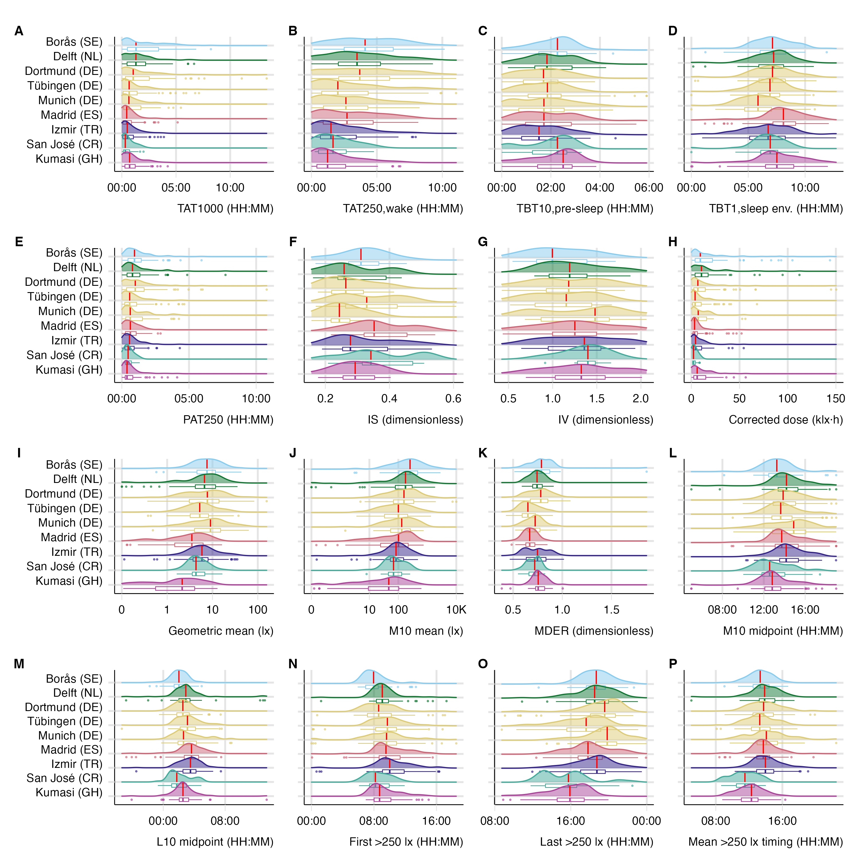
Supplementary Figure S1. Detailed near-eye metric distributions by country-coded study site.

Supplementary Figure S2. Worked metric derivation
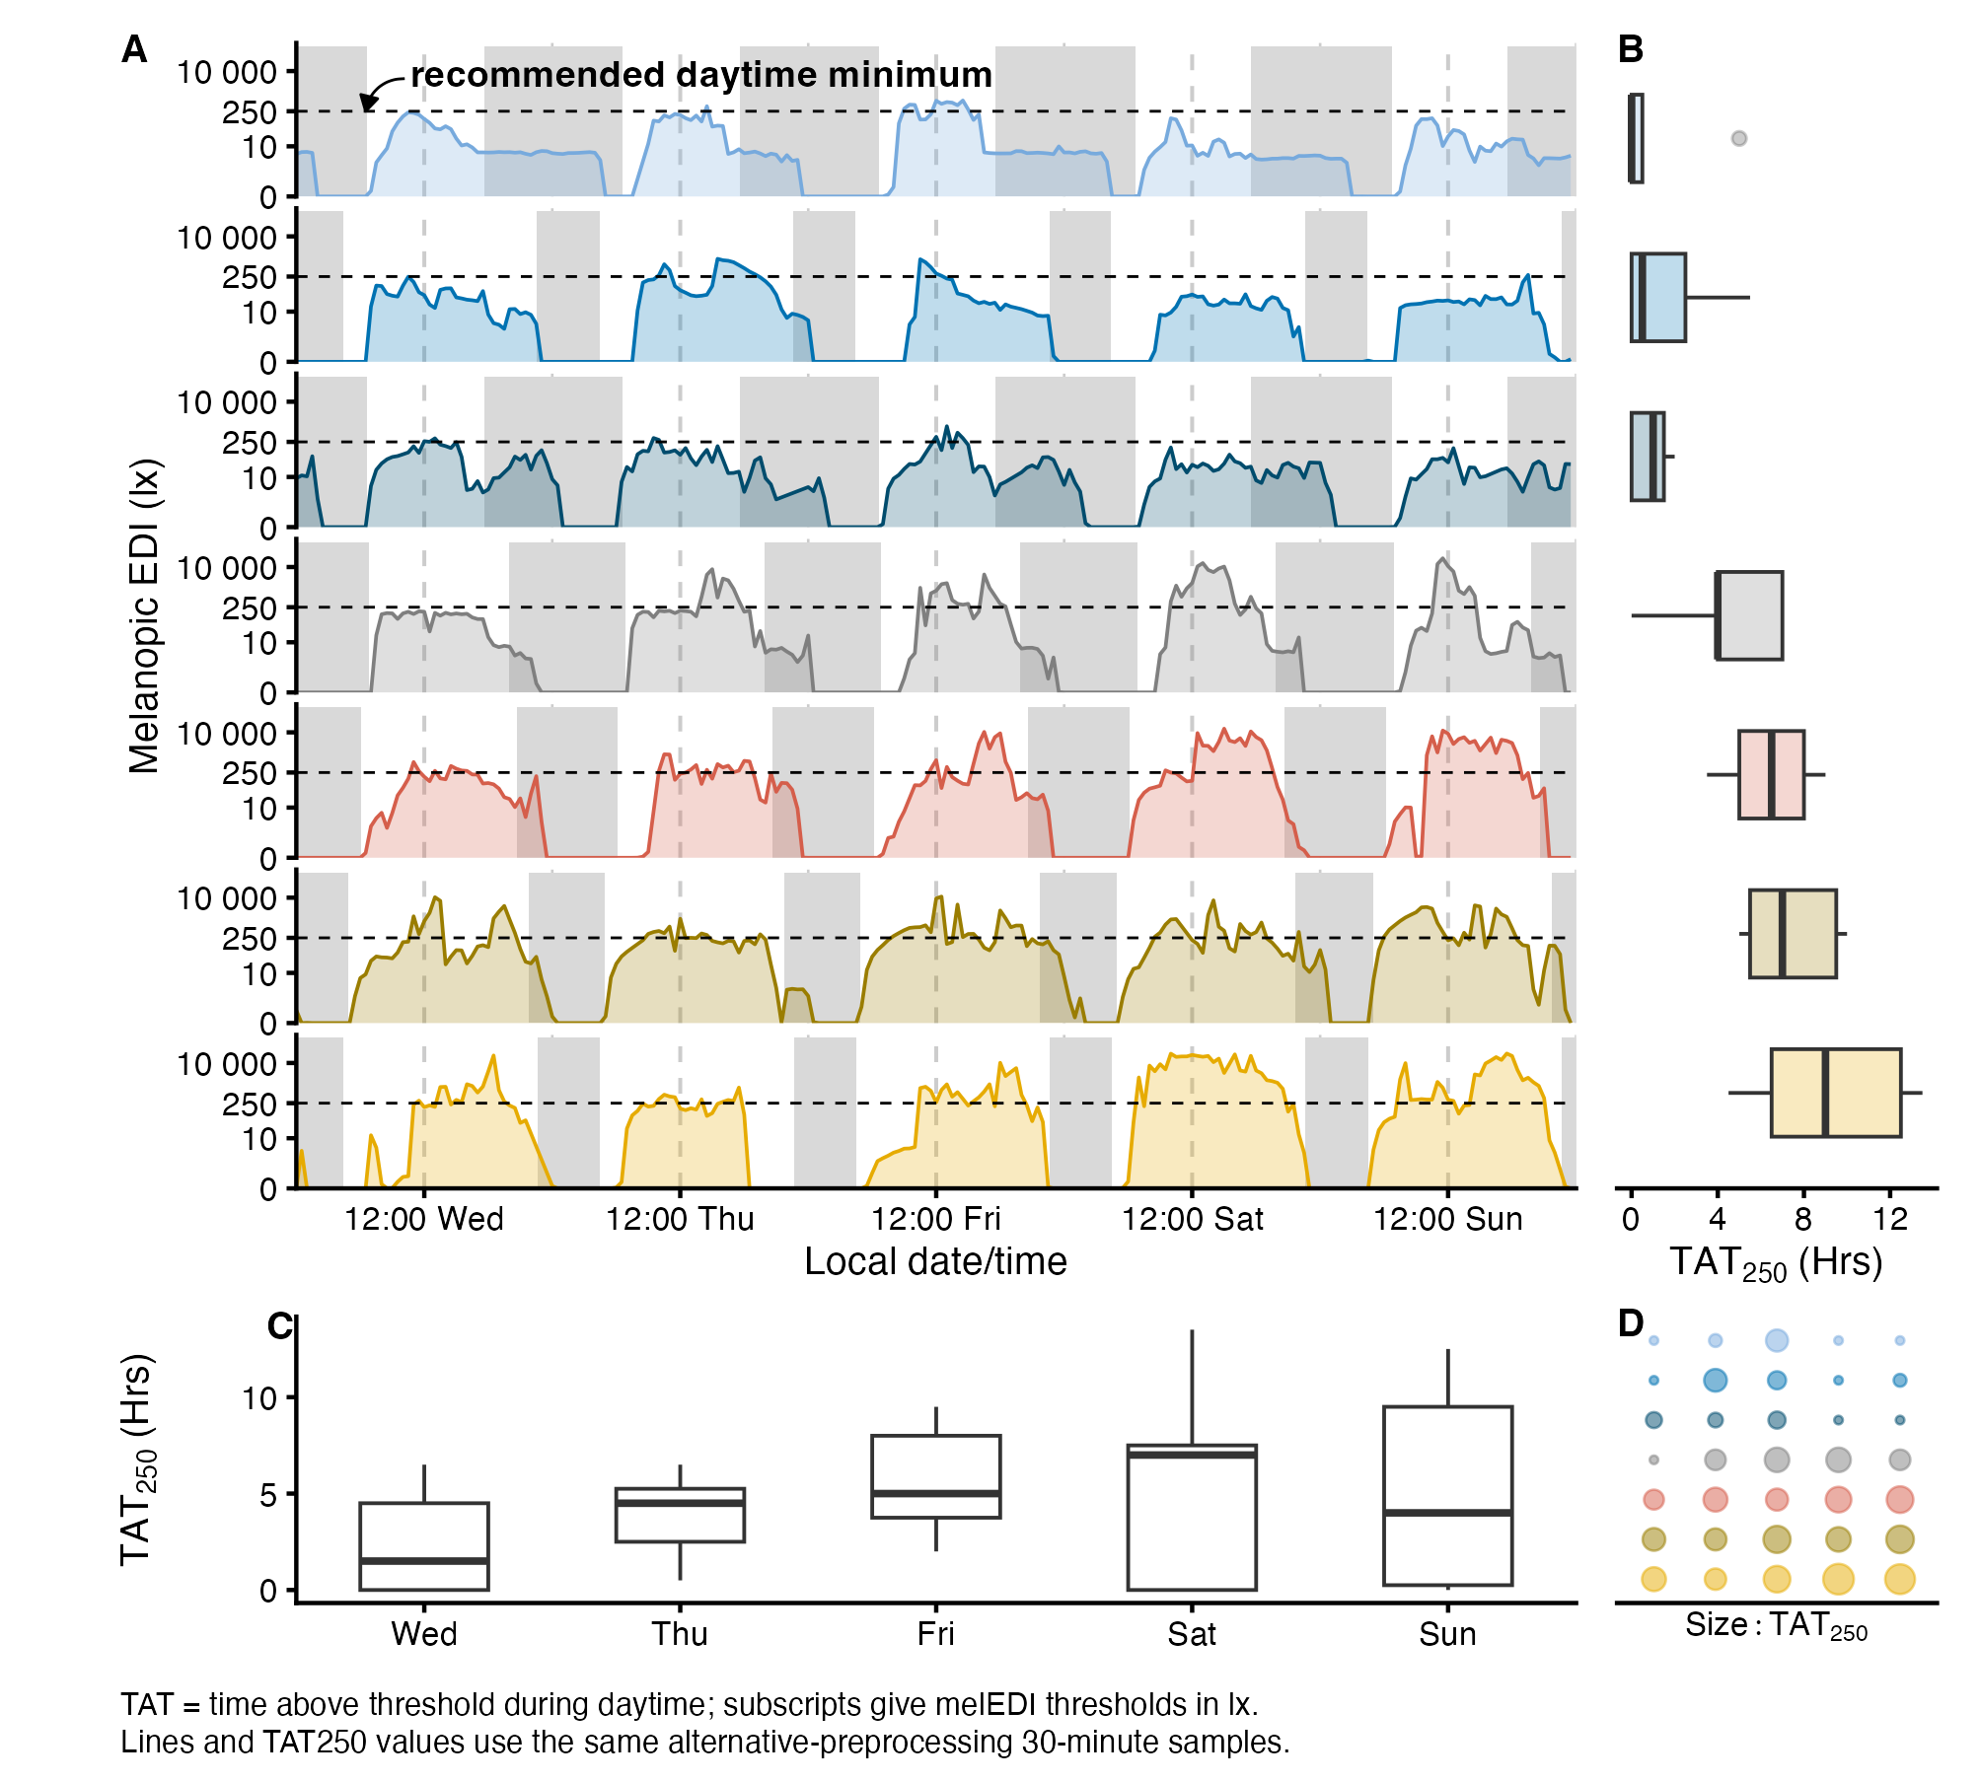
Supplementary Figure S2. Examples linking 30-minute time series to the daily time-above-250-lx metric.

Supplementary Figure S3. Latitude and civil-photoperiod measurement range
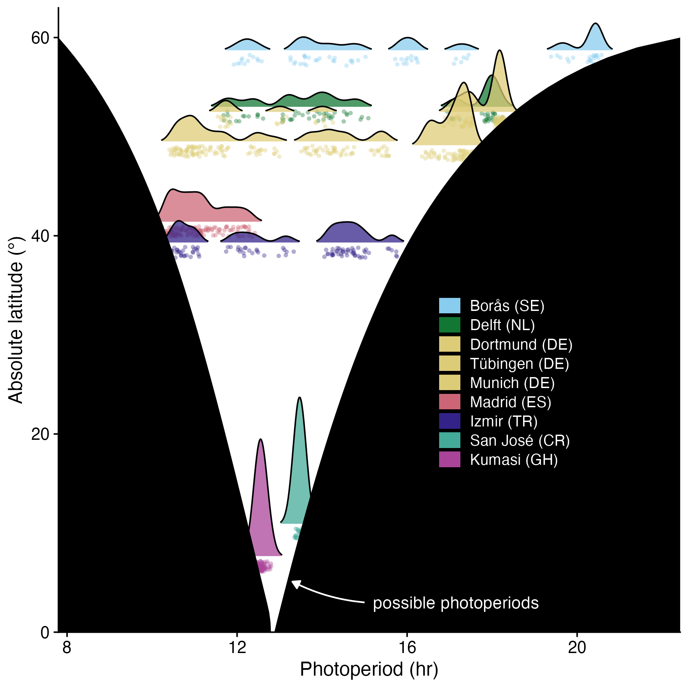
Supplementary Figure S3. Observed civil photoperiod and theoretical bounds by absolute latitude.

Supplementary Figure S4. Site-average recommendation adherence
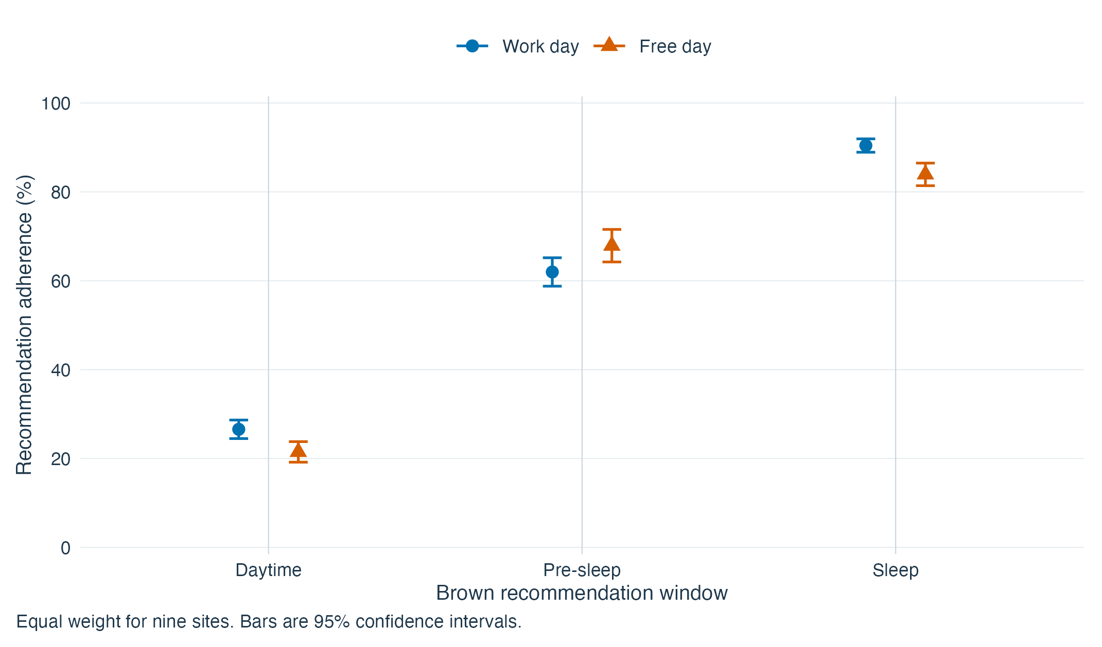
Supplementary Figure S4. Site-average recommendation adherence on work and free days. Daytime, Pre-sleep and Sleep identify the Brown et al. recommendation windows. Each point gives equal weight to nine sites; bars are 95% confidence intervals. The wake-start date labels the preceding sleep, daytime and following pre-sleep windows. Sleep describes the device-recorded bedside environment, not ocular exposure or a whole-bedroom measurement. The pre-sleep contrast remains positive but its interval includes zero under the 80% coverage restriction; temporal dependence remains unresolved. The coverage sensitivity is reported in the Results and Methods.

Supplementary Figure S5. Site-specific adherence and day-type differences
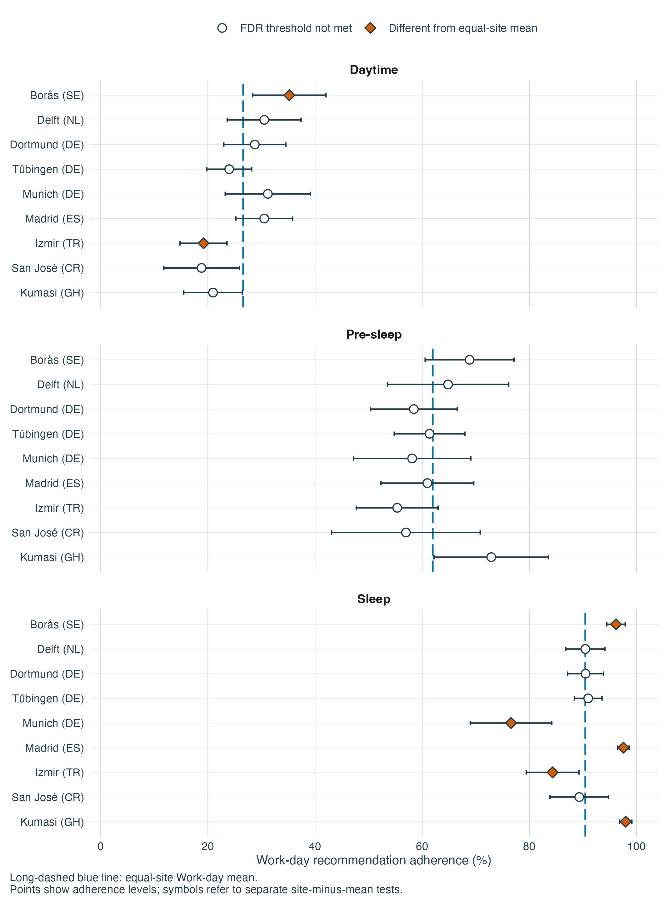
Supplementary Figure S5A. Site-specific work-day recommendation adherence. Filled diamonds identify site-minus-average comparisons retained after FDR adjustment; bars are 95% confidence intervals. The full explanation accompanies part B.

Supplementary Figure S5. Site-specific adherence (continued)
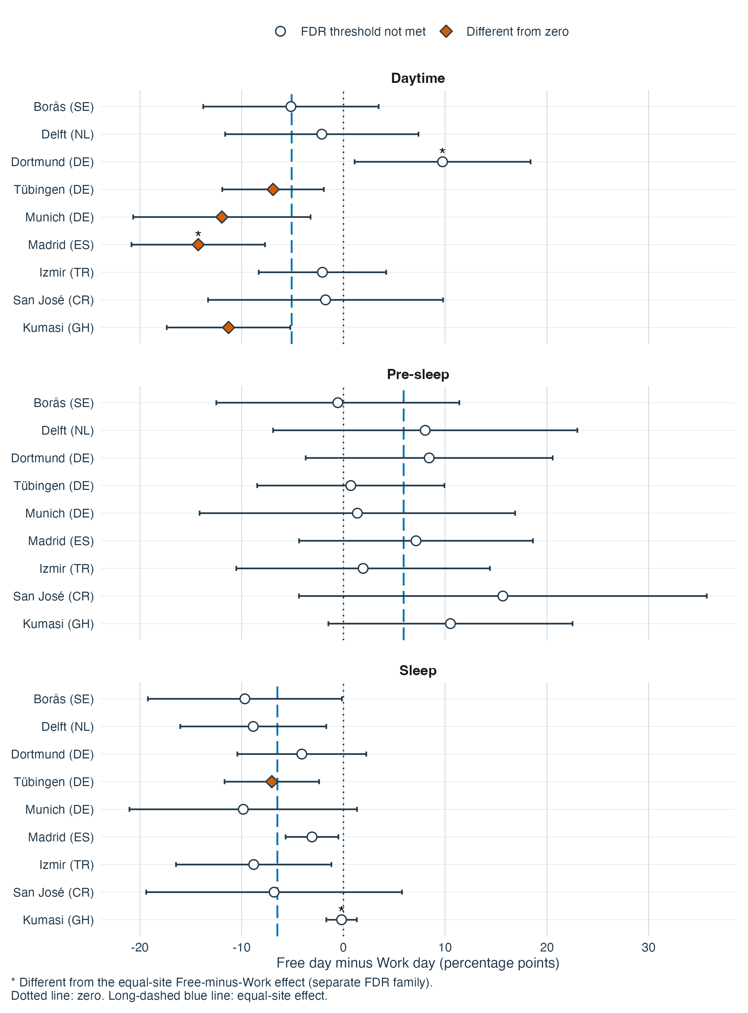
Supplementary Figure S5. Site-specific recommendation adherence, shown as two separate images. A, Work-day adherence, with filled diamonds identifying site-minus-average differences that met their FDR criterion. B, Free-minus-work differences, with filled diamonds identifying differences from zero and asterisks identifying departures from the window-specific equal-site difference in a separate 27-comparison FDR family. Daytime, Pre-sleep and Sleep identify the Brown et al. recommendation windows. Points are estimates and bars are 95% confidence intervals. Each equal-site reference includes the indexed site. Sites are components of one pooled observational model, not independent replications or causal effects of location. Day type follows the wake-start date; sleep is the preceding bedside sleep-environment window. Temporal dependence remains unresolved, and the pre-sleep coverage qualification applies.

Supplementary Figure S6. Anonymous participant recommendation-adherence profiles
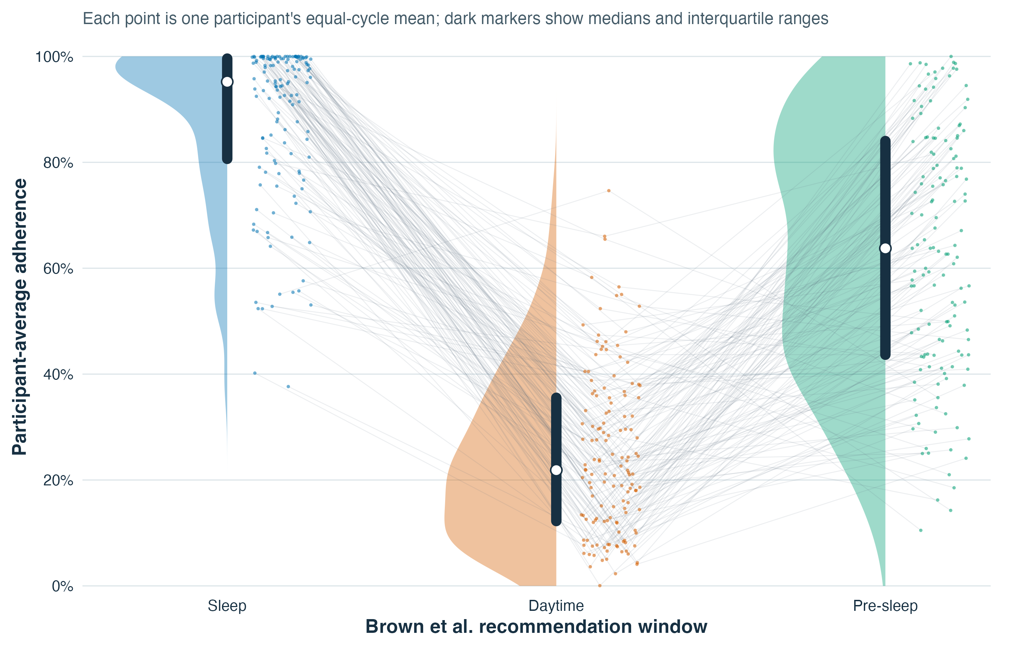
Supplementary Figure S6. Participant-average recommendation adherence across the Brown et al. recommendation windows. Daytime, Pre-sleep, and Sleep are the window labels. Each colored point is one anonymous participant’s equal-cycle mean within that window. Faint lines connect the same anonymous participant across the three window summaries; they are not time trajectories or ranks. Half-violin shapes show the window distributions, and dark bars with white points show interquartile ranges and medians. Because each window has its own Brown et al. threshold and direction, absolute percentages should be interpreted within window.

Supplementary Figure S7. Geographic and civil-photoperiod support
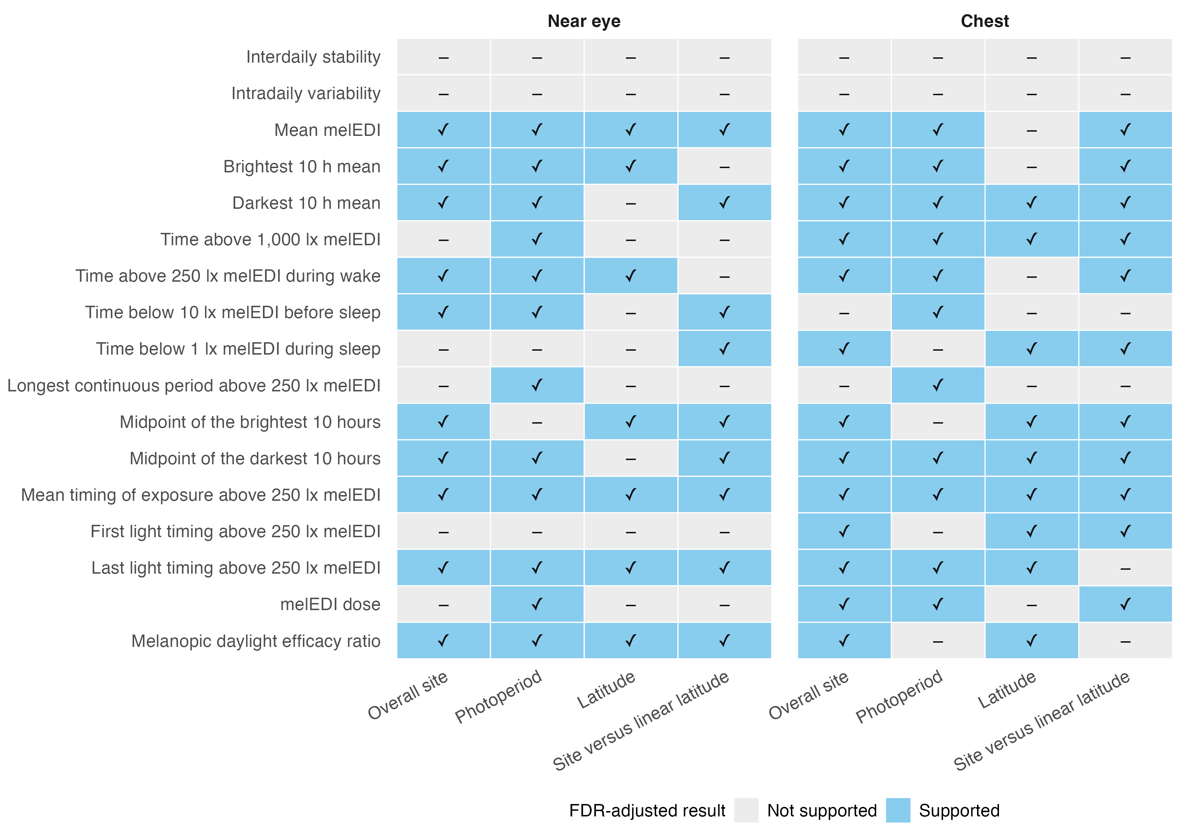
Supplementary Figure S7. Geographic and civil-photoperiod associations across near-eye personal light-exposure metrics. Evidence retained after FDR adjustment for overall site, civil photoperiod, latitude, and site-versus-linear-latitude adequacy. These descriptive associations do not identify a mechanism.

Supplementary Figure S8. Nonlinear civil-photoperiod associations and fitted slopes
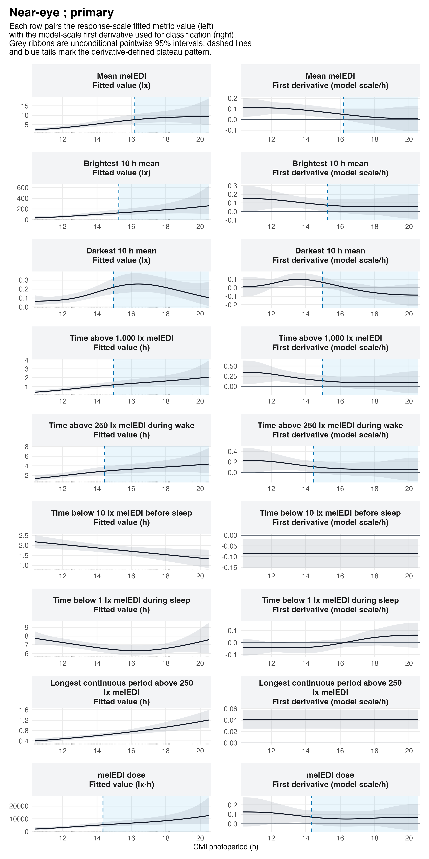
Supplementary Figure S8. Nonlinear civil-photoperiod associations and their fitted slopes. A qualifying transition denotes an increase followed by a sustained near-flat tail under the specified slope rule. These descriptive associations do not identify a mechanism, and no physiological or environmental ceiling was identified.

Supplementary Figure S9. Light-source category and local-clock pattern of near-eye melanopic EDI
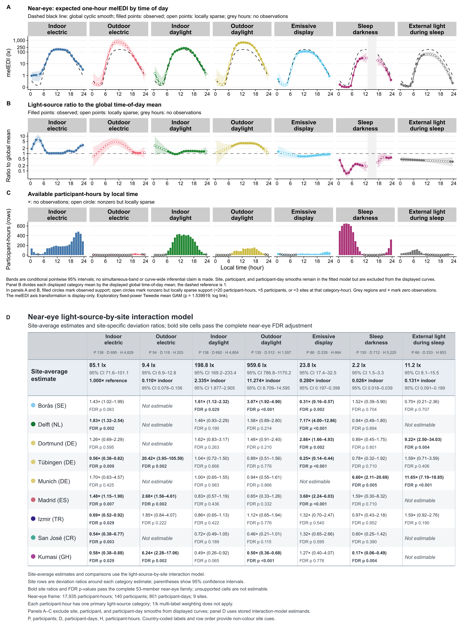
Supplementary Figure S9. Near-eye light exposure by reported light source across time of day and study site. A–C, Exploratory time-of-day analysis. Panel A shows expected one-hour melanopic EDI with clock-specific 95% confidence intervals; the dashed line is the site-average local-clock smooth. Panel B shows each light-source curve relative to that smooth, with 1 as the reference. Panel C shows available participant-hours; open circles indicate locally sparse support and grey gaps indicate no observations. D, Site-average category estimates and site-specific deviation ratios from the light-source-by-site interaction model, with participant-cluster-robust 95% confidence intervals, FDR-adjusted p values, and exact support. The analysis includes 17,935 participant-hours from 140 participants, covering 801 participant-days and nine sites. Panels A–C and panel D answer different questions and are not numerically interchangeable. Estimates are observational. During reported sleep, measurements describe the bedside sleep environment.

Supplementary Figure S10. Paired sensor-position hourly associations
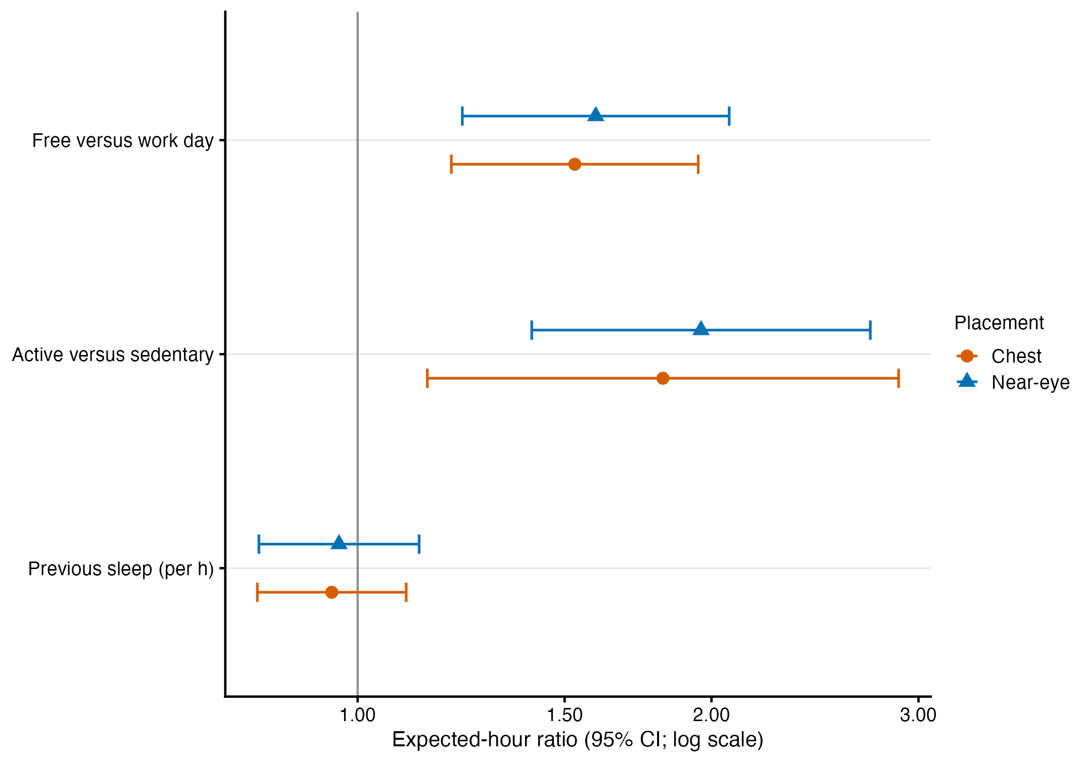
Supplementary Figure S10. Near-eye and complementary chest associations estimated separately for the same participants and participant-days. The sets of supported participant-hours differ between sensor positions, so the display is not an observation-level identity comparison and does not test equivalence.

Supplementary Figure S11. Free-versus-Work hourly timing
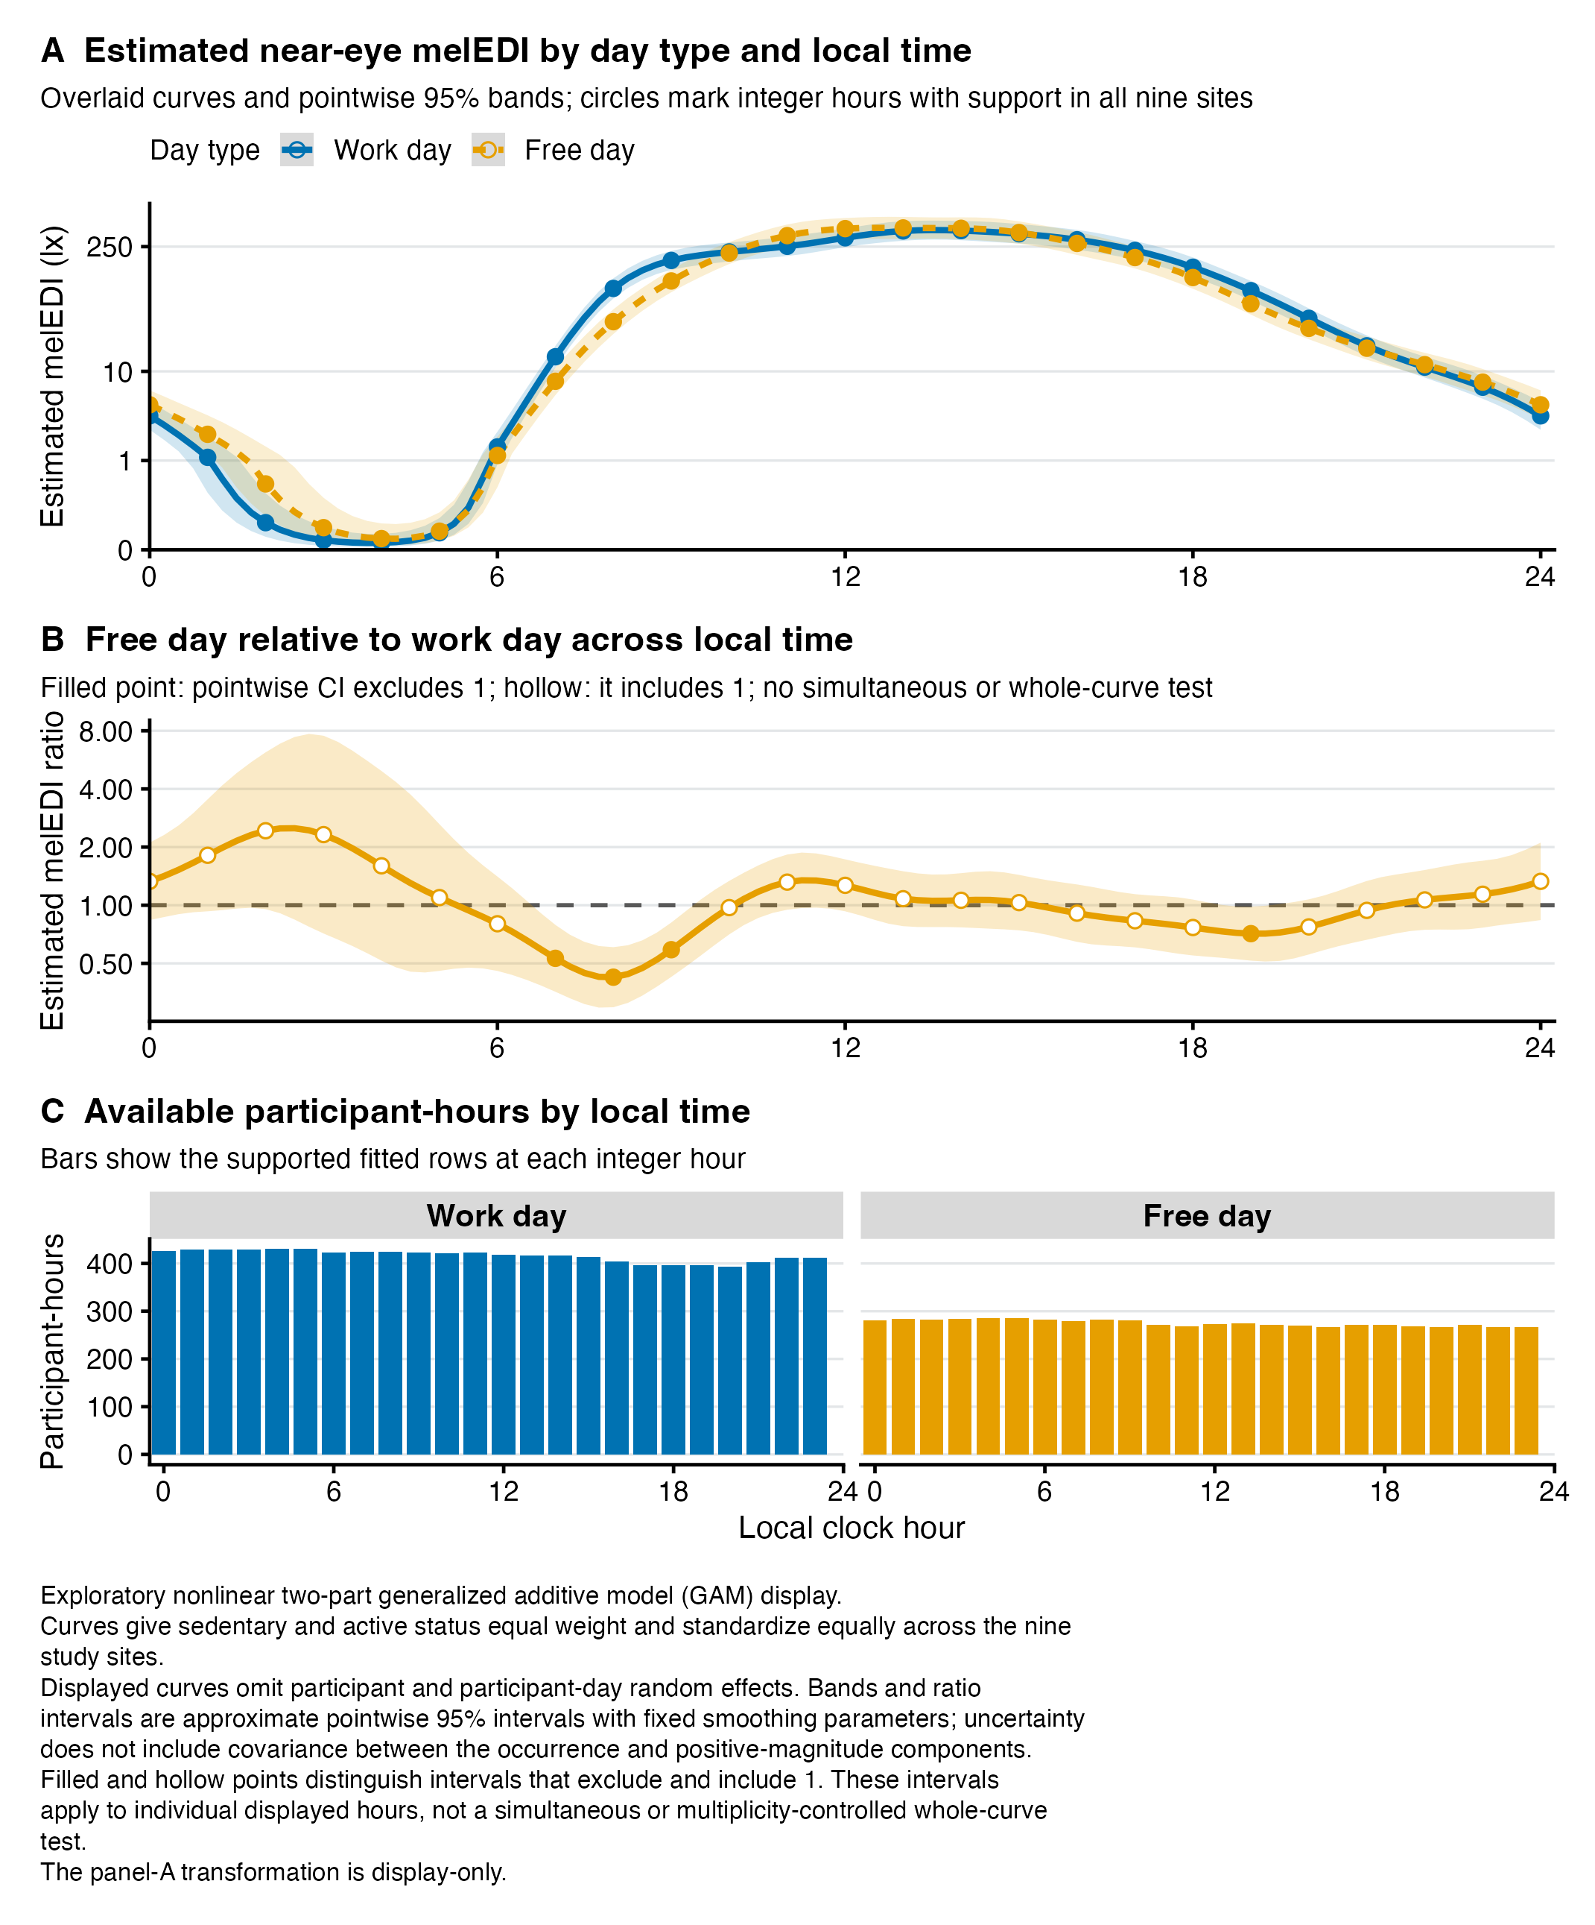
Supplementary Figure S11. Exploratory Free-versus-Work hourly fitted exposure and response-scale ratio curves with 95% confidence intervals and participant-hour support.

Supplementary Figure S12. Active-versus-Sedentary hourly timing
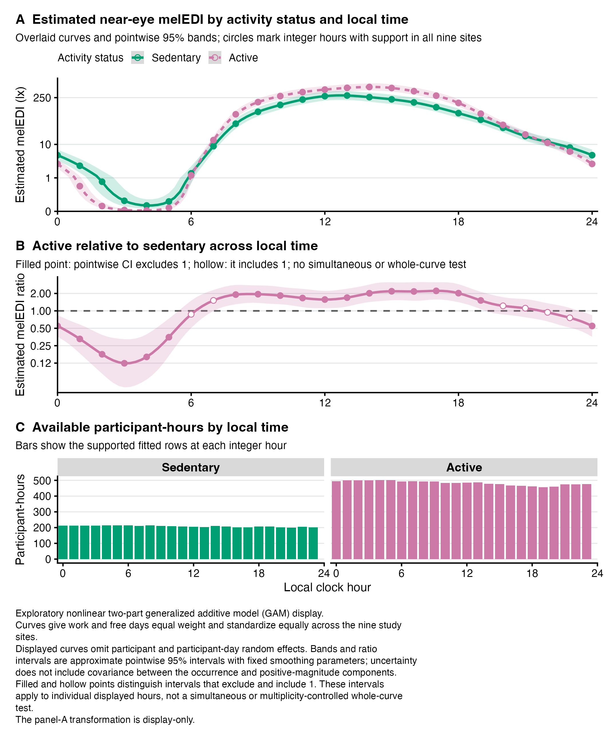
Supplementary Figure S12. Exploratory Active-versus-Sedentary hourly fitted exposure and response-scale ratio curves with 95% confidence intervals and participant-hour support.

Supplementary Figure S13. Site-specific hourly routine associations
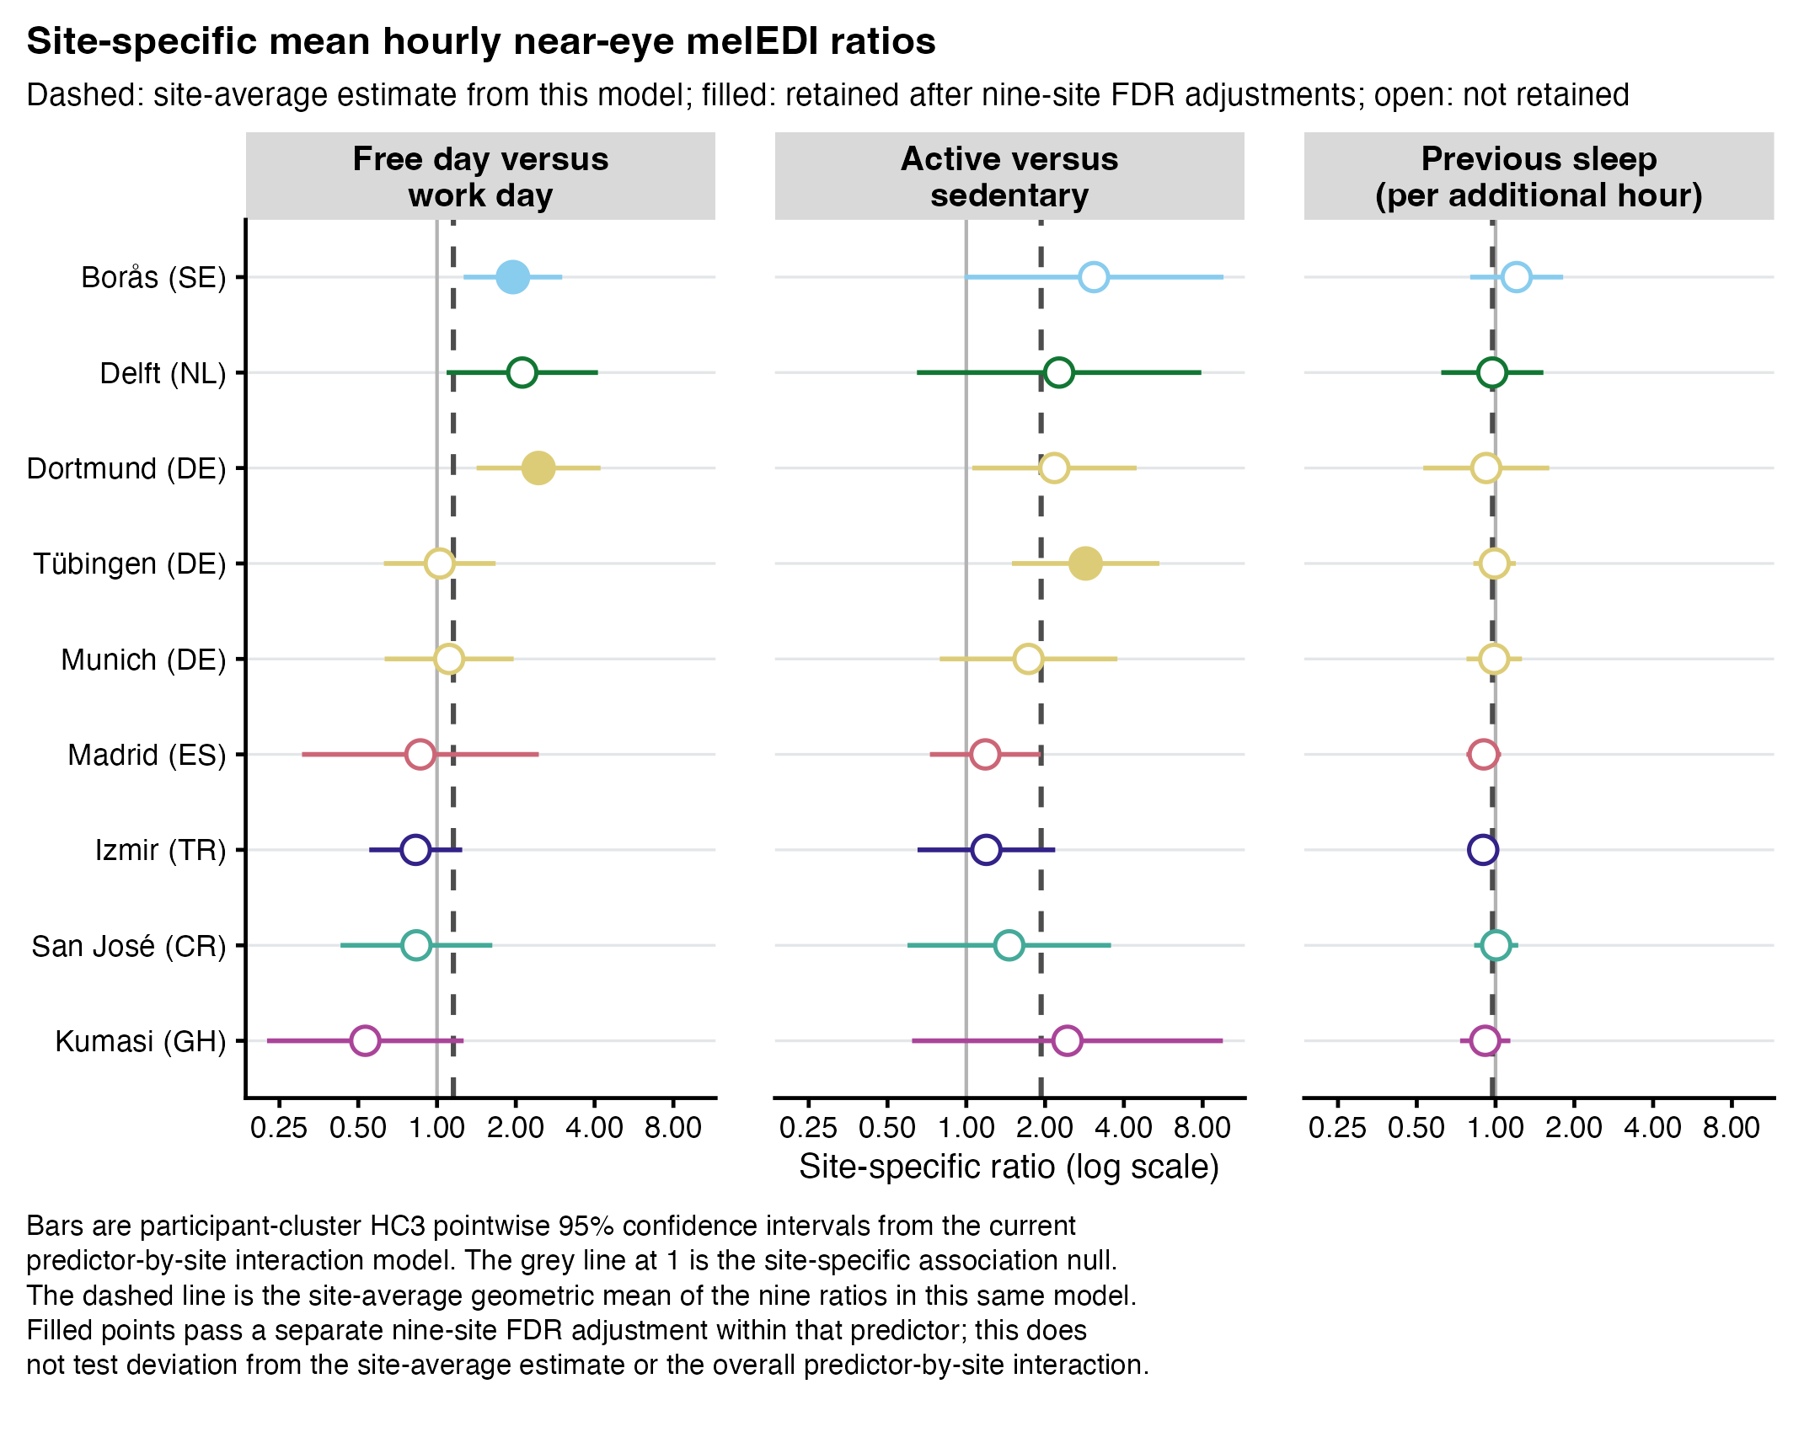
Supplementary Figure S13. Site-specific estimates from the predictor-by-site interaction model. Filled and hollow points distinguish associations that did and did not meet the 0.050 criterion after a separate nine-site FDR adjustment within each predictor. The 95% confidence intervals are unadjusted; dashed lines show site-average estimates calculated with equal weight for each of the nine sites. Sites are components of one pooled model, not independent replications or causal effects of location.

Supplementary Figure S14. Light-exposure behaviour and awareness
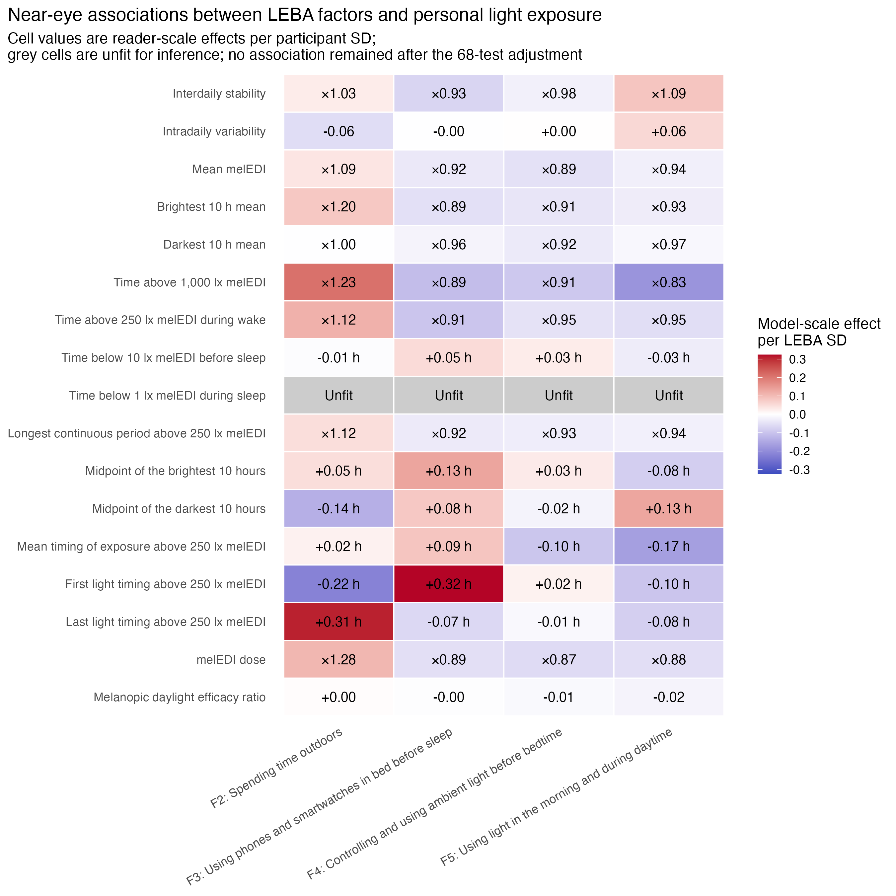
Supplementary Figure S14. Near-eye associations per one participant-level standard deviation of each Light Exposure Behaviour Assessment factor. None of the 68 tests retained FDR-adjusted support. Four sleep-environment cells were unfit for inference and are labelled Unfit with estimates suppressed. Lack of adjusted support is inconclusive rather than proof of no association.

Supplementary Figure S15. Visual light sensitivity
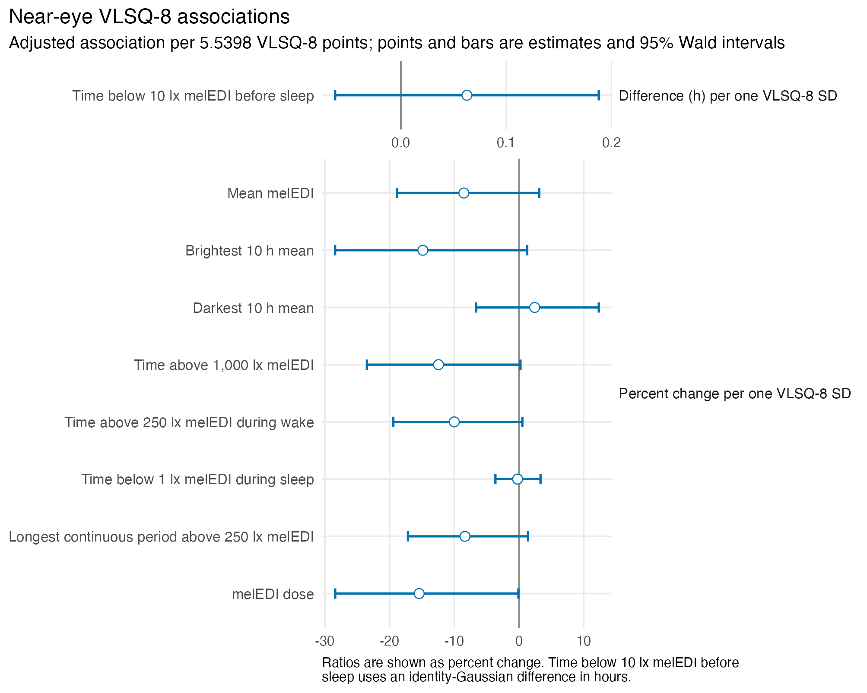
Supplementary Figure S15. Near-eye site-average associations between the Visual Light Sensitivity Questionnaire-8 and nine personal light-exposure metrics. Associations compare scores separated by one participant-level standard deviation. Horizontal bars are 95% Wald confidence intervals. None of the nine associations retained FDR-adjusted support.

Supplementary Figure S16. Adjusted chronotype associations
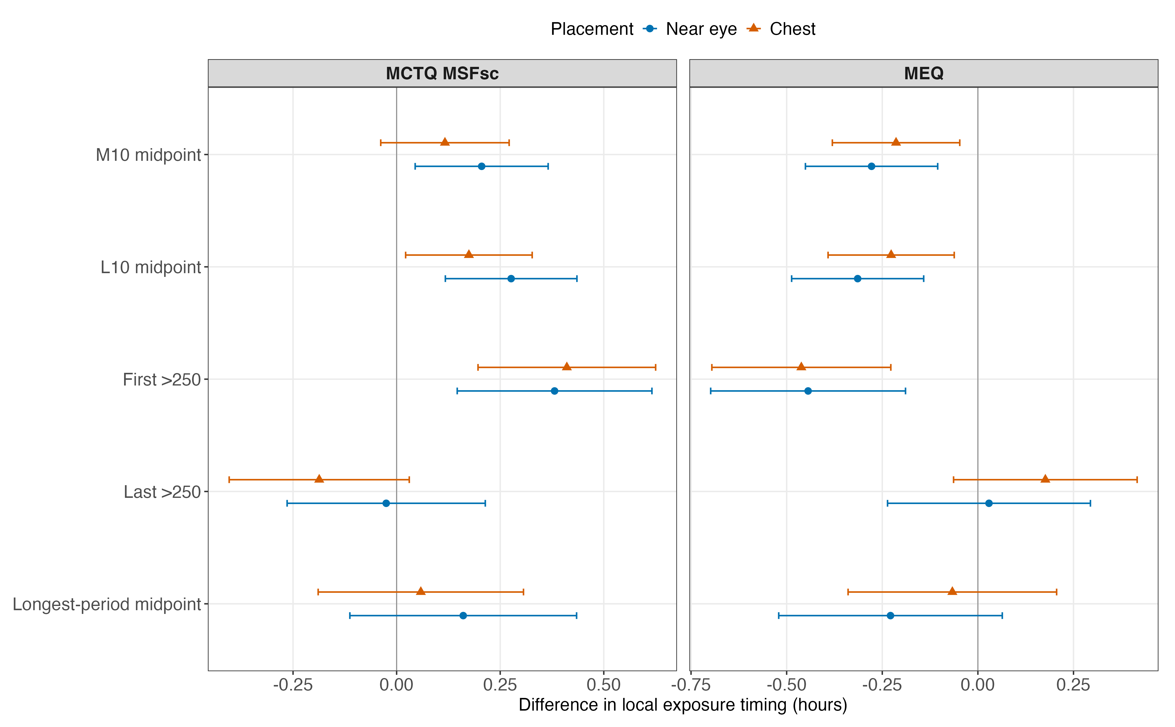
Supplementary Figure S16. Chronotype and timing of personal light exposure. Study-site-adjusted associations of sleep-timing-based corrected midsleep on Free days and questionnaire-based morningness-eveningness with the analysed timing metrics. Points are estimates and bars are 95% confidence intervals; the two chronotype instruments remain separate. Near-eye estimates provide ocular-exposure evidence; chest estimates, where shown, are complementary non-ocular evidence.

Supplementary Figure S17. Observed timing across chronotype and study sites
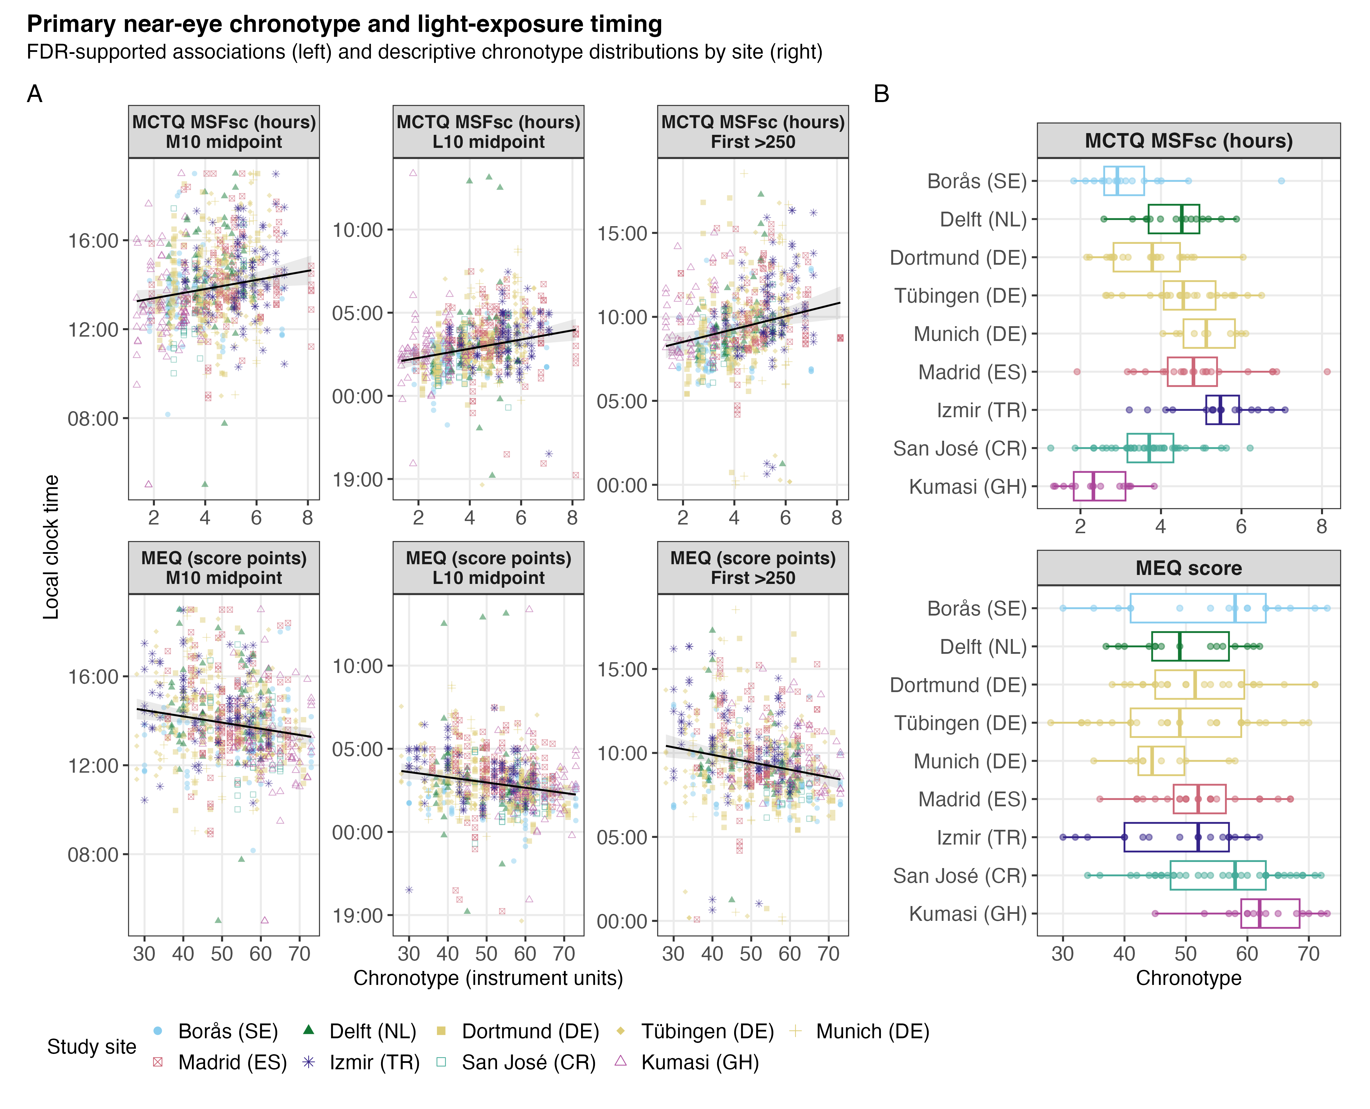
Supplementary Figure S17. Observed timing across chronotype and study sites. Observed participant-day timing values across chronotype and country-coded study sites for the samples used in the corresponding models. Each point represents one participant-day in a fitted sample. This figure is descriptive and does not replace the adjusted models or estimate independent site effects. Near-eye estimates provide ocular-exposure evidence; chest estimates, where shown, are complementary non-ocular evidence.

Supplementary Figure S18. Age and biological sex
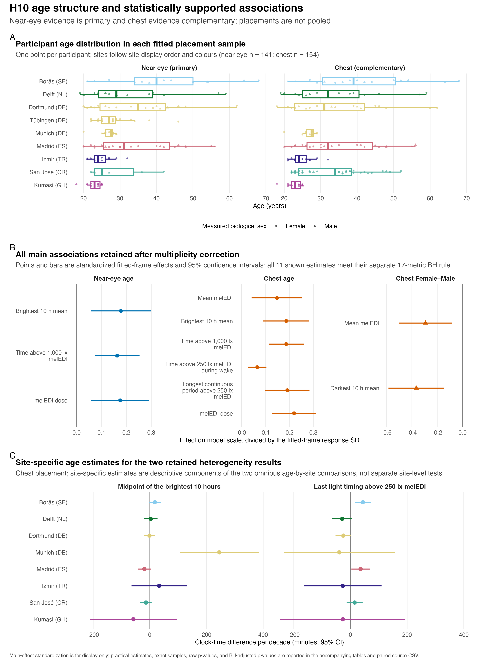
Supplementary Figure S18. Participant age distributions, the 11 main associations retained after FDR adjustment, and descriptive site-specific estimates for two retained age-by-site interactions in the complementary chest analysis. The site-specific interaction estimates are descriptive model contrasts, not independent site tests. Biological sex, coded Female or Male, was analysed; gender was recorded separately and was not analysed.

Supplementary Figure S19. Biological-sex-specific daily curves
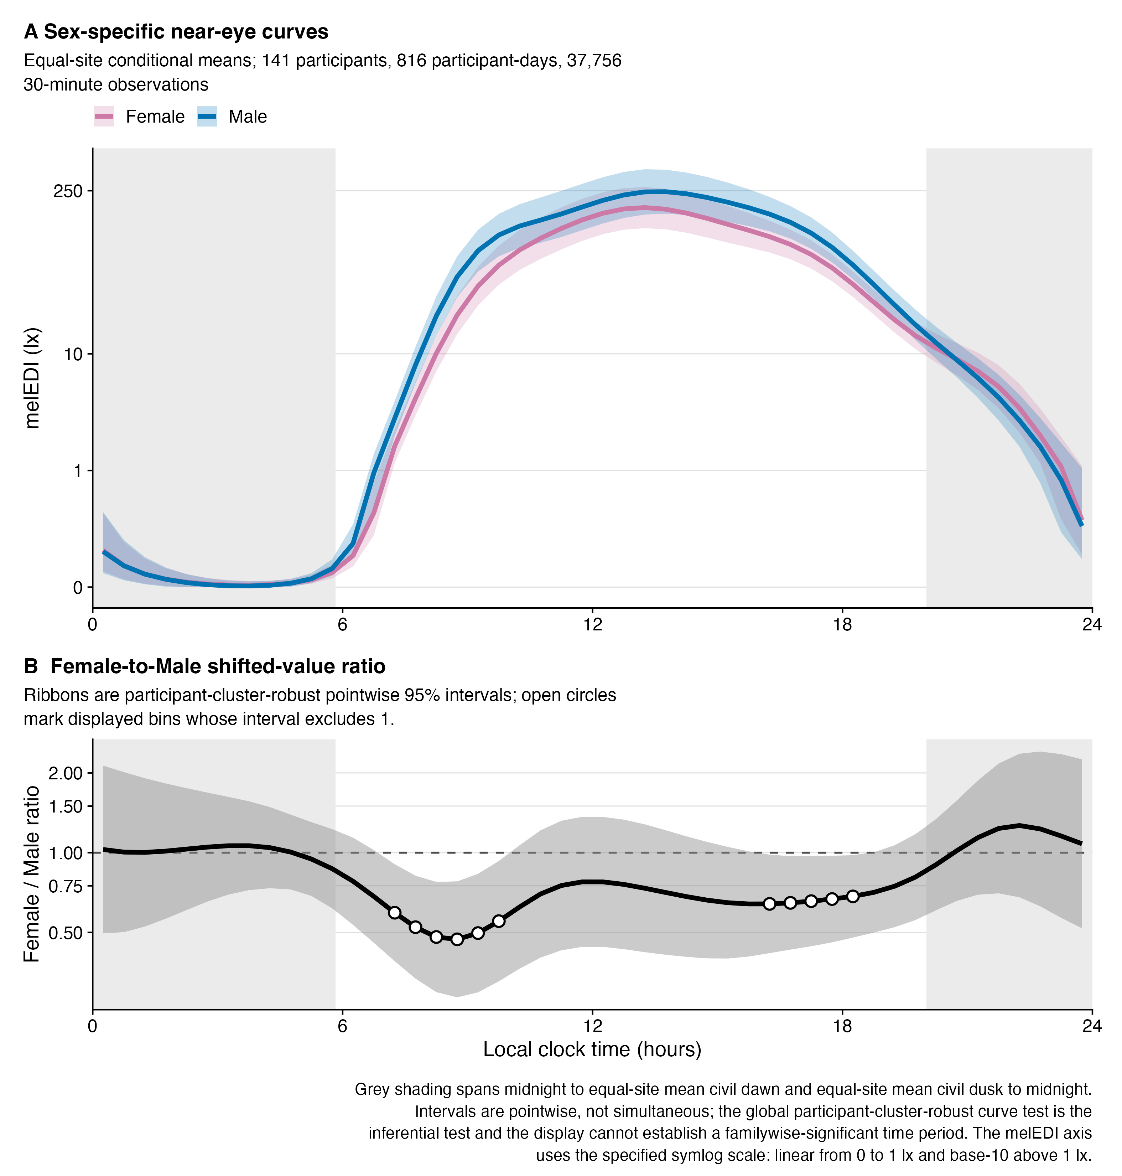
Supplementary Figure S19. Near-eye biological-sex-specific fitted melanopic equivalent daylight illuminance curves and Female-to-Male shifted-value ratio. Ribbons and contrast intervals are participant-cluster-robust 95% confidence intervals at the displayed clock times. Grey shading gives site-average civil-night context with each site weighted equally and is not a model covariate. Biological sex, coded Female or Male, was analysed; gender was recorded separately and was not analysed.

Supplementary tables

Supplementary Table S1. Descriptive sample flow
Supplementary Table S1. Participant, participant-day, and one-minute observation counts across the roster, sensor-specific completeness and all-zero screens, final descriptive datasets, and paired main subset. Each row names its denominator explicitly. An excluded participant-day is not necessarily an excluded participant.
 | Participants | Participant-days | One-minute real observations
participant roster
Available normalized participant metadata | 191 | Not applicable | Not applicable
near_eye
At least 80% complete before all-zero screen | Not applicable | 818 | Not applicable
Exact all-zero days excluded | Not applicable | 2 | Not applicable
Main dataset after all-zero screen | 141 | 816 | 1,175,160
chest
At least 80% complete before all-zero screen | Not applicable | 905 | Not applicable
Exact all-zero days excluded | Not applicable | 3 | Not applicable
Main dataset after all-zero screen | 154 | 902 | 1,298,880
paired
Paired main subset | 112 | 643 | Not applicable

Supplementary Table S2. Full near-eye metric dictionary and distributions
Overall distribution
Supplementary Table S2. Definitions, exact support, median (interquartile range) summaries, and density displays for the 17 near-eye personal light-exposure metrics overall and by site. Values use three decimal places where applicable. Metrics are distinct summaries and should not be interpreted as interchangeable outcomes.
Near-eye metric summaries: overall distribution
Metric¹ | Unit | Overall | Scaling² | Distribution³
Duration
Time above 1,000 lx melEDI; Bright-light exposure duration; relevant to daytime alerting and circadian entrainment. | HH:MM | 00:41; (00:11, 01:34); 01:10 ± 01:28; N=141; d=816 | Symlog (base 10; threshold 1)
Time above 250 lx melEDI during wake; Waking time in recommended daytime light; relevant to alertness, entrainment, and subsequent sleep. | HH:MM | 02:25; (00:51, 04:37); 03:00 ± 02:29; N=141; d=737 | Symlog (base 10; threshold 1)
Time below 10 lx melEDI before sleep; Low-light time before bed; limits evening melatonin suppression and circadian delay. | HH:MM | 01:53; (01:02, 02:35); 01:51 ± 01:02; N=139; d=655 | Symlog (base 10; threshold 1)
Time below 1 lx melEDI during sleep; Darkness during sleep; supports nocturnal melatonin and an undisturbed sleep environment. | HH:MM | 07:08; (05:58, 08:15); 07:04 ± 01:57; N=141; d=778 | Symlog (base 10; threshold 1)
Longest period above 250 lx melEDI; Longest sustained bright-light bout; captures continuity of daytime circadian stimulation. | HH:MM | 00:38; (00:17, 01:12); 00:55 ± 01:00; N=141; d=816 | Symlog (base 10; threshold 1)
Dynamics
Interdaily stability; Day-to-day regularity of the light–dark pattern; higher regularity supports circadian stability. | dimensionless | 0.308; (0.248, 0.38); 0.318 ± 0.095; N=141; d=816 | Identity
Intradaily variability; Within-day fragmentation of light exposure; higher values indicate less consolidated light–dark input. | dimensionless | 1.253; (0.93, 1.502); 1.229 ± 0.389; N=141; d=816 | Identity
Exposure history
melEDI dose; Intensity–duration-weighted melanopic exposure; summarizes cumulative non-visual retinal light input. | klx·h | 4.96; (1.936, 12.313); 10.358 ± 16.216; N=141; d=761 | Symlog (base 10; threshold 1)
Level
Mean melEDI; Geometric average of daily melEDI values, including zeros; summarizes overall exposure while reducing peak influence. | lx | 5.154; (2.831, 9.225); 7.587 ± 9.496; N=141; d=816 | Symlog (base 10; threshold 1)
Brightest 10 h mean; Mean of the brightest 10 hours; reflects the strength of the main daytime light episode. | lx | 110.566; (41.513, 243.212); 214.866 ± 508.56; N=141; d=816 | Symlog (base 10; threshold 1)
Darkest 10 h mean; Mean of the darkest 10 hours; lower values during the biological night favour melatonin preservation and sleep. | lx | 0.103; (0.02, 0.253); 0.243 ± 0.513; N=141; d=816 | Symlog (base 10; threshold 1)
Spectrum
Melanopic daylight efficacy ratio; Mean of viable one-minute melEDI/illuminance ratios; indicates melanopic efficacy relative to visual light. | dimensionless | 0.724; (0.643, 0.795); 0.724 ± 0.116; N=137; d=687 | Identity
Timing
Midpoint of the brightest 10 hours; Centre time of the brightest 10 hours; indexes the main daily circadian light cue. | HH:MM; clock time | 13:44; (12:48, 15:00); 13:56 ± 01:51; N=141; d=816 | Circular clock
Midpoint of the darkest 10 hours; Centre time of the darkest 10 hours; indexes the main daily darkness cue. | HH:MM; clock time | 02:54; (02:01, 03:50); 02:58 ± 01:41; N=141; d=816 | Circular clock
First light timing above 250 lx melEDI; First waking bright-light exposure; morning timing can advance circadian phase and promote alertness. | HH:MM; clock time | 09:08; (08:02, 10:40); 09:26 ± 02:22; N=140; d=727 | Circular clock
Last light timing above 250 lx melEDI; Last bright-light exposure; later timing may delay circadian phase and sleep onset. | HH:MM; clock time | 18:08; (16:27, 19:42); 18:03 ± 02:36; N=141; d=687 | Circular clock
Mean timing of exposure above 250 lx melEDI; Average bright-light timing; summarizes the phase of daily circadian stimulation. | HH:MM; clock time | 13:29; (12:29, 14:39); 13:31 ± 01:52; N=141; d=742 | Circular clock
Median (25th percentile, 75th percentile), circular or arithmetic mean ± standard deviation, N=participants; d=participant-days with a finite value for that metric.
¹ The brief meaning and relevance notes describe established physiological constructs; this descriptive table does not estimate individual health effects.
² Scaling describes the distribution column only; printed values remain on their stated scale. Symlog uses base 10 with a linear region through 1 in the stated unit; Identity is linear; Circular clock unwraps values around the metric-specific clock centre.
³ Red lines indicate site medians. Symlog and circular-clock rows are transformed only for plotting.
Site summaries 1
Near-eye metric summaries: site group 1
Metric¹ | Borås (SE) | Delft (NL) | Dortmund (DE)
Duration
Time above 1,000 lx melEDI | 01:18; (00:31, 03:24); 02:00 ± 01:54; N=13; d=78 | 01:18; (00:29, 02:12); 01:33 ± 01:28; N=13; d=78 | 01:03; (00:20, 02:32); 01:48 ± 02:14; N=18; d=107
Time above 250 lx melEDI during wake | 04:06; (02:30, 06:15); 04:21 ± 02:24; N=13; d=73 | 03:29; (02:03, 05:16); 03:39 ± 02:25; N=13; d=64 | 03:42; (02:05, 05:58); 04:05 ± 02:51; N=18; d=90
Time below 10 lx melEDI before sleep | 02:16; (01:30, 02:39); 02:05 ± 00:53; N=13; d=67 | 01:50; (01:21, 02:52); 01:59 ± 00:57; N=12; d=50 | 01:42; (00:53, 02:17); 01:41 ± 00:58; N=18; d=84
Time below 1 lx melEDI during sleep | 07:08; (06:03, 08:18); 07:12 ± 01:46; N=13; d=76 | 07:14; (05:56, 08:06); 07:01 ± 01:50; N=13; d=68 | 07:08; (05:56, 08:16); 07:05 ± 01:50; N=18; d=95
Longest period above 250 lx melEDI | 00:56; (00:28, 01:27); 01:12 ± 01:02; N=13; d=78 | 00:48; (00:23, 01:20); 01:09 ± 01:15; N=13; d=78 | 01:00; (00:21, 01:40); 01:20 ± 01:31; N=18; d=107
Dynamics
Interdaily stability | 0.311; (0.272, 0.367); 0.315 ± 0.078; N=13; d=78 | 0.258; (0.239, 0.389); 0.288 ± 0.094; N=13; d=78 | 0.264; (0.219, 0.319); 0.274 ± 0.074; N=18; d=107
Intradaily variability | 0.997; (0.818, 1.388); 1.088 ± 0.343; N=13; d=78 | 1.193; (0.96, 1.389); 1.238 ± 0.345; N=13; d=78 | 1.182; (0.928, 1.49); 1.177 ± 0.407; N=18; d=107
Exposure history
melEDI dose | 9.296; (3.892, 21.895); 19.923 ± 27.784; N=13; d=71 | 10.495; (3.855, 17.395); 15.881 ± 20.395; N=13; d=74 | 6.751; (2.469, 14.435); 13.809 ± 23.711; N=18; d=97
Level
Mean melEDI | 7.569; (4.55, 11.613); 9.171 ± 7.111; N=13; d=78 | 6.659; (4.18, 11.674); 8.274 ± 6.558; N=13; d=78 | 7.704; (3.081, 13.924); 12.017 ± 18.865; N=18; d=107
Brightest 10 h mean | 252.689; (104.514, 461.953); 399.302 ± 518.102; N=13; d=78 | 175.974; (78.625, 299.106); 262.206 ± 329.201; N=13; d=78 | 156.184; (67.783, 339.731); 422.54 ± 1,209.616; N=18; d=107
Darkest 10 h mean | 0.08; (0.016, 0.191); 0.183 ± 0.299; N=13; d=78 | 0.1; (0.035, 0.23); 0.2 ± 0.332; N=13; d=78 | 0.14; (0.036, 0.282); 0.223 ± 0.299; N=18; d=107
Spectrum
Melanopic daylight efficacy ratio | 0.788; (0.725, 0.872); 0.796 ± 0.162; N=13; d=74 | 0.743; (0.699, 0.796); 0.743 ± 0.077; N=13; d=65 | 0.781; (0.675, 0.853); 0.768 ± 0.118; N=18; d=97
Timing
Midpoint of the brightest 10 hours | 13:16; (12:28, 14:10); 13:20 ± 01:33; N=13; d=78 | 14:12; (13:23, 15:18); 14:22 ± 01:51; N=13; d=78 | 13:52; (12:54, 15:04); 14:00 ± 01:42; N=18; d=107
Midpoint of the darkest 10 hours | 02:02; (01:24, 02:48); 02:03 ± 01:07; N=13; d=78 | 02:55; (02:01, 03:28); 02:50 ± 02:05; N=13; d=78 | 02:32; (01:45, 03:22); 02:37 ± 01:19; N=18; d=107
First light timing above 250 lx melEDI | 07:57; (06:56, 08:33); 08:03 ± 01:32; N=13; d=74 | 09:04; (08:18, 09:52); 09:17 ± 01:56; N=13; d=68 | 08:36; (07:10, 10:13); 08:45 ± 02:21; N=18; d=93
Last light timing above 250 lx melEDI | 18:41; (17:38, 19:38); 18:39 ± 01:38; N=13; d=73 | 18:30; (17:37, 19:59); 18:37 ± 02:08; N=13; d=62 | 19:34; (18:04, 20:42); 19:16 ± 02:28; N=18; d=89
Mean timing of exposure above 250 lx melEDI | 13:20; (12:29, 14:24); 13:21 ± 01:25; N=13; d=72 | 13:52; (13:13, 15:06); 14:02 ± 01:41; N=13; d=71 | 13:44; (12:28, 14:55); 13:51 ± 01:56; N=18; d=93
Median (25th percentile, 75th percentile), circular or arithmetic mean ± standard deviation, N=participants; d=participant-days with a finite value for that metric.
¹ The brief meaning and relevance notes describe established physiological constructs; this descriptive table does not estimate individual health effects.
Site summaries 2
Near-eye metric summaries: site group 2
Metric¹ | Tübingen (DE) | Munich (DE) | Madrid (ES)
Duration
Time above 1,000 lx melEDI | 00:40; (00:07, 01:25); 01:06 ± 01:22; N=26; d=150 | 00:39; (00:10, 01:46); 01:09 ± 01:18; N=10; d=60 | 00:27; (00:06, 00:53); 00:38 ± 00:47; N=23; d=129
Time above 250 lx melEDI during wake | 02:01; (00:47, 04:20); 02:52 ± 02:39; N=26; d=141 | 02:38; (00:55, 04:19); 02:57 ± 02:19; N=10; d=54 | 02:43; (00:54, 04:43); 03:02 ± 02:19; N=23; d=113
Time below 10 lx melEDI before sleep | 01:52; (01:04, 02:25); 01:52 ± 01:06; N=26; d=132 | 01:43; (00:42, 02:32); 01:45 ± 01:10; N=10; d=52 | 01:43; (00:58, 02:50); 01:50 ± 01:05; N=23; d=105
Time below 1 lx melEDI during sleep | 06:54; (05:52, 07:46); 06:47 ± 01:30; N=26; d=150 | 05:52; (04:41, 07:03); 05:58 ± 01:58; N=10; d=60 | 08:06; (07:10, 09:10); 08:02 ± 01:57; N=23; d=118
Longest period above 250 lx melEDI | 00:35; (00:13, 01:06); 00:50 ± 00:54; N=26; d=150 | 00:38; (00:18, 01:32); 01:01 ± 01:02; N=10; d=60 | 00:38; (00:16, 01:04); 00:45 ± 00:36; N=23; d=129
Dynamics
Interdaily stability | 0.329; (0.263, 0.424); 0.344 ± 0.107; N=26; d=150 | 0.244; (0.218, 0.277); 0.252 ± 0.058; N=10; d=60 | 0.352; (0.321, 0.455); 0.368 ± 0.092; N=23; d=129
Intradaily variability | 1.154; (0.801, 1.442); 1.125 ± 0.354; N=26; d=150 | 1.48; (0.869, 1.642); 1.332 ± 0.477; N=10; d=60 | 1.251; (0.999, 1.497); 1.251 ± 0.413; N=23; d=129
Exposure history
melEDI dose | 3.862; (1.411, 10.217); 7.719 ± 9.847; N=26; d=137 | 7.11; (1.897, 15.789); 10.055 ± 11.237; N=10; d=55 | 3.317; (1.703, 6.29); 6.115 ± 8.79; N=23; d=125
Level
Mean melEDI | 5.232; (3.224, 8.188); 7.221 ± 6.33; N=26; d=150 | 9.013; (4.011, 15.089); 12.102 ± 12.013; N=10; d=60 | 3.505; (1.469, 6.211); 4.166 ± 3.272; N=23; d=129
Brightest 10 h mean | 100.057; (33.255, 209.904); 179.372 ± 241.53; N=26; d=150 | 130.78; (54.044, 259.726); 201.947 ± 194.042; N=10; d=60 | 101.102; (24.355, 218.457); 136.312 ± 134.07; N=23; d=129
Darkest 10 h mean | 0.149; (0.074, 0.309); 0.273 ± 0.465; N=26; d=150 | 0.325; (0.119, 0.71); 0.515 ± 0.653; N=10; d=60 | 0.022; (0, 0.08); 0.054 ± 0.075; N=23; d=129
Spectrum
Melanopic daylight efficacy ratio | 0.65; (0.592, 0.728); 0.667 ± 0.098; N=26; d=144 | 0.724; (0.652, 0.773); 0.72 ± 0.093; N=10; d=55 | 0.668; (0.629, 0.721); 0.673 ± 0.07; N=22; d=83
Timing
Midpoint of the brightest 10 hours | 13:38; (12:47, 14:44); 13:52 ± 01:42; N=26; d=150 | 14:54; (12:50, 16:03); 14:31 ± 02:14; N=10; d=60 | 13:44; (13:06, 15:20); 14:10 ± 01:51; N=23; d=129
Midpoint of the darkest 10 hours | 03:08; (02:11, 04:10); 03:16 ± 01:34; N=26; d=150 | 02:37; (01:54, 04:17); 03:10 ± 02:00; N=10; d=60 | 03:39; (02:43, 04:34); 03:34 ± 01:49; N=23; d=129
First light timing above 250 lx melEDI | 09:43; (08:13, 10:53); 09:45 ± 02:21; N=25; d=133 | 09:36; (07:58, 10:53); 09:39 ± 03:12; N=10; d=56 | 09:32; (08:40, 11:21); 10:05 ± 02:18; N=23; d=118
Last light timing above 250 lx melEDI | 17:37; (15:35, 19:09); 17:18 ± 02:44; N=26; d=121 | 19:50; (18:37, 20:50); 19:33 ± 02:11; N=10; d=53 | 17:48; (16:46, 19:19); 18:01 ± 02:21; N=23; d=106
Mean timing of exposure above 250 lx melEDI | 13:17; (12:17, 14:31); 13:24 ± 01:45; N=26; d=138 | 14:04; (12:58, 15:25); 14:09 ± 02:22; N=10; d=55 | 13:43; (12:55, 14:29); 13:47 ± 01:33; N=23; d=117
Median (25th percentile, 75th percentile), circular or arithmetic mean ± standard deviation, N=participants; d=participant-days with a finite value for that metric.
¹ The brief meaning and relevance notes describe established physiological constructs; this descriptive table does not estimate individual health effects.
Site summaries 3
Near-eye metric summaries: site group 3
Metric¹ | Izmir (TR) | San José (CR) | Kumasi (GH)
Duration
Time above 1,000 lx melEDI | 00:30; (00:06, 01:04); 00:44 ± 00:51; N=17; d=101 | 00:19; (00:09, 00:43); 00:32 ± 00:33; N=6; d=32 | 00:43; (00:17, 01:14); 00:58 ± 00:57; N=15; d=81
Time above 250 lx melEDI during wake | 01:30; (00:41, 03:26); 02:09 ± 01:57; N=17; d=94 | 01:39; (00:32, 02:40); 01:48 ± 01:21; N=6; d=30 | 01:14; (00:25, 02:37); 01:45 ± 01:46; N=15; d=78
Time below 10 lx melEDI before sleep | 01:31; (00:48, 02:15); 01:38 ± 01:00; N=17; d=82 | 02:16; (01:15, 02:39); 01:56 ± 01:00; N=6; d=25 | 02:30; (01:28, 02:52); 02:09 ± 00:57; N=14; d=58
Time below 1 lx melEDI during sleep | 06:45; (05:08, 08:15); 06:40 ± 02:07; N=17; d=99 | 06:56; (06:06, 07:36); 06:39 ± 01:43; N=6; d=31 | 07:31; (06:31, 09:00); 07:35 ± 02:15; N=15; d=81
Longest period above 250 lx melEDI | 00:34; (00:14, 00:55); 00:43 ± 00:41; N=17; d=101 | 00:28; (00:16, 00:43); 00:30 ± 00:20; N=6; d=32 | 00:23; (00:15, 00:49); 00:38 ± 00:45; N=15; d=81
Dynamics
Interdaily stability | 0.278; (0.254, 0.394); 0.323 ± 0.104; N=17; d=101 | 0.342; (0.315, 0.473); 0.37 ± 0.118; N=6; d=32 | 0.293; (0.255, 0.354); 0.299 ± 0.062; N=15; d=81
Intradaily variability | 1.359; (0.95, 1.546); 1.307 ± 0.415; N=17; d=101 | 1.399; (1.282, 1.483); 1.355 ± 0.256; N=6; d=32 | 1.324; (1.029, 1.595); 1.344 ± 0.413; N=15; d=81
Exposure history
melEDI dose | 4.35; (1.791, 10.625); 7.49 ± 8.898; N=17; d=96 | 2.195; (1.339, 4.117); 3.281 ± 2.573; N=6; d=30 | 6.045; (2.49, 14.907); 10.016 ± 10.799; N=15; d=76
Level
Mean melEDI | 5.857; (3.726, 7.986); 7.778 ± 6.946; N=17; d=101 | 4.325; (3.585, 6.77); 5.248 ± 2.85; N=6; d=32 | 2.144; (0.744, 4.042); 3.019 ± 2.896; N=15; d=81
Brightest 10 h mean | 83.24; (53.17, 151.786); 120.172 ± 101.545; N=17; d=101 | 68.143; (45.331, 132.458); 96.735 ± 72.311; N=6; d=32 | 46.66; (9.242, 103.175); 82.489 ± 115.07; N=15; d=81
Darkest 10 h mean | 0.152; (0.052, 0.481); 0.475 ± 0.882; N=17; d=101 | 0.133; (0.055, 0.309); 0.411 ± 1.044; N=6; d=32 | 0.01; (0, 0.092); 0.059 ± 0.104; N=15; d=81
Spectrum
Melanopic daylight efficacy ratio | 0.747; (0.634, 0.834); 0.735 ± 0.122; N=17; d=91 | 0.719; (0.661, 0.761); 0.706 ± 0.067; N=6; d=30 | 0.755; (0.729, 0.82); 0.758 ± 0.097; N=12; d=48
Timing
Midpoint of the brightest 10 hours | 14:10; (13:32, 15:21); 14:25 ± 01:37; N=17; d=101 | 12:34; (11:49, 14:02); 12:55 ± 01:44; N=6; d=32 | 12:49; (12:06, 13:39); 13:03 ± 01:58; N=15; d=81
Midpoint of the darkest 10 hours | 03:31; (02:33, 04:14); 03:26 ± 01:25; N=17; d=101 | 01:45; (01:05, 03:01); 02:10 ± 01:27; N=6; d=32 | 02:33; (02:04, 03:17); 02:36 ± 01:36; N=15; d=81
First light timing above 250 lx melEDI | 10:01; (09:06, 11:52); 10:26 ± 02:28; N=17; d=95 | 08:11; (07:26, 09:57); 08:36 ± 01:30; N=6; d=29 | 08:43; (08:01, 10:10); 09:19 ± 01:52; N=15; d=61
Last light timing above 250 lx melEDI | 18:45; (17:02, 19:38); 18:23 ± 02:15; N=17; d=89 | 15:45; (13:20, 16:38); 15:22 ± 02:38; N=6; d=28 | 15:54; (14:34, 17:25); 15:46 ± 02:13; N=15; d=66
Mean timing of exposure above 250 lx melEDI | 13:58; (12:54, 14:58); 14:04 ± 01:39; N=17; d=94 | 11:30; (10:28, 12:38); 11:26 ± 01:36; N=6; d=31 | 12:17; (11:04, 13:04); 12:11 ± 01:36; N=15; d=71
Median (25th percentile, 75th percentile), circular or arithmetic mean ± standard deviation, N=participants; d=participant-days with a finite value for that metric.
¹ The brief meaning and relevance notes describe established physiological constructs; this descriptive table does not estimate individual health effects.

Supplementary Table S3. Descriptive recommendation-range fractions
Supplementary Table S3. Fractions of valid near-eye minutes meeting each Brown et al. recommendation range, with explicit numerators and denominators. Daytime, Pre-sleep, and Sleep identify the recommendation windows. The Sleep summaries use near-eye illuminance recorded during sleep and describe the bedside sleep environment rather than verified ocular exposure. These pooled-minute summaries are descriptive and differ from the modelled recommendation-window-period estimates in main Table 2.
Site¹ | Minutes in the recommended range:² |  |  |  | Share of all eligible real minutes:³
Site¹ | Daytime | Pre-sleep | Sleep⁴ | Total⁵ | Wake | Pre-sleep | Sleep | Unclassified⁶
Overall | 24.0%  137,792 / 573,712 | 63.3%  81,894 / 129,390 | 87.7%  336,052 / 383,366 | 51.2%  555,738 / 1,086,468 | 51.6%  606,215 / 1,175,160 | 11.9%  140,152 / 1,175,160 | 32.6%  383,607 / 1,175,160 | 3.8%  45,186 / 1,175,160
Borås (SE) | 33.2%  19,225 / 57,952 | 69.9%  8,914 / 12,759 | 93.4%  33,152 / 35,489 | 57.7%  61,291 / 106,200 | 54.0%  60,642 / 112,260 | 12.2%  13,704 / 112,260 | 31.7%  35,549 / 112,260 | 2.1%  2,365 / 112,260
Delft (NL) | 29.6%  14,760 / 49,852 | 66.7%  7,181 / 10,774 | 86.4%  29,915 / 34,621 | 54.4%  51,856 / 95,247 | 47.0%  52,755 / 112,260 | 10.9%  12,283 / 112,260 | 30.9%  34,682 / 112,260 | 11.2%  12,540 / 112,260
Dortmund (DE) | 32.4%  22,631 / 69,900 | 59.6%  9,749 / 16,361 | 87.5%  42,829 / 48,928 | 55.6%  75,209 / 135,189 | 48.1%  74,094 / 154,080 | 11.3%  17,409 / 154,080 | 31.8%  48,928 / 154,080 | 8.9%  13,649 / 154,080
Tübingen (DE) | 22.5%  25,082 / 111,396 | 61.8%  15,623 / 25,283 | 87.1%  61,030 / 70,029 | 49.2%  101,735 / 206,708 | 55.1%  119,150 / 216,120 | 12.4%  26,881 / 216,120 | 32.4%  70,089 / 216,120 | 0.0%  0 / 216,120
Munich (DE) | 25.0%  10,681 / 42,685 | 60.6%  5,963 / 9,833 | 71.7%  21,485 / 29,951 | 46.2%  38,129 / 82,469 | 53.0%  45,831 / 86,400 | 12.3%  10,618 / 86,400 | 34.7%  29,951 / 86,400 | 0.0%  0 / 86,400
Madrid (ES) | 24.2%  21,067 / 87,030 | 62.7%  12,766 / 20,366 | 95.9%  58,374 / 60,891 | 54.8%  92,207 / 168,287 | 48.4%  89,948 / 185,880 | 11.7%  21,684 / 185,880 | 32.8%  60,891 / 185,880 | 7.2%  13,357 / 185,880
Izmir (TR) | 17.8%  12,708 / 71,562 | 55.1%  9,221 / 16,736 | 79.0%  39,936 / 50,556 | 44.6%  61,865 / 138,854 | 51.5%  74,926 / 145,440 | 12.3%  17,883 / 145,440 | 34.8%  50,556 / 145,440 | 1.4%  2,075 / 145,440
San José (CR) | 13.8%  3,266 / 23,640 | 64.6%  3,124 / 4,839 | 87.1%  12,438 / 14,275 | 44.0%  18,828 / 42,754 | 54.9%  25,285 / 46,080 | 11.5%  5,320 / 46,080 | 31.0%  14,275 / 46,080 | 2.6%  1,200 / 46,080
Kumasi (GH) | 14.0%  8,372 / 59,695 | 75.2%  9,353 / 12,439 | 95.5%  36,893 / 38,626 | 49.3%  54,618 / 110,760 | 54.5%  63,584 / 116,640 | 12.3%  14,370 / 116,640 | 33.2%  38,686 / 116,640 | 0.0%  0 / 116,640
¹Near eye participant and participant-day sample sizes are reported in the participant table; every percentage cell gives its exact minute denominator.
²Recommended ranges follow Brown et al. (2022): Daytime ≥250 lx melanopic EDI, Pre-sleep ≤10 lx melanopic EDI, and Sleep ≤1 lx melanopic EDI. Daytime, Pre-sleep, and Sleep identify the recommendation windows. Each grey numerator/denominator gives minutes within the applicable recommendation range over all valid one-minute observations in that window. Sleep describes the bedside sleep environment.
³Each grey numerator/denominator gives minutes in the displayed diary state over all eligible real minutes before classification by diary state or measurement availability.
⁴During diary-defined sleep the bedside sensor describes the sleep environment rather than direct ocular exposure.
⁵Total pools all classified valid minutes.
⁶Unclassified time can result from missing diary state, missing or removed melEDI measurements, or both.

Supplementary Table S4. Exploratory cross-window recommendation-adherence associations
Supplementary Table S4. Exploratory within-participant and between-participant associations across Brown et al. recommendation windows. Results are percentage-point differences per 10 percentage points higher Daytime adherence. The four tests form one FDR family. The within-participant day-level claim is withheld because serial dependence remains unresolved. Between-participant results describe observed monitoring-period averages and do not establish rankings, stable traits, or causal effects.
Window | Difference, percentage points (95% CI) | FDR-adjusted p
Within participant
Sleep | -0.26 (-0.95 to 0.43) | 0.453
Pre-sleep | -1.09 (-2.75 to 0.56) | 0.258
Between participants
Sleep | -2.52 (-3.55 to -1.48) | <0.001
Pre-sleep | -3.59 (-5.94 to -1.25) | 0.005
Contrasts are per 10 percentage points higher daytime adherence. Within-participant contrasts concern deviations from each participant's monitoring-period average; between-participant contrasts concern those averages. The four associations form one FDR family. Unresolved temporal dependence precludes a within-participant day-level claim.

Supplementary Table S5. Near-eye fitted-curve dispersion and full-model R² allocation
Supplementary Table S5. Near-eye fitted-curve dispersion and Shapley allocation of full-model in-sample R². Fitted-curve variation is in squared log10(melanopic EDI + 0.1 lx) prediction units; dispersion and R²-share ratios are unitless. The allocation includes the shared local-clock curve in every component model as the baseline. Intervals are 95% hierarchical cluster-bootstrap percentile intervals from 2,000 replicates and are conditional on the fitted models. Dispersion and R² allocation describe different estimands and should not be added or interpreted causally.
 | Fitted-curve result (95% CI) | Shapley allocation (95% CI) | Share of full-model R² (95% CI)
Shared local-clock curve | Not applicable | 0.611 (0.550 to 0.657) | 78.9 (73.6 to 82.6)%
Site pattern | 0.100 (0.041 to 0.139) | 0.016 (0.007 to 0.026) | 2.0 (0.9 to 3.5)%
Participant pattern | 0.180 (0.126 to 0.214) | 0.100 (0.079 to 0.125) | 12.9 (10.1 to 16.4)%
Participant-day shift | 0.019 (0.010 to 0.024) | 0.048 (0.035 to 0.064) | 6.2 (4.4 to 8.6)%
Participant pattern + day shift | 0.200 (0.140 to 0.230) | Not separately allocated | Not applicable
Participant / site | 1.797 (1.157 to 4.332) | 6.41 (3.85 to 15.14) | Not applicable
(Participant + day) / site | 1.991 (1.291 to 4.767) | 9.49 (5.77 to 21.81) | 90.5 (85.2 to 95.6)%
Fitted-curve variation is in squared log10(melanopic EDI + 0.1 lx) prediction units; ratios are unitless. The shared local-clock curve remains the baseline in every component model. Intervals are conditional hierarchical cluster-bootstrap percentiles from 2,000 replicates. In the final row, the percentage is the participant-plus-day share of heterogeneity, excluding the shared local-clock contribution. Dispersion and R² allocation are distinct estimands.

Supplementary Table S6. Chest fitted-curve dispersion and full-model R² allocation
Supplementary Table S6. Complementary chest fitted-curve dispersion and Shapley allocation of full-model in-sample R². The quantities, bootstrap intervals and interpretation follow Supplementary Table S5; chest and near-eye measurements remain distinct sensor-position estimands.
 | Fitted-curve result (95% CI) | Shapley allocation (95% CI) | Share of full-model R² (95% CI)
Shared local-clock curve | Not applicable | 0.583 (0.523 to 0.629) | 79.1 (73.6 to 82.8)%
Site pattern | 0.101 (0.049 to 0.116) | 0.015 (0.008 to 0.024) | 2.1 (1.1 to 3.3)%
Participant pattern | 0.148 (0.100 to 0.199) | 0.087 (0.071 to 0.110) | 11.9 (9.5 to 15.3)%
Participant-day shift | 0.035 (0.020 to 0.039) | 0.051 (0.040 to 0.067) | 7.0 (5.3 to 9.4)%
Participant pattern + day shift | 0.183 (0.127 to 0.228) | Not separately allocated | Not applicable
Participant / site | 1.465 (0.973 to 3.179) | 5.69 (3.72 to 10.68) | Not applicable
(Participant + day) / site | 1.809 (1.219 to 3.736) | 9.02 (6.01 to 17.03) | 90.0 (85.7 to 94.5)%
Fitted-curve variation is in squared log10(melanopic EDI + 0.1 lx) prediction units; ratios are unitless. The shared local-clock curve remains the baseline in every component model. Intervals are conditional hierarchical cluster-bootstrap percentiles from 2,000 replicates. In the final row, the percentage is the participant-plus-day share of heterogeneity, excluding the shared local-clock contribution. Dispersion and R² allocation are distinct estimands.

Supplementary Table S7. Geographic and photoperiod associations
Supplementary Table S7. Overall-site, civil-photoperiod and absolute-latitude associations for the 17 near-eye personal light-exposure metrics. Each displayed p value is FDR-adjusted within its stated 17-test family. Site and latitude were evaluated in separate models because absolute latitude is fixed within and confounded with study site.
 |  | Photoperiod |  | Latitude
 | Overall site FDR-adjusted p | Photoperiod association (95% CI) | Photoperiod FDR-adjusted p | Latitude association per 10° (95% CI) | Latitude FDR-adjusted p | Site-versus-latitude FDR-adjusted p | Exact fitted sample
Dynamics
Interdaily stability | 0.228 | ×0.98 [0.94–1.02] | 0.401 | ×1.01 [0.96–1.06] | 0.903 | 0.175 | n_{participants} = 141; n_{participant-days} = 816
Intradaily variability | 0.483 | -0.02 [-0.06–0.02] | 0.327 | -0.04 [-0.08–0.01] | 0.139 | 0.723 | n_{participants} = 141; n_{participant-days} = 816
Level
Mean melEDI | <0.001 | ×1.18 [1.11–1.26] | <0.001 | ×1.15 [1.07–1.25] | 0.002 | 0.032 | n_{participants} = 141; n_{participant-days} = 816
Brightest 10 h mean | 0.011 | ×1.24 [1.13–1.36] | <0.001 | ×1.24 [1.11–1.39] | 0.001 | 0.325 | n_{participants} = 141; n_{participant-days} = 816
Darkest 10 h mean | <0.001 | ×1.09 [1.03–1.14] | 0.002 | ×1.04 [0.97–1.11] | 0.400 | <0.001 | n_{participants} = 141; n_{participant-days} = 816
Duration
Time above 1,000 lx melEDI | 0.071 | ×1.21 [1.13–1.29] | <0.001 | ×1.03 [0.94–1.12] | 0.769 | 0.053 | n_{participants} = 141; n_{participant-days} = 816
Time above 250 lx melEDI during wake | 0.007 | ×1.14 [1.07–1.20] | <0.001 | ×1.12 [1.04–1.20] | 0.013 | 0.053 | n_{participants} = 141; n_{participant-days} = 737
Time below 10 lx melEDI before sleep | 0.049 | -0.13 [-0.20–-0.07] h | <0.001 | 0.00 [-0.09–0.09] h | 0.962 | 0.040 | n_{participants} = 139; n_{participant-days} = 655
Time below 1 lx melEDI during sleep | 0.058 | ×0.99 [0.97–1.01] | 0.227 | ×1.00 [0.97–1.02] | 0.903 | 0.043 | n_{participants} = 141; n_{participant-days} = 778
Longest continuous period above 250 lx melEDI | 0.398 | ×1.12 [1.07–1.19] | <0.001 | ×1.06 [0.99–1.13] | 0.139 | 0.626 | n_{participants} = 141; n_{participant-days} = 816
Timing
Midpoint of the brightest 10 hours | <0.001 | 0.05 [-0.05–0.15] h | 0.305 | 0.19 [0.06–0.32] h | 0.013 | 0.010 | n_{participants} = 141; n_{participant-days} = 816
Midpoint of the darkest 10 hours | 0.020 | -0.15 [-0.25–-0.05] h | 0.004 | 0.12 [-0.00–0.24] h | 0.114 | 0.043 | n_{participants} = 141; n_{participant-days} = 816
Mean timing of exposure above 250 lx melEDI | <0.001 | 0.12 [0.03–0.21] h | 0.013 | 0.33 [0.21–0.46] h | <0.001 | <0.001 | n_{participants} = 141; n_{participant-days} = 742
First light timing above 250 lx melEDI | 0.112 | -0.10 [-0.25–0.05] h | 0.227 | 0.02 [-0.17–0.21] h | 0.903 | 0.077 | n_{participants} = 140; n_{participant-days} = 727
Last light timing above 250 lx melEDI | <0.001 | 0.32 [0.19–0.46] h | <0.001 | 0.46 [0.27–0.64] h | <0.001 | <0.001 | n_{participants} = 141; n_{participant-days} = 687
Exposure history
melEDI dose | 0.209 | ×1.28 [1.17–1.39] | <0.001 | ×1.02 [0.91–1.13] | 0.903 | 0.156 | n_{participants} = 141; n_{participant-days} = 761
Spectrum
Melanopic daylight efficacy ratio | <0.001 | 0.02 [0.02–0.03] | <0.001 | -0.01 [-0.02–-0.00] | 0.013 | 0.010 | n_{participants} = 137; n_{participant-days} = 702
This summary combines the model-level decisions, photoperiod and latitude associations, 95% CIs, and exact fitted samples. Each displayed p-value is FDR-adjusted within its explicitly labelled complete 17-test family; bold values meet the FDR-adjusted p < 0.050 rule. Full raw p-values and test statistics remain in the detailed tables below. Exact fitted samples use italic n with participant and participant-day subscripts. For the 15 participant-day models, the participant-day count equals the number of fitted observations. The two participant-level dynamics models use one fitted observation per participant and retain the participant-day count as contributing repeated-day support. All models include nine sites.

Supplementary Table S8. Nonlinear civil-photoperiod classifications
Supplementary Table S8. Derivative-based classifications for nine near-eye personal light-exposure metrics across the observed civil-photoperiod range. A qualifying transition required the preceding fitted-slope interval to be wholly above zero, the next interval to include zero and every later interval through the recorded maximum to remain zero-compatible. These classifications are descriptive and do not identify a physiological or environmental ceiling.
 | Qualifying transition | Qualifying transition bracket (h) | Endpoint derivative | Interpretation
Light level
Mean melEDI | Yes | 16.10–16.20 | 0.008 (95% CI -0.111 to 0.127) | Detected increase followed by a sustained zero-compatible tail
Brightest 10 h mean | Yes | 15.17–15.27 | 0.059 (95% CI -0.083 to 0.201) | Detected increase followed by a sustained zero-compatible tail
Darkest 10 h mean | Yes | 14.86–14.96 | -0.086 (95% CI -0.216 to 0.044) | Detected increase followed by a sustained zero-compatible tail
Duration and continuous period
Time above 1,000 lx melEDI | Yes | 14.86–14.96 | 0.098 (95% CI -0.176 to 0.371) | Detected increase followed by a sustained zero-compatible tail
Time above 250 lx melEDI during wake | Yes | 14.35–14.45 | 0.060 (95% CI -0.159 to 0.279) | Detected increase followed by a sustained zero-compatible tail
Time below 10 lx melEDI before sleep | No | Not applicable | -0.085 (95% CI -0.154 to -0.016) | No preceding detected increase
Time below 1 lx melEDI during sleep | No | Not applicable | 0.062 (95% CI -0.042 to 0.165) | No preceding detected increase
Longest continuous period above 250 lx melEDI | No | Not applicable | 0.041 (95% CI 0.025 to 0.058) | Increase remained detected at the recorded maximum
Exposure history
melEDI dose | Yes | 14.24–14.35 | 0.070 (95% CI -0.069 to 0.209) | Detected increase followed by a sustained zero-compatible tail
A ‘Yes’ is the formal derivative-defined classification: the immediately preceding point has an interval wholly above zero, the next contains zero, and every later interval through the recorded maximum remains zero-compatible. Endpoint derivatives and 95% confidence intervals are on each model's linear-predictor scale, in model-scale units per hour of civil photoperiod.

Supplementary Table S9. Participant-hour routine associations
Supplementary Table S9. Common-association estimates from the participant-hour analysis of Free versus Work day, Active versus Sedentary daily activity status and each additional hour of previous-night sleep duration. Ratios and participant-cluster-robust 95% confidence intervals come from the fixed-site model; the three p values form one FDR-adjusted family. Predictor-by-site differences are shown in Supplementary Figure S13.
Predictor | Ratio (95% CI) | FDR-adjusted p
Free day versus work day | 1.45 × (1.14–1.85) | 0.004
Active versus sedentary | 2.06 × (1.54–2.76) | <0.001
Previous sleep duration (per hour) | 0.98 × (0.85–1.12) | 0.745
Directions are free versus work day, active versus sedentary day status, and the ratio per one additional hour of previous sleep. Participant-cluster-robust 95% CIs use HC3 with 137 participants. The three p-values form one FDR-adjusted family; the null ratio is 1.

Supplementary Table S10. Person-level evidence synthesis
Supplementary Table S10. Summary of person-level results in the near-eye analyses. Each row identifies the analysis-specific FDR-correction set or decision structure applied to that result. Results that did not meet the applicable FDR criterion are inconclusive rather than evidence of no association. Four light-behaviour sleep-environment cells were unfit for inference. The two chronotype instruments were analysed separately. Biological sex and gender were recorded separately; gender was not analysed. The complete available-data curve difference was attenuated and not retained in the activity-complete near-eye analysis.
 | Scale | Result | FDR family | Decision | Sample | Qualification
Light-exposure behaviour and awareness | Metric associations per participant-level factor SD | None retained; 4 cells were unfit for inference | 68 factor-by-metric tests | None retained | Metric-specific samples in Supplementary Table S11 | Non-retention is inconclusive rather than evidence of no association.
Visual light sensitivity | Metric associations per VLSQ-8 SD | Melanopic EDI dose ratio: 0.846 (0.716 to 0.999) | 9 metric tests | None retained; dose adjusted p = 0.160 | 141 participants; 761 participant-days; 9 sites | Confidence intervals and FDR decisions are separate summaries.
Corrected midsleep on free days | Timing per one-hour later corrected midsleep | First light timing above 250 lx melEDI: 0.381 (0.146 to 0.616) h; Midpoint of the darkest 10 hours: 0.276 (0.118 to 0.435) h; Midpoint of the brightest 10 hours: 0.205 (0.045 to 0.366) h | 5 MCTQ timing outcomes | 3 associations retained | 139 to 140 participants; 722 to 810 participant-days; 9 sites | The two chronotype instruments are analysed separately; associations do not identify causal direction.
Morningness-eveningness preference | Timing per 10 points greater morning preference | First light timing above 250 lx melEDI: -0.444 (-0.699 to -0.189) h; Midpoint of the darkest 10 hours: -0.314 (-0.487 to -0.142) h; Midpoint of the brightest 10 hours: -0.278 (-0.451 to -0.105) h | 5 MEQ timing outcomes | 3 associations retained | 140 to 141 participants; 727 to 816 participant-days; 9 sites | The two chronotype instruments are analysed separately; associations do not identify causal direction.
Age | Metric associations per 10 years | Brightest 10 h mean: 1.31× (1.09–1.58); Time above 1,000 lx melEDI: 1.27× (1.11–1.45); melEDI dose: 1.31× (1.09–1.56) | 17 near-eye metric tests | 3 associations retained | 141 participants; 761 to 816 participant-days; 9 sites | Cross-sectional associations may reflect cohort, occupation, behaviour or other confounding.
Metric-level biological sex | Female minus Male | None retained | 17 near-eye metric tests | None retained | Metric-specific samples in Supplementary Table S14 | Biological sex and gender were recorded separately; gender was not analysed.
Biological-sex-specific daily curve | Complete curve and activity-complete sensitivity | Complete available-data curve: FDR-adjusted p = 0.028. Activity-complete adjusted curve: exploratory global curve not supported. | Global complete-curve tests and separate sensitivity decisions | Analysis-specific global decisions | 141 participants; 816 participant-days; 9 sites; 37,756 observations | Restriction and activity adjustment cannot be disentangled as mechanisms. Clock-specific intervals are pointwise.

Supplementary Table S11. Light-exposure behaviour and awareness
Supplementary Table S11. Light-exposure behaviour and awareness (part 1)
 | F2 | F3 | F4 | F5
Interdaily stability | OR 1.028 (0.956–1.106)  Raw p = 0.445; FDR-adjusted p = 0.658 | OR 0.931 (0.868–0.999)  Raw p = 0.042; FDR-adjusted p = 0.260 | OR 0.975 (0.906–1.050)  Raw p = 0.489; FDR-adjusted p = 0.679 | OR 1.089 (1.011–1.174)  Raw p = 0.021; FDR-adjusted p = 0.202
Intradaily variability | -0.057 (-0.124–+0.009)  Raw p = 0.083; FDR-adjusted p = 0.351 | -0.001 (-0.068–+0.065)  Raw p = 0.971; FDR-adjusted p = 0.978 | +0.001 (-0.068–+0.069)  Raw p = 0.978; FDR-adjusted p = 0.978 | +0.057 (-0.013–+0.127)  Raw p = 0.099; FDR-adjusted p = 0.362
Mean melEDI | ×1.092 (0.965–1.235)  Raw p = 0.150; FDR-adjusted p = 0.379 | ×0.917 (0.813–1.034)  Raw p = 0.146; FDR-adjusted p = 0.379 | ×0.891 (0.787–1.009)  Raw p = 0.060; FDR-adjusted p = 0.313 | ×0.941 (0.827–1.070)  Raw p = 0.336; FDR-adjusted p = 0.585
Brightest 10 h mean | ×1.204 (1.008–1.439)  Raw p = 0.035; FDR-adjusted p = 0.260 | ×0.888 (0.745–1.058)  Raw p = 0.169; FDR-adjusted p = 0.384 | ×0.906 (0.756–1.087)  Raw p = 0.272; FDR-adjusted p = 0.545 | ×0.931 (0.772–1.123)  Raw p = 0.436; FDR-adjusted p = 0.658
Darkest 10 h mean | ×0.995 (0.905–1.094)  Raw p = 0.917; FDR-adjusted p = 0.958 | ×0.956 (0.871–1.049)  Raw p = 0.322; FDR-adjusted p = 0.577 | ×0.921 (0.838–1.013)  Raw p = 0.080; FDR-adjusted p = 0.351 | ×0.970 (0.879–1.070)  Raw p = 0.526; FDR-adjusted p = 0.716
Time above 1,000 lx melEDI | ×1.234 (1.084–1.405)  Raw p = 0.002; FDR-adjusted p = 0.124 | ×0.895 (0.785–1.020)  Raw p = 0.097; FDR-adjusted p = 0.362 | ×0.911 (0.797–1.043)  Raw p = 0.178; FDR-adjusted p = 0.390 | ×0.831 (0.725–0.953)  Raw p = 0.009; FDR-adjusted p = 0.169
Time above 250 lx melEDI during wake | ×1.122 (1.006–1.252)  Raw p = 0.041; FDR-adjusted p = 0.260 | ×0.907 (0.814–1.010)  Raw p = 0.075; FDR-adjusted p = 0.351 | ×0.953 (0.852–1.065)  Raw p = 0.397; FDR-adjusted p = 0.614 | ×0.946 (0.843–1.061)  Raw p = 0.345; FDR-adjusted p = 0.586
Time below 10 lx melEDI before sleep | -0.005 h (-0.135–+0.124 h)  Raw p = 0.930; FDR-adjusted p = 0.958 | +0.052 h (-0.073–+0.177 h)  Raw p = 0.392; FDR-adjusted p = 0.614 | +0.028 h (-0.104–+0.159 h)  Raw p = 0.654; FDR-adjusted p = 0.781 | -0.031 h (-0.167–+0.105 h)  Raw p = 0.646; FDR-adjusted p = 0.781
Time below 1 lx melEDI during sleep | Unfit for inference  Estimate and p-values suppressed from the reader display | Unfit for inference  Estimate and p-values suppressed from the reader display | Unfit for inference  Estimate and p-values suppressed from the reader display | Unfit for inference  Estimate and p-values suppressed from the reader display
Longest continuous period above 250 lx melEDI | ×1.117 (1.007–1.238)  Raw p = 0.031; FDR-adjusted p = 0.260 | ×0.924 (0.835–1.023)  Raw p = 0.117; FDR-adjusted p = 0.375 | ×0.933 (0.840–1.037)  Raw p = 0.185; FDR-adjusted p = 0.393 | ×0.945 (0.847–1.053)  Raw p = 0.287; FDR-adjusted p = 0.557
Associations are reported per one participant-level SD of the LEBA score with 95% CIs. Raw p has no separate bolding rule; FDR-adjusted p is bold only at alpha = 0.050 across all 68 tests. Sleep-environment cells are unfit for inference and suppressed.

Supplementary Table S11. Light-exposure behaviour and awareness (part 2)
 | F2 | F3 | F4 | F5
Midpoint of the brightest 10 hours | +0.049 h (-0.132–+0.229 h)  Raw p = 0.584; FDR-adjusted p = 0.747 | +0.133 h (-0.042–+0.309 h)  Raw p = 0.124; FDR-adjusted p = 0.375 | +0.030 h (-0.153–+0.213 h)  Raw p = 0.740; FDR-adjusted p = 0.868 | -0.083 h (-0.270–+0.105 h)  Raw p = 0.371; FDR-adjusted p = 0.601
Midpoint of the darkest 10 hours | -0.136 h (-0.317–+0.044 h)  Raw p = 0.127; FDR-adjusted p = 0.375 | +0.080 h (-0.097–+0.258 h)  Raw p = 0.358; FDR-adjusted p = 0.594 | -0.020 h (-0.204–+0.164 h)  Raw p = 0.825; FDR-adjusted p = 0.935 | +0.132 h (-0.056–+0.320 h)  Raw p = 0.156; FDR-adjusted p = 0.379
Mean timing of exposure above 250 lx melEDI | +0.020 h (-0.152–+0.192 h)  Raw p = 0.819; FDR-adjusted p = 0.935 | +0.086 h (-0.081–+0.253 h)  Raw p = 0.295; FDR-adjusted p = 0.558 | -0.097 h (-0.267–+0.074 h)  Raw p = 0.247; FDR-adjusted p = 0.510 | -0.166 h (-0.339–+0.008 h)  Raw p = 0.053; FDR-adjusted p = 0.301
First light timing above 250 lx melEDI | -0.219 h (-0.489–+0.052 h)  Raw p = 0.101; FDR-adjusted p = 0.362 | +0.324 h (+0.062–+0.585 h)  Raw p = 0.013; FDR-adjusted p = 0.179 | +0.019 h (-0.252–+0.291 h)  Raw p = 0.887; FDR-adjusted p = 0.958 | -0.097 h (-0.380–+0.185 h)  Raw p = 0.486; FDR-adjusted p = 0.679
Last light timing above 250 lx melEDI | +0.308 h (+0.043–+0.573 h)  Raw p = 0.020; FDR-adjusted p = 0.202 | -0.066 h (-0.328–+0.196 h)  Raw p = 0.615; FDR-adjusted p = 0.760 | -0.011 h (-0.280–+0.259 h)  Raw p = 0.927; FDR-adjusted p = 0.958 | -0.081 h (-0.361–+0.200 h)  Raw p = 0.558; FDR-adjusted p = 0.743
melEDI dose | ×1.278 (1.079–1.514)  Raw p = 0.004; FDR-adjusted p = 0.124 | ×0.885 (0.748–1.048)  Raw p = 0.143; FDR-adjusted p = 0.379 | ×0.872 (0.732–1.038)  Raw p = 0.112; FDR-adjusted p = 0.375 | ×0.881 (0.736–1.054)  Raw p = 0.153; FDR-adjusted p = 0.379
Melanopic daylight efficacy ratio | +0.004 (-0.011–+0.019)  Raw p = 0.586; FDR-adjusted p = 0.747 | -0.004 (-0.019–+0.011)  Raw p = 0.593; FDR-adjusted p = 0.747 | -0.010 (-0.026–+0.005)  Raw p = 0.162; FDR-adjusted p = 0.380 | -0.020 (-0.035–-0.004)  Raw p = 0.010; FDR-adjusted p = 0.169
Associations are reported per one participant-level SD of the LEBA score with 95% CIs. Raw p has no separate bolding rule; FDR-adjusted p is bold only at alpha = 0.050 across all 68 tests. Sleep-environment cells are unfit for inference and suppressed.

Supplementary Table S12. Visual light sensitivity
Supplementary Table S12. Visual light sensitivity
Metric | Scale | Association per VLSQ-8 SD (95% CI) | Raw p | FDR-adjusted p | Participants / participant-days / sites
Mean melEDI | Ratio (percentage change) | ×0.915 (0.811–1.031) | 0.147 | 0.221 | 141 / 816 / 9
Brightest 10 h mean | Ratio (percentage change) | ×0.851 (0.716–1.013) | 0.071 | 0.160 | 141 / 816 / 9
Darkest 10 h mean | Ratio (percentage change) | ×1.024 (0.934–1.123) | 0.612 | 0.689 | 141 / 816 / 9
Time above 1,000 lx melEDI | Ratio (percentage change) | ×0.876 (0.765–1.002) | 0.056 | 0.160 | 141 / 816 / 9
Time above 250 lx melEDI during wake | Ratio (percentage change) | ×0.900 (0.806–1.005) | 0.063 | 0.160 | 141 / 737 / 9
Time below 10 lx melEDI before sleep | Difference in hours | +0.063 h (-0.062–+0.188 h) | 0.328 | 0.422 | 139 / 655 / 9
Time below 1 lx melEDI during sleep | Ratio (percentage change) | ×0.998 (0.964–1.033) | 0.903 | 0.903 | 141 / 778 / 9
Longest continuous period above 250 lx melEDI | Ratio (percentage change) | ×0.917 (0.828–1.014) | 0.093 | 0.167 | 141 / 816 / 9
melEDI dose | Ratio (percentage change) | ×0.846 (0.716–0.999) | 0.051 | 0.160 | 141 / 761 / 9
Associations compare scores separated by one participant-level SD (5.540 VLSQ-8 points). The hour-scale row is an absolute difference; ratio rows can be read as percentage changes. Intervals are two-sided 95% Wald CIs. FDR adjustment is across all nine metrics; adjusted p-values would be bold at 0.050.

Supplementary Table S13. Chronotype and timing
Metric | Instrument | Signed association, h (95% CI) | Raw p | FDR-adjusted p | Fitted sample: participants / days / observations / hours / sites
Midpoint of the brightest 10 hours | MCTQ MSFsc | +0.205 (+0.045 to +0.366) | 0.010 | 0.017 | 140 / 810 / 810 / 18711.7 h / 9
Midpoint of the brightest 10 hours | MEQ | -0.278 (-0.451 to -0.105) | 0.001 | 0.002 | 141 / 816 / 816 / 18851.0 h / 9
Midpoint of the darkest 10 hours | MCTQ MSFsc | +0.276 (+0.118 to +0.435) | <0.001 | 0.003 | 140 / 810 / 810 / 18711.7 h / 9
Midpoint of the darkest 10 hours | MEQ | -0.314 (-0.487 to -0.142) | <0.001 | 0.001 | 141 / 816 / 816 / 18851.0 h / 9
First light timing above 250 lx melEDI | MCTQ MSFsc | +0.381 (+0.146 to +0.616) | 0.001 | 0.003 | 139 / 722 / 722 / 16716.3 h / 9
First light timing above 250 lx melEDI | MEQ | -0.444 (-0.699 to -0.189) | <0.001 | 0.001 | 140 / 727 / 727 / 16832.5 h / 9
Last light timing above 250 lx melEDI | MCTQ MSFsc | -0.025 (-0.264 to +0.214) | 0.811 | 0.811 | 140 / 683 / 683 / 15900.8 h / 9
Last light timing above 250 lx melEDI | MEQ | +0.029 (-0.236 to +0.294) | 0.814 | 0.814 | 141 / 687 / 687 / 15995.0 h / 9
Midpoint of the longest continuous period above 250 lx melEDI | MCTQ MSFsc | +0.161 (-0.113 to +0.434) | 0.227 | 0.284 | 131 / 478 / 478 / 11325.5 h / 9
Midpoint of the longest continuous period above 250 lx melEDI | MEQ | -0.228 (-0.521 to +0.064) | 0.108 | 0.135 | 132 / 482 / 482 / 11419.8 h / 9
MCTQ associations are per one-hour later MSFsc; MEQ associations are per 10 points greater morning preference. Positive associations indicate later timing and negative associations earlier. Intervals are 95% Wald CIs. Raw p-values are bold when raw p < 0.050; adjusted p-values are bold when FDR-adjusted p < 0.050 within the instrument-specific five-outcome family.

Supplementary Table S14. Age and biological sex
Supplementary Table S14. Age and biological sex
Placement and role | Predictor | Metric | Practical association (95% CI) | Raw p | FDR-adjusted p | Sample
Near eye (primary) | Age, per 10 years | Brightest 10 h mean | 1.31× (1.09–1.58) | 0.003 | 0.018 | 141 participants; 816 participant-days/observations
Near eye (primary) | Age, per 10 years | Time above 1,000 lx melEDI | 1.27× (1.11–1.45) | <0.001 | 0.009 | 141 participants; 816 participant-days/observations
Near eye (primary) | Age, per 10 years | melEDI dose | 1.31× (1.09–1.56) | 0.003 | 0.018 | 141 participants; 761 participant-days/observations
Chest (complementary) | Age, per 10 years | Mean melEDI | 1.16× (1.04–1.30) | 0.006 | 0.017 | 154 participants; 902 participant-days/observations
Chest (complementary) | Age, per 10 years | Brightest 10 h mean | 1.35× (1.15–1.57) | <0.001 | <0.001 | 154 participants; 902 participant-days/observations
Chest (complementary) | Age, per 10 years | Time above 1,000 lx melEDI | 1.31× (1.18–1.46) | <0.001 | <0.001 | 154 participants; 902 participant-days/observations
Chest (complementary) | Age, per 10 years | Time above 250 lx melEDI during wake | 1.16× (1.06–1.26) | 0.001 | 0.004 | 154 participants; 818 participant-days/observations
Chest (complementary) | Age, per 10 years | Longest continuous period above 250 lx melEDI | 1.18× (1.09–1.27) | <0.001 | <0.001 | 154 participants; 902 participant-days/observations
Chest (complementary) | Age, per 10 years | melEDI dose | 1.40× (1.21–1.61) | <0.001 | <0.001 | 154 participants; 851 participant-days/observations
Chest (complementary) | Measured biological sex, Female minus Male | Mean melEDI | 0.74× (0.60–0.92) | 0.006 | 0.048 | 154 participants; 902 participant-days/observations
Chest (complementary) | Measured biological sex, Female minus Male | Darkest 10 h mean | 0.76× (0.65–0.90) | <0.001 | 0.016 | 154 participants; 902 participant-days/observations
Associations are site-adjusted estimates per 10-year age increase or Female minus Male. Ratios are back-transformed to the practical scale. Each FDR-adjusted p-value belongs to its sensor-position- and predictor-specific complete 17-test family; bold values meet the FDR-adjusted p < 0.050 rule. Samples give the exact fitted participants and participant-day observations for these retained daily-response results.

Supplementary Table S15. Biological-sex-specific daily curves
Supplementary Table S15. Biological-sex-specific daily curves and global tests
 | Role | Test | F statistic | Numerator df | Denominator df | Raw p | FDR-adjusted p | Support
Near eye | Primary | Complete Female-minus-Male 24-hour curve | 20.946 | 9.692 | 131 | 0.028 | 0.028 | Supported
Chest | Complementary | Complete Female-minus-Male 24-hour curve | 4.876 | 1.003 | 152 | 0.029 | 0.029 | Supported
Primary near-eye fitted sample: 141 participants, 816 participant-days, 37,756 30-minute observations, and 9 sites. Complementary chest fitted sample: 154 participants, 902 participant-days, 41,842 30-minute observations, and 8 sites.
Each row is one joint complete-curve test. Raw p is bold at raw p < 0.050; FDR-adjusted p is bold independently at adjusted p < 0.050. Each labelled global family contains one test, so the stored raw and adjusted values coincide.

